MCN Triplet issue

Sample TT: 000000227451617

CADM Error: 17771001 MCN/SOC/GRC [SV0579A0|MD|027] combination does not exist

Step:1) Run CADM reject query

select a.sales_order_name, a.action, a.ntwk_entity_id, l.mlppp_ind, l.ml_ipd_serv_acc_pt_id, cic.ipd_serv_acc_pt_id,l.billing_sap_id, cl.access_type, ap.cadm_load_date, ap.cadm_load_status, ap.cadm_reject_reason from acty_by_so a,logical_ip l,ip_info ii,connection_ip_ckt cic,activity_plus ap,ckt_loc cl where a.activity_id = ap.activity_id and a.ntwk_entity_id = l.log_ip_id and a.sales_order_name like "IP%" and a.ntwk_entity_id = ii.log_ip_id and a.ntwk_entity_id = cic.log_ip_id and cl.ckl_no = '2' and cl.circuit_id = l.circuit_id and a.ntwk_entity_id in (select ntwk_entity_id from acty_by_so where sales_order_name = "IP16033031" and valid_ind ='Y' and cancel_ind ='N' and activity_type =27)

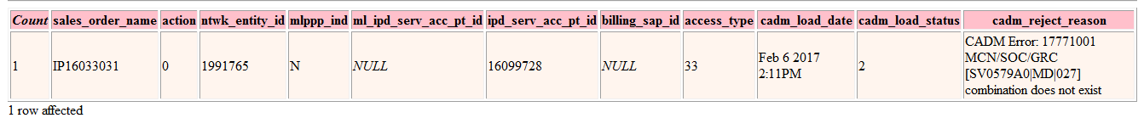

Step:2) Ask user to provide correct service triplets to be updated in USRP.

Step:3) Once user provides the correct service triplets to be updated in USRP. Engage USRP DEV Team.

Step:4) Once USRP DEV Team provides script, execute it.

Step:5) Ask EFMS to retrigger the order to CADM.

Step:6) Run CADM reject query again and check for the cadm_reject_reason, if it says data sent successfully means order has been retrigger to CADM successfully.