|  |  |  |
| --- | --- | --- |
|  | Name | Date |
| Created by | Sarita Borikar | 12-Oct-17 |
| Reviewed by | Aman Bector | 18-Oct-17 |
| Version Number |  |  |

MnP Dummy TNs Workaround

# Issue

## Description:

HOTUT -User unable to add TNs on Phase 2 order.

Prime to BVoIP – there is also on going issue on P2B, user unable to place Prime Disco order

# Trouble Shoot:

## UNIX Logs:

N/A

## Database:

p1gio1d6.sldc.sbc.com / p1gio1d6

# Interfacing Applications:

CADM, EFMS

# Sample Ticket

269395532  
268754797

# Workaround Provided:

**Step 1:**

Provide user with the Dummy TNs range. Those TNs should not be in GIOM DB and CADM.

* You can check the below tables to verify in GIOM DB

select * from iomdbo.TN where tel_num in ('');

* You can check TNs in CADM on EUAM UI

URL: <http://euam.ims.att.com:8010/EUAM/InitialSAMGateway?jadeAction=INITIAL_SEARCH_ACROSS_BILLER_ACTION_HANDLER>

Example: Click on search after entering the TN.

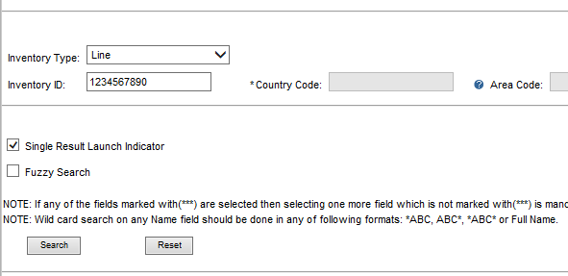

**Step 2:**

Ask user to create an order with dummy TNs.

Get the cart number before checking out.

Verify the cart is created with the Dummy TNs as provided.

If cart looks ok, ask user to check out and provide order number as soon as order is created.

**Step 3:**

BOA need to halt the order flow as soon as order is created.

So once the user provide the order number use below to change the order status immediately and there upon halting the order flow.

select order_status, order_name from iom_order where order_name in ('');

update iomdbo.iom_order set order_status=4 where order_name='';

**Step 4:**

BOA need to replace the Dummy TNs with the required TNs in GIOM DB

1. **Table – TN**

Get the TN_ID from below query:

select t.*, o.iom_order_id from iomdbo.tn t, iomdbo.iom_order o

where t.iom_order_id = o.iom_order_id

and o.order_name = '172485920';

and Run the update statement to replace Dummy with required.

update iomdbo.tn set tel_num = 6107076000, tn_end_range = '6087' where tn_id = '29047173';

1. **Table – TN2GROUP**

Get the tn2group_id from below query for dummy TNs

select lidb_care_cnam_id,substr(tel_num,1,10) tn,tn2group_id,

to_char(lidb_option,'990') l_opt,to_char(cnum_option,'990') c_opt,cnam

from iomdbo.tn2group g,iomdbo.iom_order o,iomdbo.lidb_care_cnam l

where g.group_id=l.lidb_care_cnam_id and o.iom_order_id=l.iom_order_id

and g.valid_ind='Y' and l.valid_ind='Y'

and order_name='172485920'

order by tel_num;

and Run the update statement for replacing Dummy with required.

update iomdbo.tn2group set tel_num='2317272600' where tn2group_id = 120463070;

1. **Table- DIAL_PLAN_RANGE**

Get the dial_plan_range_id for dummy TNs

select iom_order_id from iomdbo.iom_order where order_name = '172485920';

select voip_info_id from iomdbo.voip_info where iom_order_id = 9194597;

select dial_plan_info_id from iomdbo.dial_plan_info where voip_info_id = 10245673;

select * from iomdbo.dial_plan_range where dial_plan_info_id in (10979768,10979769 ) and valid_ind='Y';

and update the required start range and end range accordingly

update iomdbo.dial_plan_range set start_range='6107076089', end_range='6107076099' where dial_plan_range_id = 19985803;

1. **Table- PORTING**

This is only for P2B orders.

Confirm LEC BTN with user on the given range and verify it in PORTING table; update if needed.

select * from iomdbo.porting where porting_id in ('29944378', '29944379');

update iomdbo.porting set LEC_BTN = '' where porting_id = '';

BOA can get the porting_id from table iomdbo.TN for the given range of TNs.

**Step 5:**

Once updates are done ask user to check the cart, if everything is ok.

**Step 6:**

Clear transaction cache, if there is any, using below delete statement.

select * from iomdbo.transaction_cache where order_name in ('172485920');

delete from iomdbo.transaction_cache where order_name in ('172485920');

**Step 7:**

Now change the order status to make it flow.

update iomdbo.iom_order set order_status=0 where order_name in ('172485920');

# Validation:

BOA can verify the order progress through BVOIP tool. Check the order status.