**eSign BOA M&P**

**M&P for Barcoded coversheet**

**Problem Description:**

Sales person requested to generate the Barcoded Coversheet for the particular contract.

**Sample Requests:**

To generate the Barcoded Coversheet issue is reported to BOA team through the USH ticketing system or eSignHelpDesk [dl-eSignHelpDesk@att.com](mailto:dl-eSignHelpDesk@att.com) or eSignSupport [dl-eSignSupport@att.com](mailto:dl-eSignSupport@att.com) distribution lists.

**Sample:**

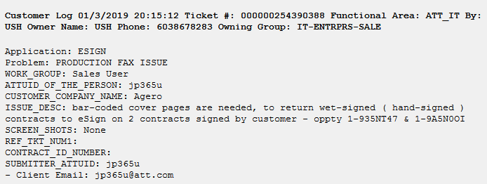

# **Which application do we use for this issue?**

eSign Admin

# **Resolution Steps:**

**A) Attention**

For most types of un-signed Contracts, eSign offers electronic Customer signature by Web or by Phone, which is **instant** and by far, the **least error prone** methods for Customers to sign Contracts.

Effective July 18, 2016, there was a change in the eSign process, to **discourage** the use of hand-signed Contracts and the associated use of Fax or scan/e-mail.

so the required bar-coded Fax coversheets are no longer auto-generated, when the User first arrives in eSign.

Note that hand-signed Contracts, must have a bar-coded Fax coversheet and be Faxed, or scanned/e-mailed, back to eSign, which can become a time consuming effort for the Sales Teams.

And, if e-mailing Customer hand-signed Contracts, with their bar-coded Fax coversheet, to the eSign Fax processing queue at [esign@att.com](mailto:esign@att.com).

**The following e-mail rules must be assured:**

1. Create a new e-mail
2. type [esign@att.com](mailto:esign@att.com) on the To line of that new e-mail
3. ***do not CC anyone***
4. Type whatever you want in the Subject line or leave it blank
5. Attach **one** Customer hand-signed Contract that has a bar-coded fax coversheet
6. ***do not attach multiple files in that new e-mail***
7. ***do not make any comments in the body of that new e-mail***
8. ***do not attach large files****,,, 10MB max,,, if greater than 10MB, the file will not process*
9. Click the send button to send the new e-mail to the eSign fax processing queue and eSign sends it to the CM Team

If eSign is used as expected, with no deviation from the Contract process, then there will be less complications and less time and effort spent processing Contracts by the Sales Teams, Customers and Contract Managers.

**B) Before Sending Contracts to Customers**

If a hand-signature ( aka Wet signature ) and Fax ( or scan/e-mail ) processing is really needed, then **before** sending an un-signed Contract to a Customer.

The eSign User:

**Either**

1. checks the “Wet-signature” box

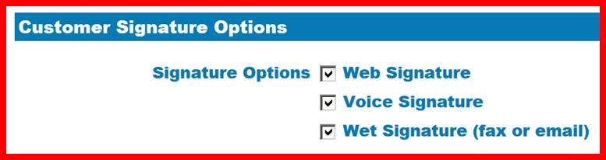

1. so when the un-signed Contract is e-mailed to whatever e-mail address is in the Customer Contact Signer Email box, the bar-coded Fax coversheet will be generated **at that moment.**

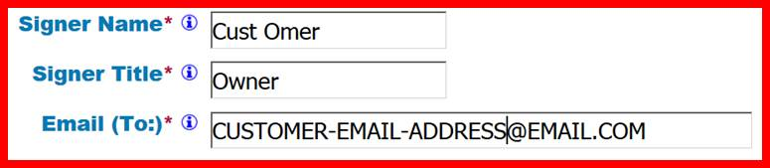

**or**

1. clicks the “Generate Contracts with Fax Cover Page” button in eSign which generates a bar-coded Fax coversheet on the un-signed Contract and checks the “Wet-signature”. box .



1. That button only appears **before** an un-signed Contract is sent to the Customer (including status New or Initiated)
2. so when the un-signed Contract is e-mailed to whatever e-mail address is in the Customer Contact Signer Email box, the bar-coded Fax coversheet will be included.

**C) Complications**

If the un-signed Contract was **already** sent to the Customer **via eSign**, without a bar-coded Fax coversheet and a bar-coded Fax coversheet is now needed to **return** a Customer hand-signed Contract to eSign.

then the eSign User:

1. Goes back to eSign by clicking this link <http://esign.marketing.att.com/esign/index.htm>

and clicks on the affected Request

1. Clicks the “Generate Fax Cover Page” button in eSign, which downloads a single file to the eSign User’s hard drive, containing 1 bar-coded Fax coversheet for each Contract in the Request:



1. That button only appears **after** the Contract is sent to the Customer (including status Sent; Signed and Countersigned)
2. Must assure each bar-coded Fax coversheet is:

* Taken from the single file and
* Applied to the appropriate Customer hand-signed Contract,
* **before** those Contracts are returned to eSign, meaning

**either**

1. the eSign User applies it and returns the Contracts to eSign, as instructed on the bar-coded coversheets

**or**

1. the Customer applies it and returns the Contracts ( meaning the eSign User has to send that downloaded file to the Customer ).

**D) Deviations**

If the un-signed Contract was **already** sent to the Customer **outside of eSign**, without a bar-coded Fax coversheet and a bar-coded Fax coversheet is now needed to **return** a Customer hand-signed Contract to eSign.

then the eSign User:

1. Goes back to eSign by clicking this link <http://esign.marketing.att.com/esign/index.htm>

and clicks on the affected Request

1. Clicks the “Generate Contracts with Fax Cover Page” button which generates a bar-coded Fax coversheet on the un-signed Contract and checks the “Wet-signature” box.



1. That button only appears **before** an un-signed Contract is sent to the Customer ( including status New or Initiated )

3)  Must assure each bar-coded Fax coversheet is

* Taken from each **un-signed** Contract and
* Applied to the appropriate Customer hand-signed Contract,
* **before** those Contracts are returned to eSign, meaning

**either**

1. the eSign User applies it and returns the Contracts to eSign, as instructed on the bar-coded coversheets

**or**

1. the Customer applies it and returns the Contracts ( meaning the eSign User has to send that downloaded file to the Customer ).

# **Validation:** User is able to generate barcode coversheet.