**NetformX Update Process**

*Monitor and make sure Netformx-Updater is updating required library/files successfully in all the 3 environments. May have to run the updater manually, if required. If failed, need to work with Netformx to get the issue resolved.*

*Schedule: Manually update in Prod. at 8:00pm EST every Monday  
 Monitor auto update in Prod. at 8:00pm EST every Wednesday  
 Monitor auto update in Dev. at 2:00am EST every Monday  
 Monitor auto update in Stage-UAT at 8:00pm EST every Tuesday*

Process to manually start updater in Prod:

1. Remote login to NetformX server with your credentials:

|  |  |
| --- | --- |
| MISOUT7DCOMMA02.ITSERVICES.SBC.COM | Netformx PROD |
| CAHYWR1DCOMMA01.ITSERVICES.SBC.COM | Netformx Test – UAT-Stage |
| WIWAUK4DCOMMA03.ITSERVICES.SBC.COM | Netformx Dev |

# Running an update

* To run the Updater:
* Open the Task Manager
* Go to the Processes or Details Tab
* Kill the process named ValidationSrv
* Double-click the updater’s icon in the desktop
* Alternatively, double click the application’s exe file in the installation path.
* A console window will appear on the server. It will be closed automatically once the updater completes all its tasks
* It is recommended to view the log file in “C:\Program Files (x86)\Netformx\NFX Updater\Logs” (or its equivalent folder).

<http://autoproxy.sbc.com/autoproxy.cgi>

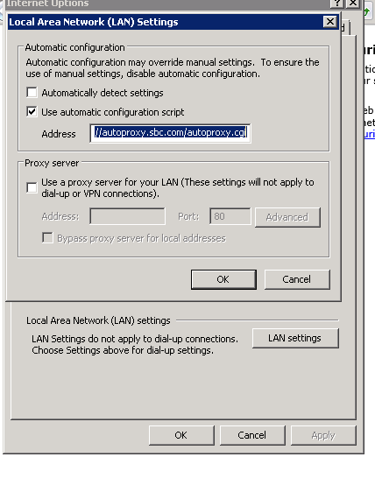

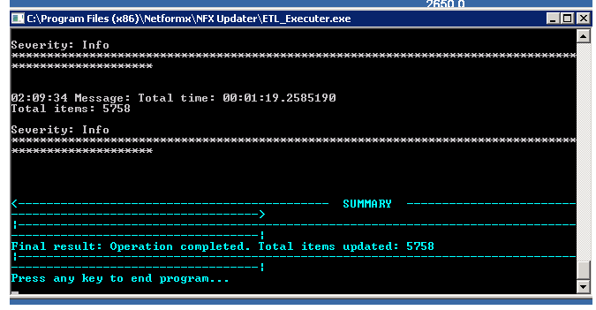

**Creation of USH ticket for Temporary ADMIN rights before running updater every Monday**

Open below USH link

<http://ushportal.it.att.com/step1.cfm?home=ush&rest_team=0&criteria=ssdq>

Click on SSDQ: Trouble Ticket

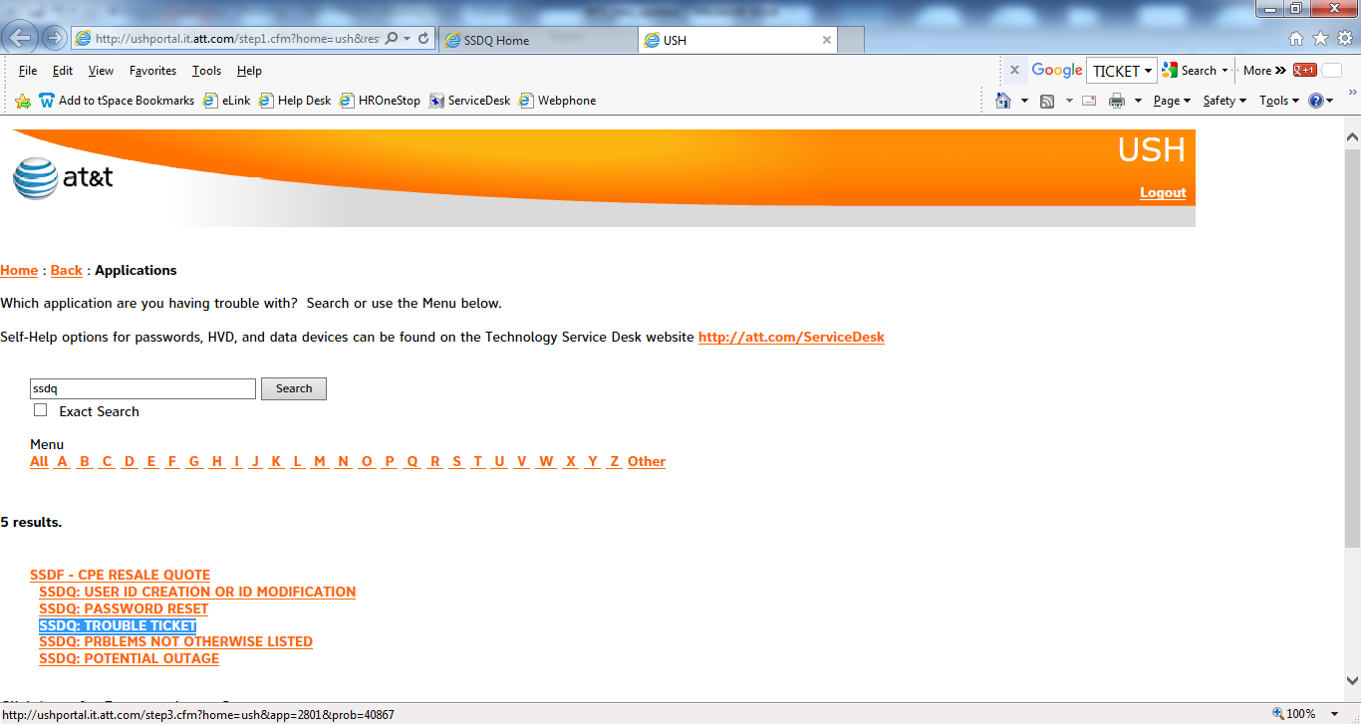

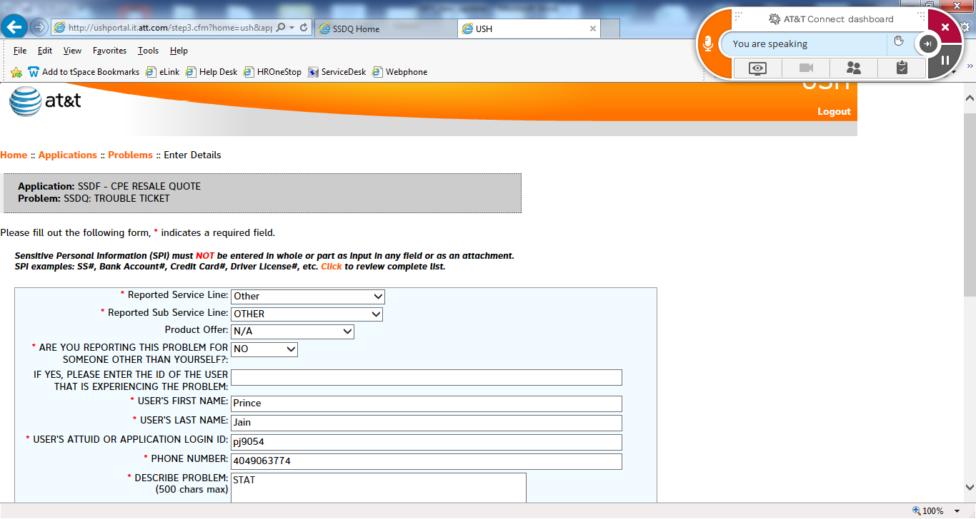

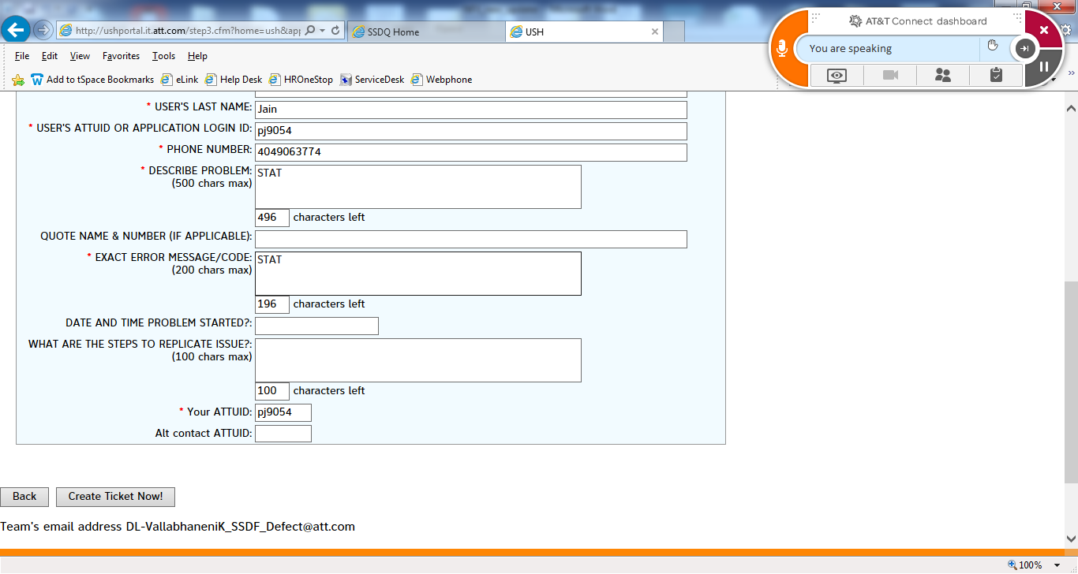

Click Create new Ticket

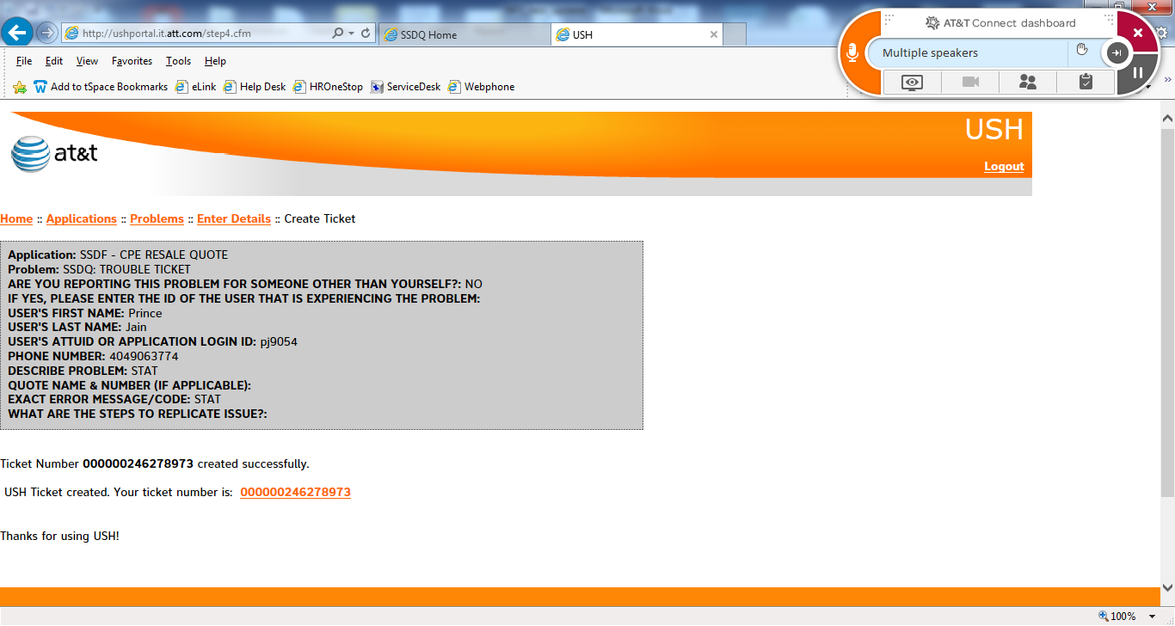

Adter this create a bew ticket using SAMM link

<http://wshsms.it.att.com/WITTIS/security/samm/request.aspx>

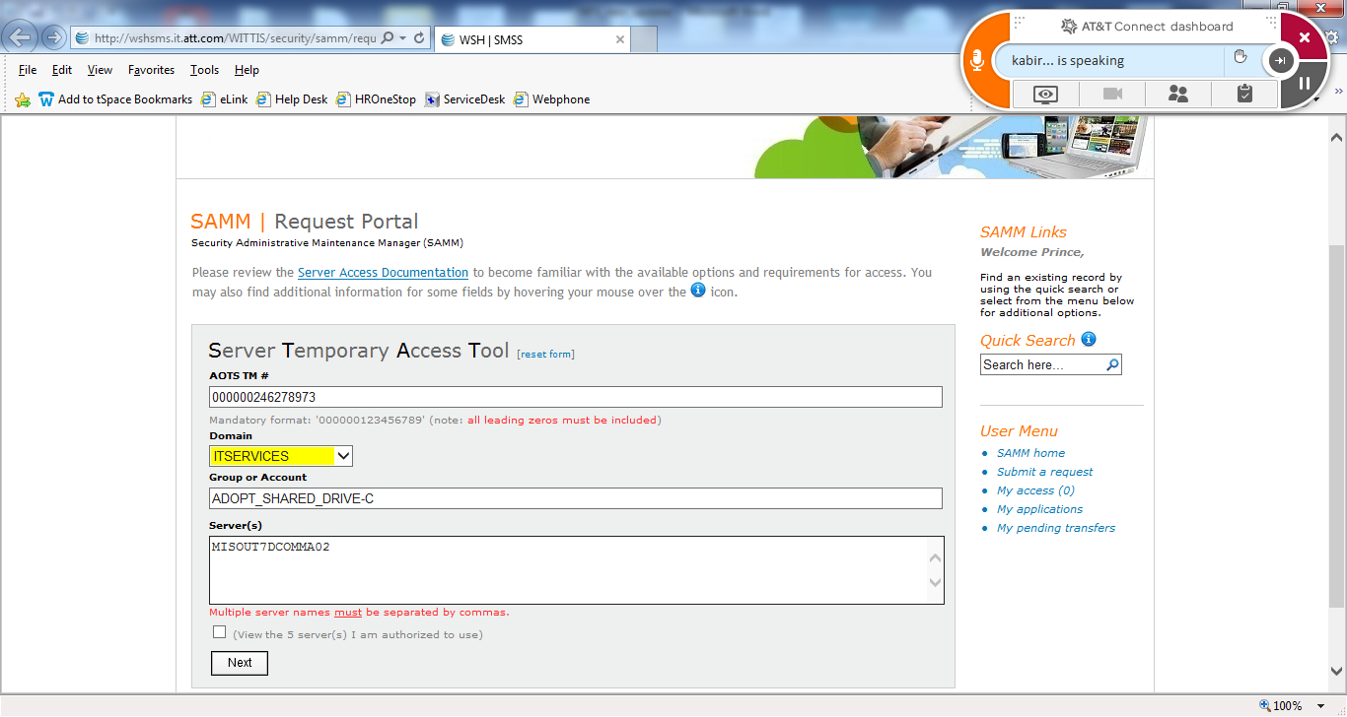

ADOPT_SHARED_DRIVE-C

MISOUT7DCOMMA02

Click Next

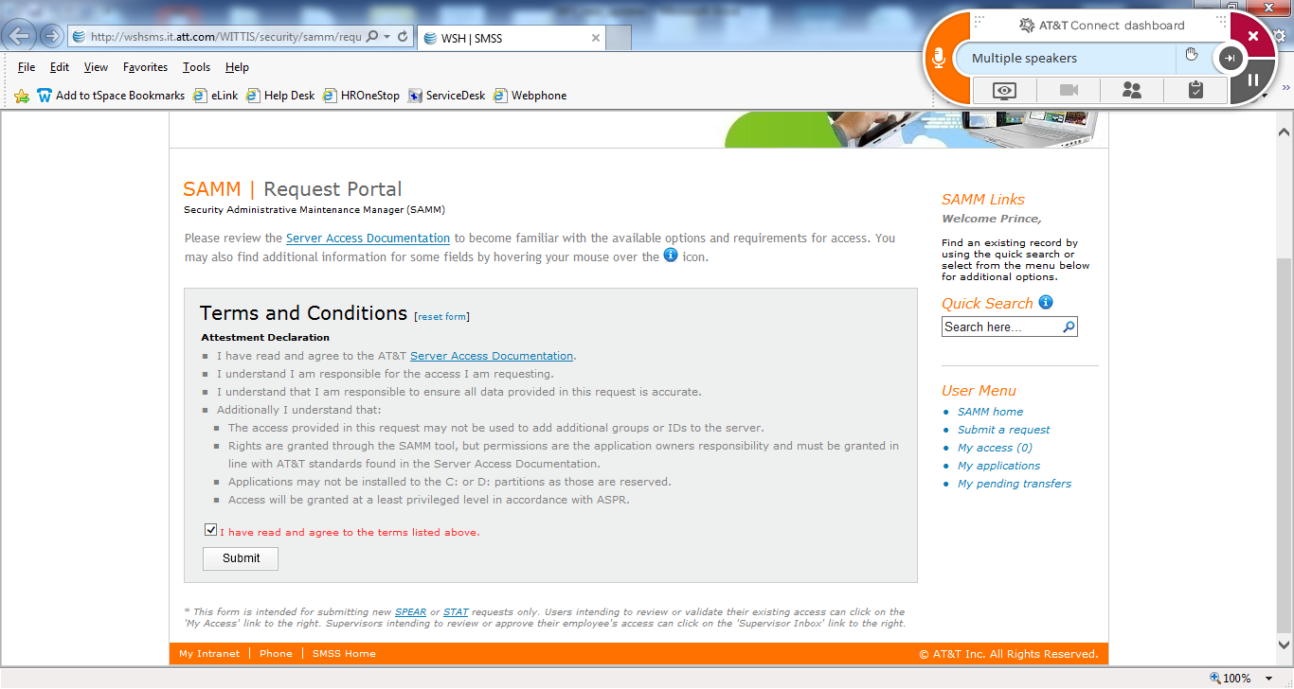

Click on Checkbox and click on Submit.

