Order not found for parameters passed in:

# Version History

|  |  |  |  |
| --- | --- | --- | --- |
| Version# | Date | Summary of Changes | Author |
| 1.0 | 27/12/18 | Created Document | Shivangi Pandey |

**Problem Description:**

**Case First:**

**If User getting error at the time of NAD complete :** **Order not found for parameters passed in [WSCaller.makeCall].**

**Action Required**

* **Check the order in OC table.**

select * from workflow_dba.lpp_order lo where lo.external_parent_order_value = 'VS18086033';



* **Here order completed that’s why user getting error .**
* **Just mark the port order pending in OC table.**

update workflow_dba.lpp_order set Status='Pending' where order_id='1001656387';



* **After that just try for NAD complete from Icore GUI**
* **Issue will fix and no need to open tier 3**

**Case Second:**

**Error Information: Error executing expression (releaseresources:getSDID( $gLPPData/wfservprov:VLAN, $gLPPData/wfservprov:Port )). Reason: An empty sequence is not allowed as the result of function releaseresources:getSDID() [WSCaller.makeCall]**

**Check points:**

* **First check the PVC is deleted or not**

**Open port order and click on “Usage” Link**

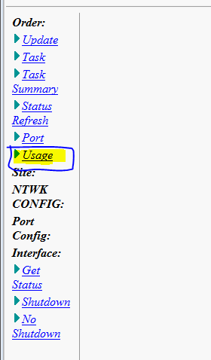

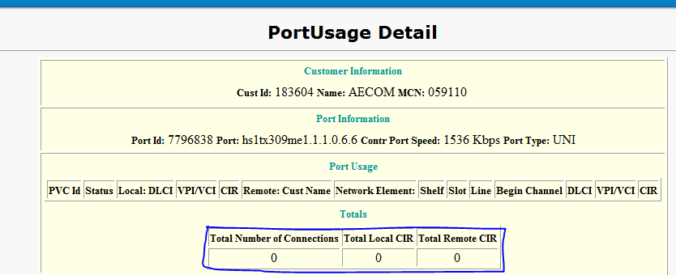

**Total Number of Connections should be “Zero”**

* **Check the configlest on the paid should be HDSC download**

**SELECT GENERATION_TIMESTAMP,CONF_ID, CONFIGLET_STATUS, CONFIGLET_TYPE,REPLACEDBYCONF_ID, DOWNLOAD_TIMESTAMP,**

**ORDER_NUM,PORTASSIGNMENT,C.INTERFACE_STRING, C.VPN_ID,EQPTID,SUPPORTED,DOWNLOAD_STATUS,VALIDATION_STATUS,EDITUSER ,EDITDATE**

**FROM CONFIGLETS C**

**--WHERE ORDER_NUM IN ( 1344491)**

**WHERE PORTASSIGNMENT IN**

**(**

**12073974**

**)**

**ORDER BY GENERATION_TIMESTAMP DESC;**

**Workaround:**

* **Mark task summary as Completed**

**UPDATE WORKFLOW_DBA.ORDER_TASK_STATE OTS SET OTS.TASK_STATUS='Initial' --, OTS.STATUS_REASON = null**

**--Valid status : 'Initial', 'InProgress', 'Failed', 'Completed','RolledBack'**

**WHERE OTS.ORDER_TASK_STATE_ID IN (46290971);**

**Note:Need to update parent order also Completed**

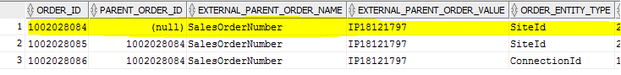

* **Update OC table as Completed**

**UPDATE WORKFLOW_DBA.LPP_ORDER SET STATUS = 'Completed' , MODIFIED_DATE=sysdate --Valid status : 'Pending', 'Cancelled', 'Completed'**

**WHERE ORDER_ID = 1000069799;**

* **Update lpp_order_id as null from the order table in icore**

UPDATE ORDER SET LPP_ORDER_ID=NULL  
WHERE ORD_ID = [11662798](javascript:var%20w=window.open('http://icoreweb.noc.att.com:5020/servlet/Client.OrderMgmt.Order?MODE=Detail&ORDERID=11662798','detailPage');if%20(isNaN(w.opener.screenX))%20%7bw.resizeTo(screen.width,screen.height);%7dw.moveTo(w.opener.screenX,w.opener.screenY);w.focus();)

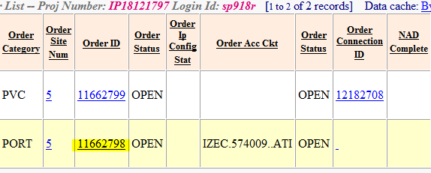

* **Ask To user for NAD compete the order**
* **After NAD order will close and Need to update lpp_order_id as previous value**

UPDATE ORDER SET LPP_ORDER_ID=[11662798](javascript:var%20w=window.open('http://icoreweb.noc.att.com:5020/servlet/Client.OrderMgmt.Order?MODE=Detail&ORDERID=11662798','detailPage');if%20(isNaN(w.opener.screenX))%20%7bw.resizeTo(screen.width,screen.height);%7dw.moveTo(w.opener.screenX,w.opener.screenY);w.focus();)  
WHERE ORD_ID = [11662798](javascript:var%20w=window.open('http://icoreweb.noc.att.com:5020/servlet/Client.OrderMgmt.Order?MODE=Detail&ORDERID=11662798','detailPage');if%20(isNaN(w.opener.screenX))%20%7bw.resizeTo(screen.width,screen.height);%7dw.moveTo(w.opener.screenX,w.opener.screenY);w.focus();)

**============================================**