**PAID issue**

**Sample Ticket** – 000000228037934

**Problem Description -** Need USRP to update the MLPPP Virtual Link Data/IP Switch Data with the correct PAID for the following orders, so that subsequent transaction to INSTAR don't fail. Thank you.

MLPPP Circuit:

IP17010655 - Correct PAID: 9446262

IP17010710 - Correct PAID: 9382610

IP17011423 - Correct PAID: 9290090

PROB_DESC: EFMS is getting INSTAR Tier Error (Failed Automated Task: Get IP Data from INSTAR 10030 and INSTAR GetPortState 10030 / Error Condition: Cannot find Port) due to wrong PAID.

**Solution:**

Step 1. Check the current value for the PAID in USRP DB using following Query:

select ml_ipd_port_asgmt_id from logical_ip where log_ip_id IN (log_ip_id, buf_log_ip_id)

Step 2. WA – Update table - logical_ip with the correct PAID provided by the user.

update logical_ip set ml_ipd_port_asgmt_id=XXXXXXXXX where log_ip_id IN (log_ip_id, buf_log_ip_id)

**** Log Ip ID of any order can be found in DSOTS - <http://usrp.web.att.com:8008/cgi-bin/display_sales_order>

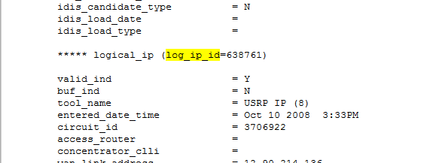

**** For the Buf Log IP ID use query:

Select * from ip_info where log_ip_id = 638761

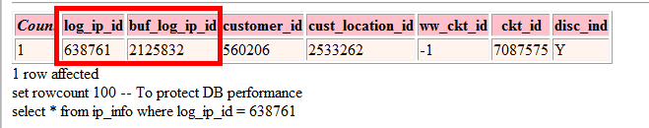

Step 3. If the order is Ethernet order, T1,T2 (other than MLPPP order)

Update the table - connection_ip_ckt with correct PAID using following query:

update connection_ip_ckt set ipd_port_asgmt_id = XXXXXXX where log_ip_id IN(log_ip_id, buf_log_ip_id)

Nisha Bedi