**HOW TO UPDATE PART NUMBER**

There will be file attached to the ticket download that file.

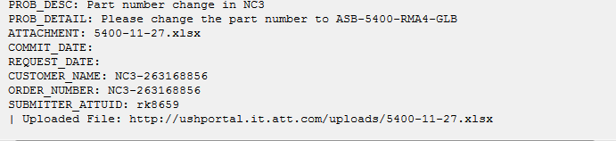

Example Ticket - 271725848

**Step 1.**

Login to database sever

gs282a@zlp12450.vci.att.com

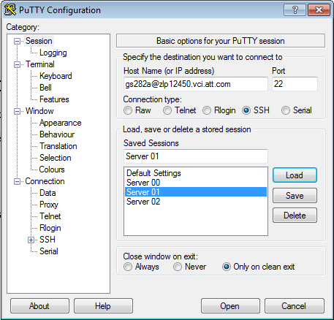

**Step 2.**

search for the odbid of the part in Catalog Item Notebook.

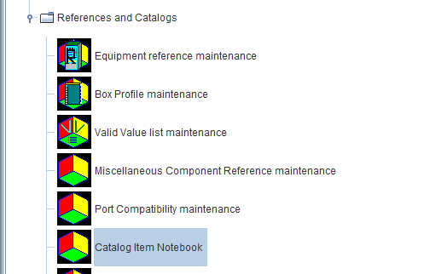

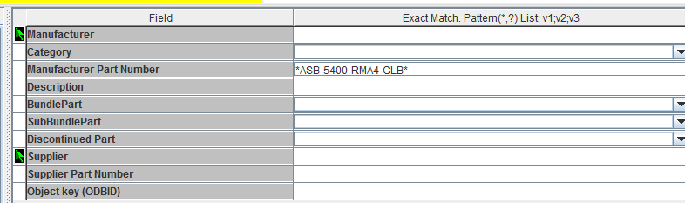

Click on search and then return odbid of the part will be on bottom right of the page.



**Step 3.**

Use this odbid in the update command you will get the asset keys from the attached spreadsheet with the ticket:

update nc3.asset set odbid_catalog_part = 229941024, lastupdtmstmp= sysdate, lastupduser='gs282a',lastupdtran= 'TKT-271725848' where asset_key in ('NC3-263168856','NC3-263168857','NC3-263168861','NC3-263168862');

Above command will update the part number of four assets as per user requirement.

**Step 4.**

Execute the command on database server gs282a @zlp12450.vci.att.com

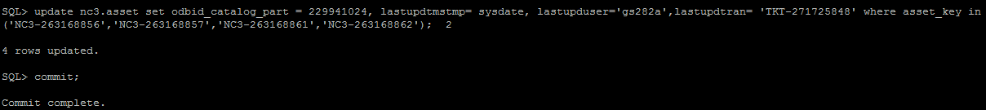

**Step 5.**

Check for part number if it is successfully updated by using select command

select odbid_catalog_part from nc3.asset where asset_key in ('NC3-263168856','NC3-263168857','NC3-263168861','NC3-263168862');