**Issue – RRN Migration Failure**

**Sample USH#** 270809519

**Step 1:** Get the list of RRNs from USH.

Each RRN will have 8YY(Toll Free No) associated to it

**Step 2**: Check the RRN in GIOM DB using below query. The RRN- 8YY combination should be correct.

Select D.DIAL_TF_OPTS_ID,D.TOLL_FREE_STATUS,D.VOIP_INFO_ID,D.VALID_IND DTF_VALID,D.TFNO_NEW_IND,D.ADV_FEATURE_IND,D.TOLL_FREE_NO,

AM.COMP_ID,AM.CHANGE_COMP,AM.CHG_TYPE_CODE,AM.ACTIVITY_ID,AM.ACTIVITY_NUM,AM.DIAL_OTHER_OPTS_ID,AM.ODB_KEY,AM.PARENT_ACTY_MUL_ID,AM.TO_COMP_ID,AM.VALID_IND AM_valid,AM.ACTY_MULTIPLE_ID,

R.RRN_ID, R.RRN,R.VALID_IND RRN_VALID, R.DIGIT_TREATMENT_ID,R.SDOP,R.RRN_NEW_IND,R.RRN_STATUS,R.SDOP_STATUS,V.IOM_ORDER_ID, O.ORDER_NAME

from IOMDBO.DIAL_TF_OPTS d, IOMDBO.RRN R, IOMDBO.VOIP_INFO v, IOMDBO.IOM_ORDER o,IOMDBO.ACTY_MULTIPLE am

where d.DIAL_TF_OPTS_ID=R.DIAL_TF_OPTS_ID

and V.VOIP_INFO_ID=D.VOIP_INFO_ID

and O.IOM_ORDER_ID=V.IOM_ORDER_ID

and AM.DIAL_TF_OPTS_ID=D.DIAL_TF_OPTS_ID

*-- O.ORDER_NAME = '183044104'*

and r.rrn = '4367840000'

order by r.rrn;

**Step 3:** The RRNs need to be check if they are being added or deleted. Attribute – Chg_type_code

**Chg_type_code -**

13055 : Add Toll Free Number to Existing APN/RA

13056 - Add Toll Free Number to New APN/RA

13057 - Add SDOP/RRN to Existing APN/RA

13058 - Add SDOP/RRN to New APN/RA

13061 : Remove Toll Free Number only

13082 - Add SDOP

13088 - Add IP Transfer Connect Feature

13109 - Change IP Transfer Connect Feature

So, if we have 13061 as chg type code, that means the RRN is getting deleted, and we can check for the corresponding orders.

The orders should be the latest order, if RRN is deleted, if there are more orders, that means RRN was added back after deletion once.

**Step 4:** If RRNs are deleted, which means RRNs not in EUAM is correct, ask user to cross check RRNs again, else proceed.

**Step 5:** Verify RRNs in CADM(EUAM)

EUAM Link: <http://euam.ims.att.com:8010/EUAM/InitialSAMGateway?jadeAction=INITIAL_SEARCH_ACROSS_BILLER_ACTION_HANDLER>

1. Open the link and select Inventory Type as RRN.
2. Put your RRN that need to be checked in Inventory ID
3. Click on Search

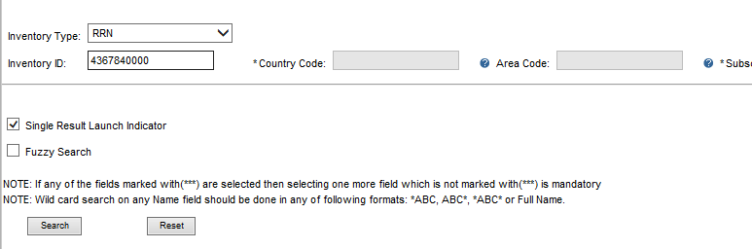

1. If RRN is not in EUAM, you will get message as “No Customer Found”
2. If RRN is in EUAM, you will get a new page, which shows the Billing Hierarchy. You can confirm with user that RRN is already migrated and ticket can be closed.

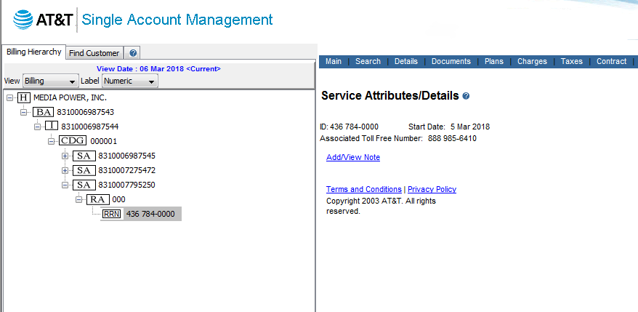

**Step 6:** Verify Billing transaction on all the orders obtained from Step 2 query is success or not.

1. Open the order in Bvoip Tool.
2. If the order has old billing flow, the below transaction should be successful for Success Billing

SEND_BSE_OUT

SEND_RSC_OUT

SEND_BTF_OUT

SEND_BTN_OUT

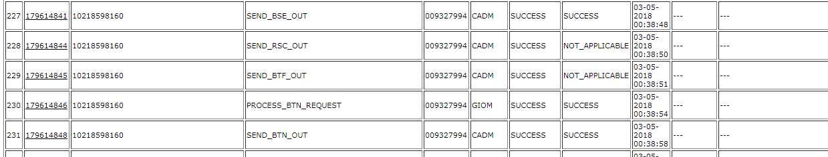

1. If the order has new flow, the below transaction should be successful for Success Billing

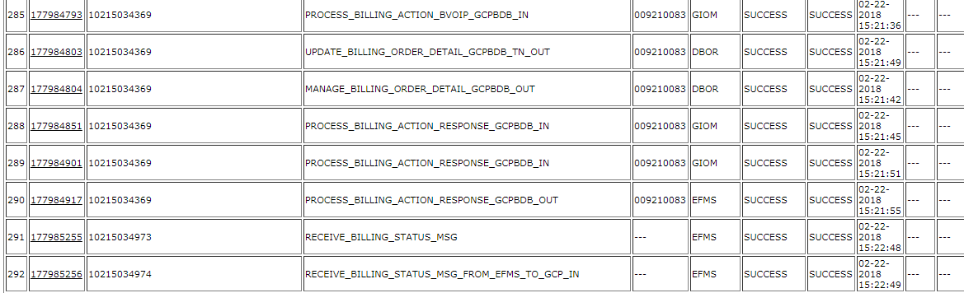

1. If any of the order doesn’t have success Billing, Stop the workaround for RRN migration.

And, work on Billing error task depending on the error. Once Billing is success, RRN should migrate on its own.

1. For success billing, go to Next Step for migration RRNs workaround.

**Step 7:** Use BTF sheet below, and update your RRNs details in the sheet.





Feilds that need to be updated –

1. Order Name – Order Number against which the RRNs are being migrated
2. Eff_bill_date – Use below query for effective billing date

Select Activity_Dates_Id,A.Activity_Id,A.Activity_Id,Decode(A.Acty_Type, 0, 'NS', 174, 'MACD', 175, 'Disconnect', A.Acty_Type) "TYPE",

Order_Name, to_char(d.billing_eff_date,'YYYYMMDDHHMMSS') Bill_Date, v.voip_info_id, v.cnr_ind

From Iomdbo.Activity_Dates D,Iomdbo.Activity A,Iomdbo.Iom_Order O, Iomdbo.Voip_Info V

where o.iom_order_id=a.iom_order_id and d.activity_id=a.activity_id and v.iom_order_id=o.iom_order_id

And O.Order_Name In ('172751728');

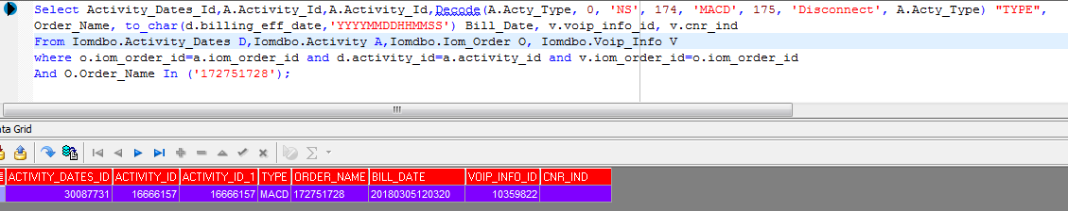

1. TF – is Toll Free Number (8YY )
2. RRN – RRN Number
3. RRN Activity – should be ‘I’, when it been added to CADM, else for removing it should be ‘O’.

**Step 8**: Go to CADM simulator –

<http://giom.cif.att.com:9001/JSP/voip/jsp/tools/BvoipToolsCADMSimulator.jsp>

Username: cadm

Password: cadmgiom

Select Transaction BTF and upload the BTF sheet here.

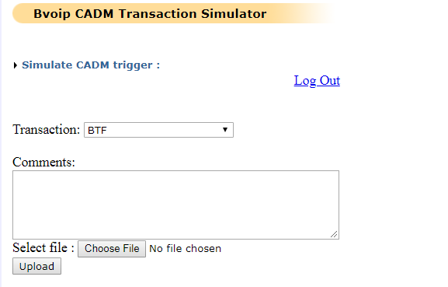

**Step 9:** Once the transaction is successful, check the RRN in EUAm, it should be present now. (Step 5).