**NTMS DISCORD ISSUE**

ERROR : "java.lang.Exception: [Error] level discord [NTMS is out of synch with the router - Perform Real time discord analysis to load current config] detected on port [8683149] at com.att.ccrt.order.tran.MultiStepTurnupTra".

Reason: There is some network issues which can be cleared by running a RTD process, after its successful completion the user can retry the task and it should progress.

WA :

1. Go to Real Time Discord URL

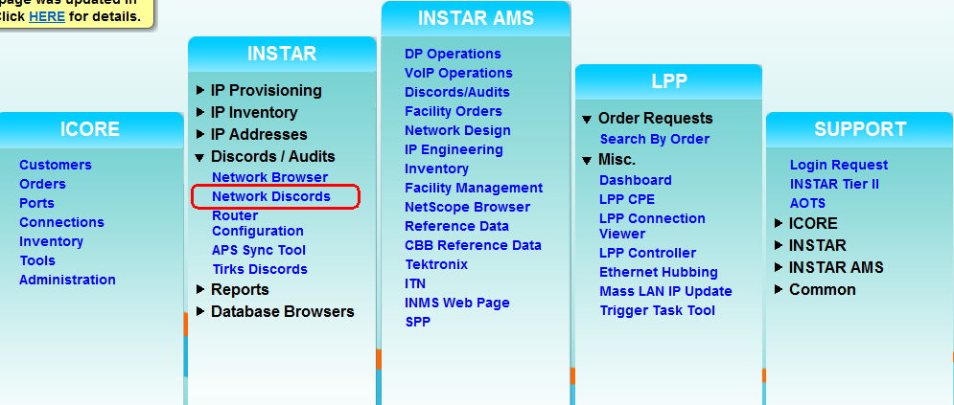

1. Go to Real Time Discord Analysis

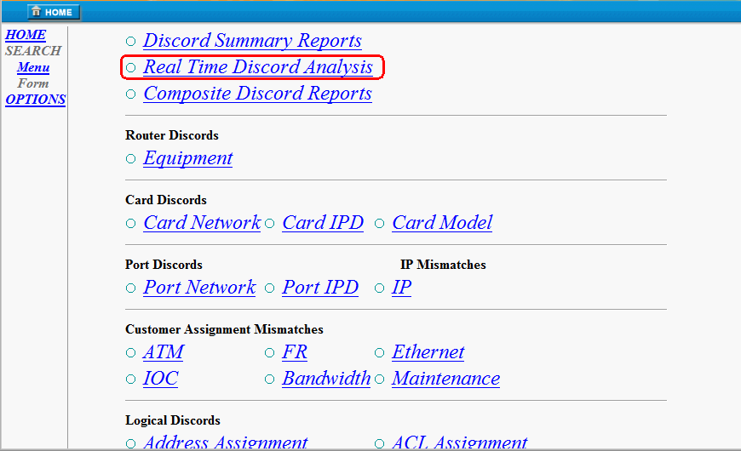

1. Enter the Port ID on which the discord exists as per the error message, then submit

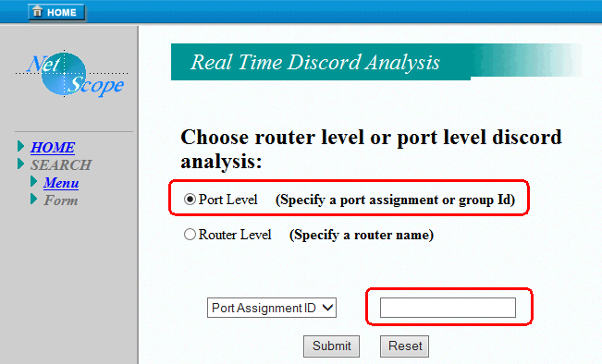

1. After this, we will get a completion email notification.
2. Then user should retry the task
3. If it fails then send the request to NOC.
4. If NOC fails to do this then create the ticket to Icore.