**Remedy**

**Use below query to pull Sales Express BOA tickets:**

('Managing Org' = "IT-ENTRPRS")

AND ('Active Org' = "IT-ENTRPRS-SALE")

AND (('Ticket State' = "Queued")

OR ('Ticket State' = "Active")

OR ('Ticket State' LIKE "Deferred%"))

AND (('Work Queue' = "SALES EXPRESS"))

**Select ticket in ‘Queued’ state by double clicking**

You will see Ticket State is ‘Queued’

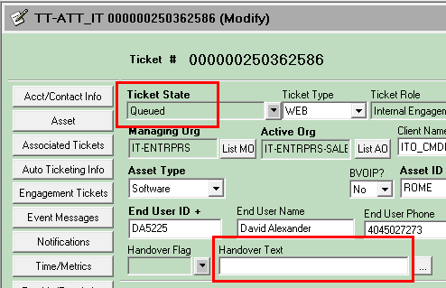

**Enter your attuid in ‘Handover Text’ field** and select ‘Yes’ for Locked



**Select ‘View Log’** on the left to open the ticket log and view the reported issue

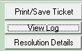

Read the log to see what product is being used/reported and **update the ‘Problem Abstract’** with the product/offer type

** **

**Update ‘Reference Number’ with oppty** (if created)



**Update Key Item Affected** with key word of the issue:

Examples:

selectValueLabelMap

IPV4Address

SAART

**Creating IE ticket to another application**

Ticket must not be in ‘Queued’ state

Clck on ‘Engagement Tickets’

 then 

Tier Level = ‘All tiers’

Active Org = use Remedy cheat sheet based on application

Remove your attuid from handover text (on IE)

Asset ID = ‘application name’

Select Work Queue based on application (Remedy cheat sheet)

Click on ‘View Log’ and post description to application and all details for which they need to investigate.

Save > copy newly created IE # and paste to your ticket log

**Closing a ticket in Remedy**

Open ticket

Select ‘Time/Metrics’

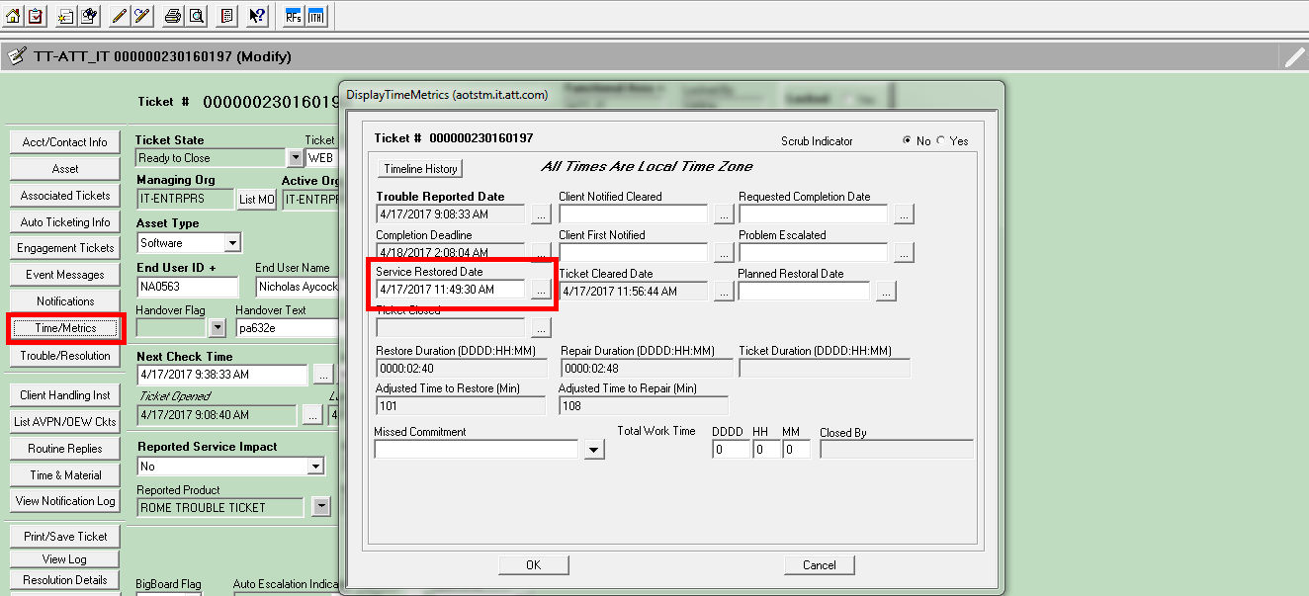

Click inside ‘Service Restore Date’ and current time/date will populate.

If you need to back date it then click on the little box with 3 dots 



Click ok

Select Trouble/Resolution

From the dropdown select what is appropriate beginning with ‘HD -…’

Hit ok

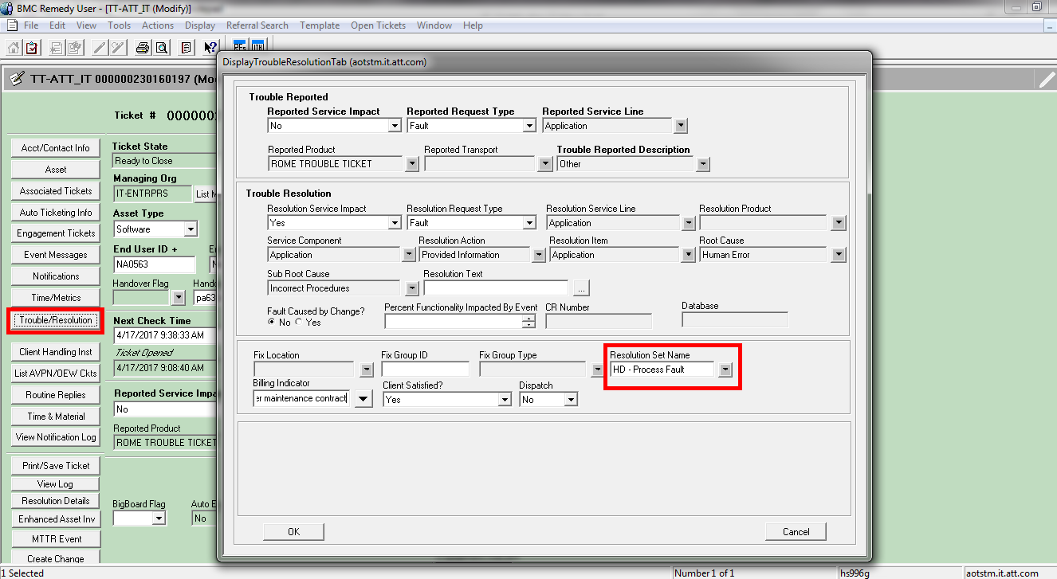



**Update Question Template** with full details of the issue, any WA, and RC (if known)

**Update BigBoard Flag** with Green or Red only:

Green = old issue; we have a WA

Red = new issue; we do not have any WA

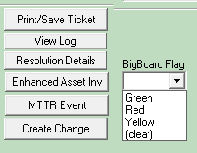

**Update Sev Class** - This field is to indicate which app provided WA. If more than 1 app provided WA select 'Multiple' from list (a.) and hit 'OK'. Then go to Notes (b.) field and add all apps that provided WA

1. 
2. 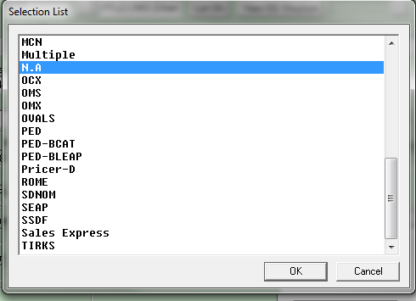

**Last set the Ticket State**

Ready to Close

Defer

Delayed Maintenance – use this for fixes and be sure to add fix date and MR if known

Delayed - Cust Information – use after we made corrections or need more info from user before we can investigate

Deferred – Cust Vendor – use when issue is with a non-TechM application

Cancel – if user created in error or incorrectly, have them cancel. BUT…if they don’t do it in timely manner we should do it