**Creating Supervisor Role:**

**Note:** Use[ibmboa@att.com/abc](mailto:ibmboa@att.com/abc)to login as supervisor for the ASOC BOA team to avoid multiple id’s.

Below is the steps if really required to add a new supervisor.

1. Go to <http://asoc.it.att.com:8080/avs/av_home.xml>
2. Enter email address and password for supervisor access and click login
3. This will ask you as, ‘Are you a new user?’. Click Yes and add the details as below in the snapshot.

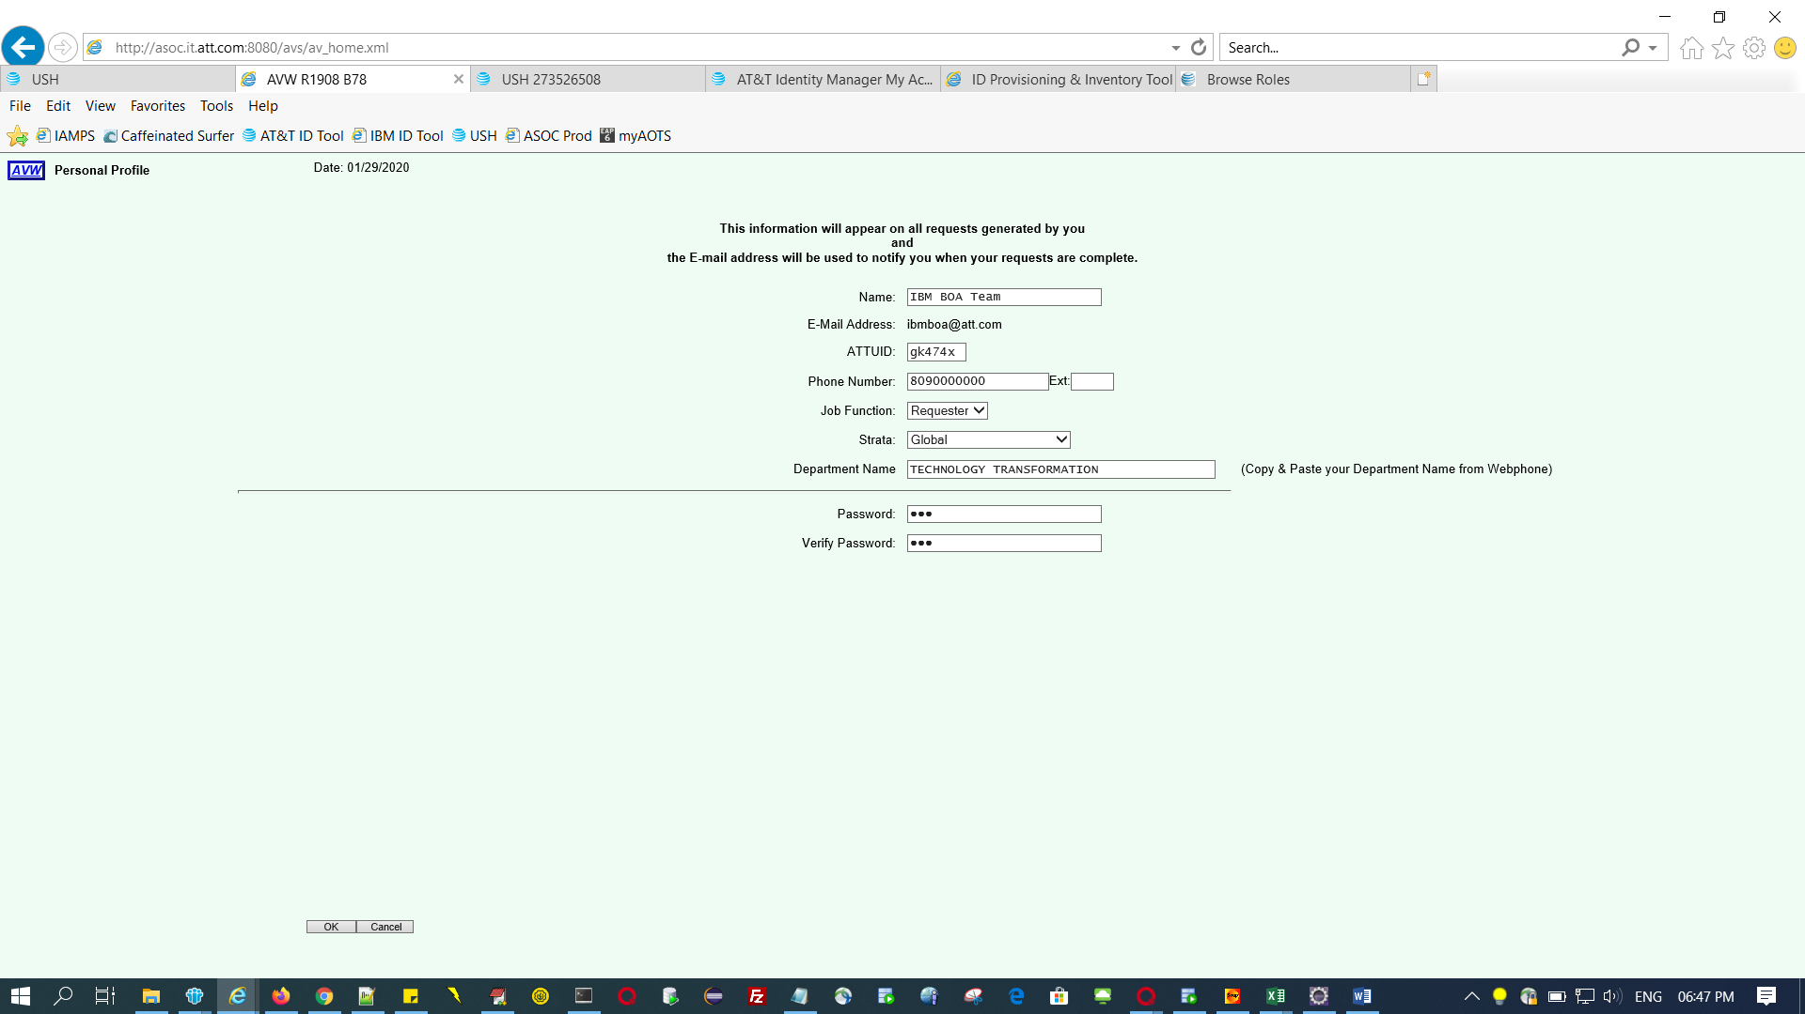

1. Once you click Ok, you will get “User added in Database”. You can see as below in the DB.



1. update user_prof set user_type_code='S' where email_addr='ibmboa@att.com';

Commit;

1. Try the above created login and see if this is logging in as Supervisor Worklist. If yes, you should be able to add address using New construction Address Admin link.