**eSign BOA M&P**

**M&P To Provide DOA Link**

Problem Description:

CM came to eSign helpdesk with the concern that they are not able to access the contract in eSign for countersignature

That process is started when CM launch into eSign and try to open the respective contract for countersignature.

Sample Requests:

The issue is reported to BOA team through the USH ticketing system or eSignHelpDesk [dl-eSignHelpDesk@att.com](mailto:dl-eSignHelpDesk@att.com) or eSignSupport [dl-eSignSupport@att.com](mailto:dl-eSignSupport@att.com) distribution lists.

**Sample:**

* Over USH ticket

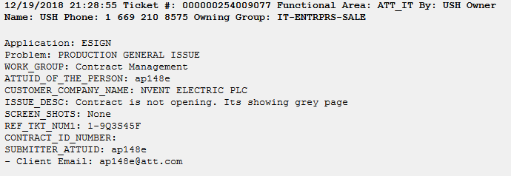

# Which application do we use for this issue?

eSign admin, Countersign Link

# Resolution Steps

1. BOA team needs to check if the CM is not able to access the countersigning link page.
2. Using the Countersigning link and appending the request id of the contract of which the CM is facing the issue

http://esign.marketing.att.com/esign/doa.htm?requestId=1834699  
3. We will use the following link to validate the issue CM is facing

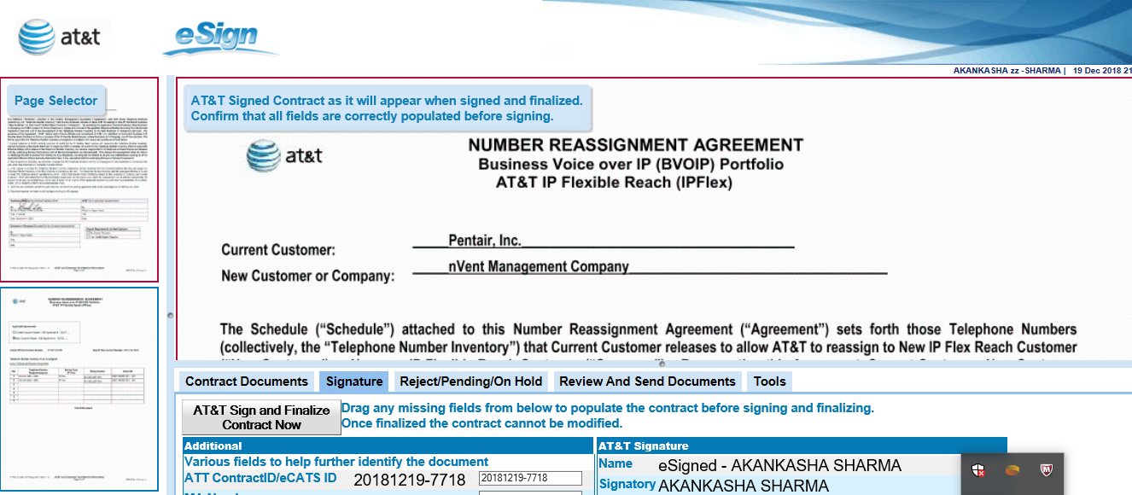

1. If eSign helpdesk, doesn’t encounter any issue on their end, we will provide them the DOA link, by appending the request id of the contract of which the CM is facing the issue

<http://esign.marketing.att.com/esign/doa.htm?requestId=1834699>

1. And eSign helpdesk share the DOA link to the user

