**To check longitude and latitude in USPS**

1. Open USPS website - <https://tools.usps.com/> (Note: this website will not open in AT&T intranet)
2. Go to Quick Tools tab
3. Then click on Look Up Zip Code

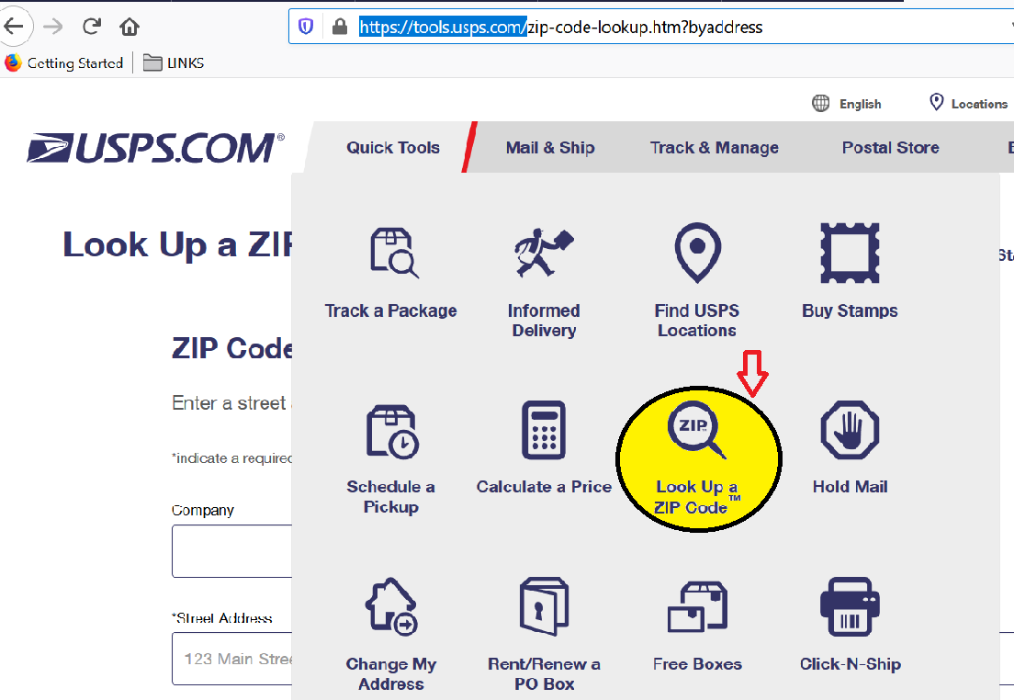

4.Then Find your address

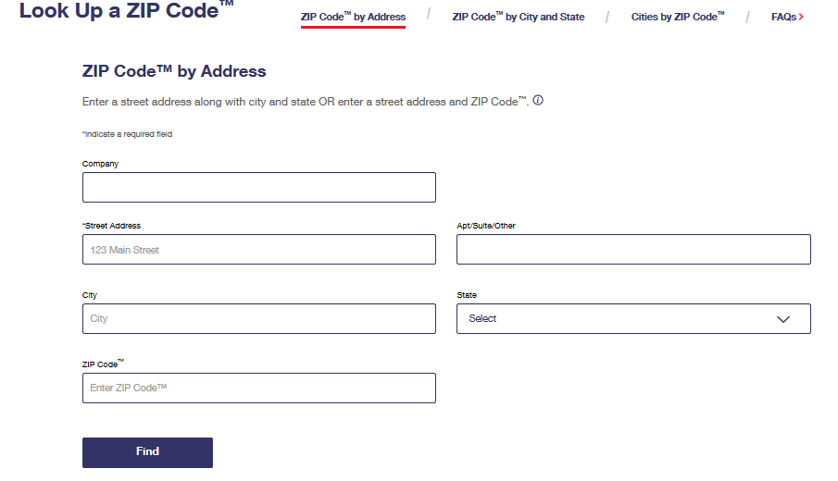

5. If the address is available in USPS you will get Longitude and Latitude.