**AT&T USRP SAFE Tool**

<http://p1usr1w5.vci.att.com:9288/psotool/index.html>

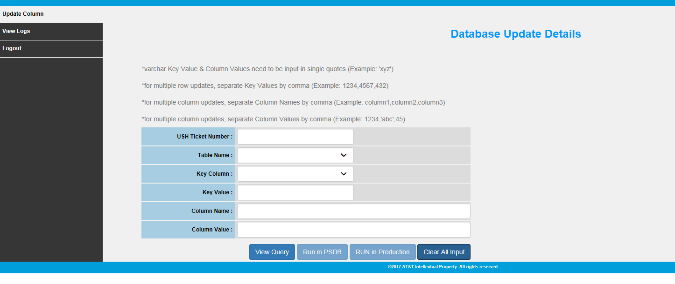

USRP safe tool is used to run the updates in DB.

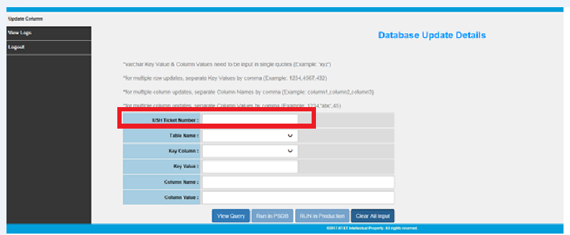

In the first field we need to enter the ticket Number.

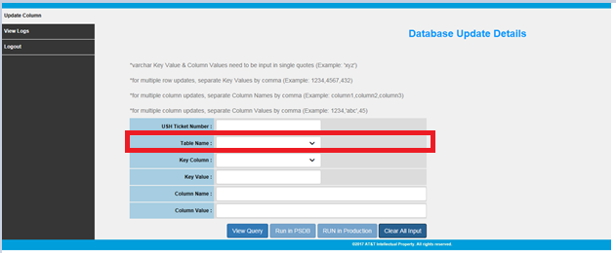

From the 2nd field we will select the table name from the drop down that we need to update in USRP.

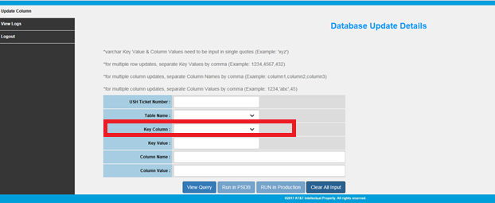

Here we will select the key value from the drop down where we need to update in the table .

Varchar key values need to be input using single quotes.

For multiple row updates key values must be separated by comma.

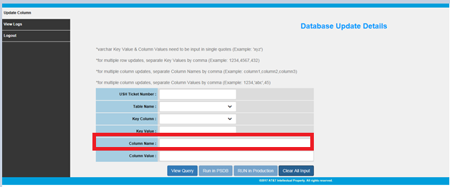

Need to enter the column name that we need to be updated in USRP.

For multiple column updates column names and column values should be separated by Comma.

* if we want to enter the new table in the tool need to send email to Szuwei chao (sz2974)