PROB_DESC: Add TSP Order. order cannot be released. Error generating while releasing the order.

Ticket #: 000000243814402

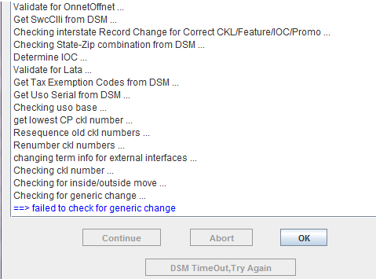

While sending the order if we are getting the error message:ValidateOrderBase::checkGenericChange then inform user to select order Action as Generic Change and specify the changes you intend to perform.

Please select the appropriate checkboxes to specify your change(s) and resend the order.