**Order Handoff OHSR 200 error**

|  |  |  |  |
| --- | --- | --- | --- |
| DATE | CREATED/MODIFIED BY | VERIFIED BY | PRODUCT |
| 11/26/2018 | Shelly Garg (sg0028) |  | ADIE/ADI/VBB/Mis/Fbb/MisIpflex |
| 11/25/2019 | Heidi Seau (hs996g) modified |  |  |

Ref: TT **252782566**

Oppty 1-9IM6AL6

Solution id: 108559909

**Issue**: User unable to submit order handoff due to error message OHSR submission error: 200 : internal : OHSR error.

**CFDO ERROR:**

Service-Name: CreateFiberDesignOrder

1>Please check the Order Handoff status of the Oppty in ROME first, If OHSR ID is present then proceed with below steps.

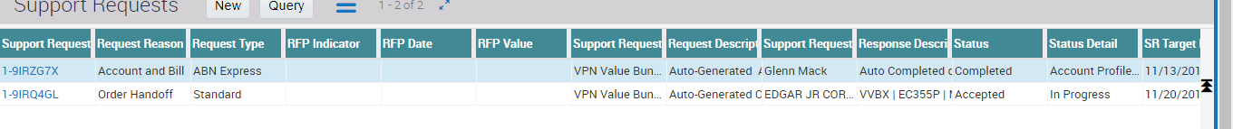

**Option 1**

Enter Request Id (as found in ROME) in admin screen, Save, ask user to clear cache and retry OH

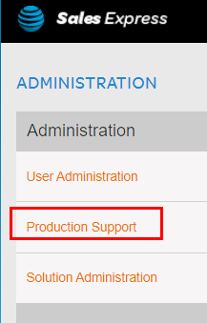

Enter the oppty id and press search

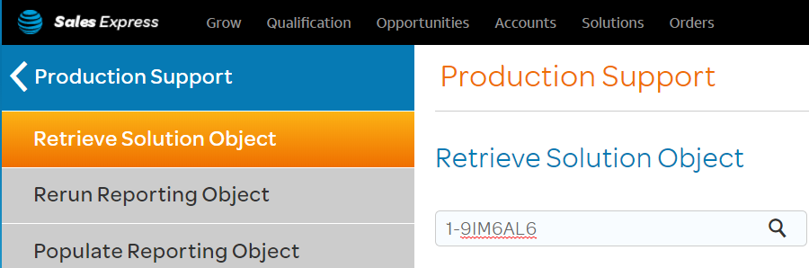

Drill down: Value > Solution > orderHandoff > requestid

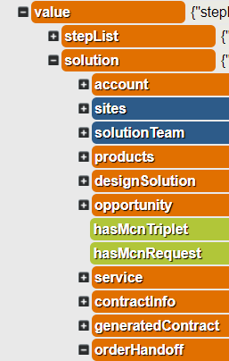



**Option 2**

Open the user solution and enter theSolution.orderHandoff.requestId = '[1-9IRQ4GL](javascript:void(0);)'

Click on OH, Save, ask user to clear cache and retry OH

