**CTH Clean up:**

Sample Order ID : 304387121

UCPE / Device Name : FIOMYSHEL170101UJZZ01

**Step #1** : To find the Service Order in OMX UI - <http://nt-svcs.it.att.com:9003/omx-web/index.html#/dashboard>

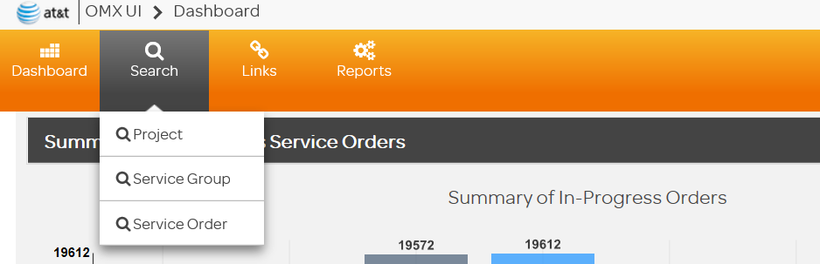

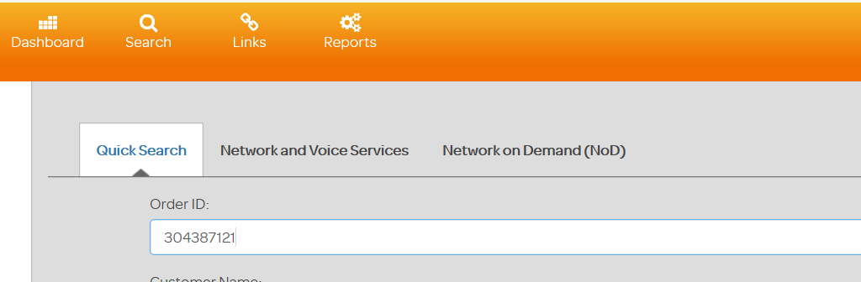

**Step #2** : To find the tasks which are in ready state , by selecting the status in ready [ as below ]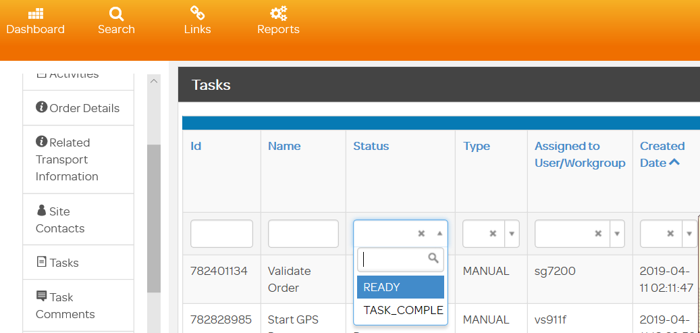

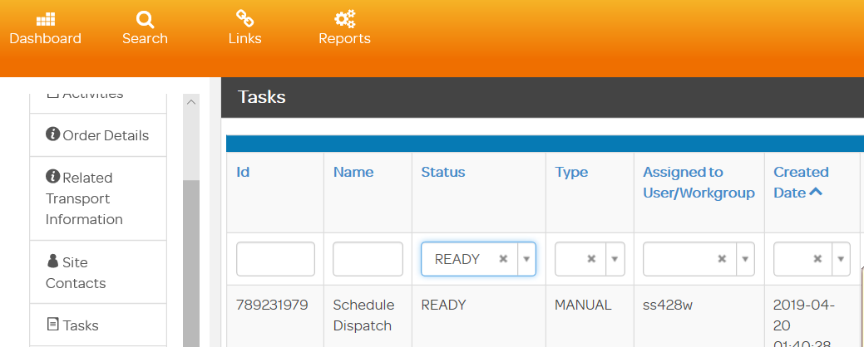

**Step #3:** Select the Task ID for the task in ready state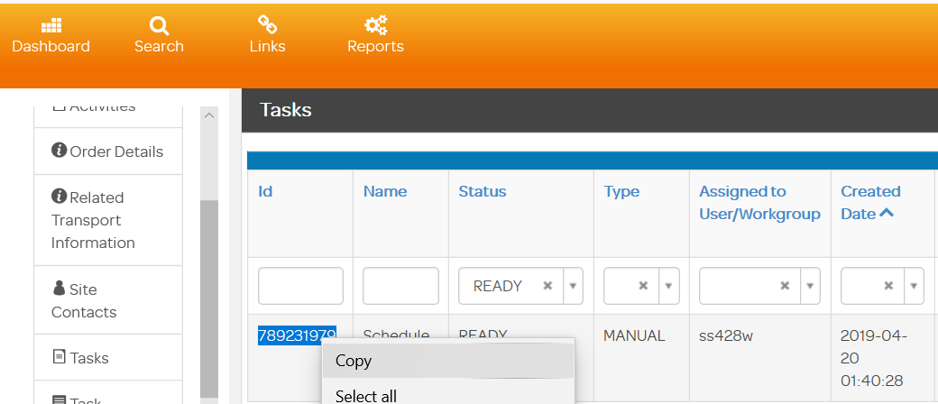

**Step #4**: Execute the below script to skip the task for service order id: 304387121

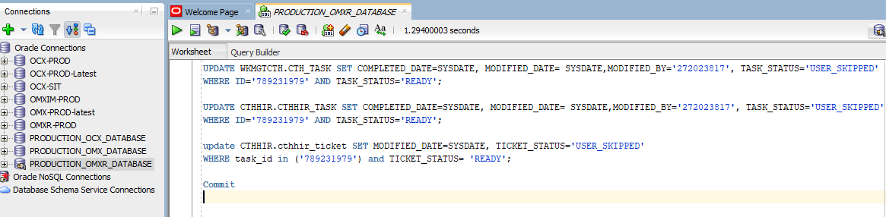

**Step #5:** Verify the task status in OMX UI for service order id: 304387121 , No Ready state

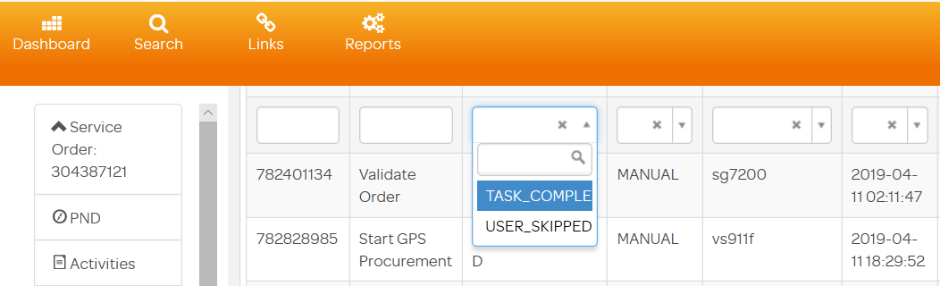

**Step #6: CTH clean up completed for order id: 304387121**