**How to fetch logs for PM issues**

For fetching logs for FOCN and SOCN issue in PM below paths are to be used:

1. /opt/app/app_data2/app_logs



1. cd WS7_20180313.0405



Date is to be changed accordingly.

1. cd was_pm1_efmswb01



1. less SystemOut_18.03.12_15.37.28.log

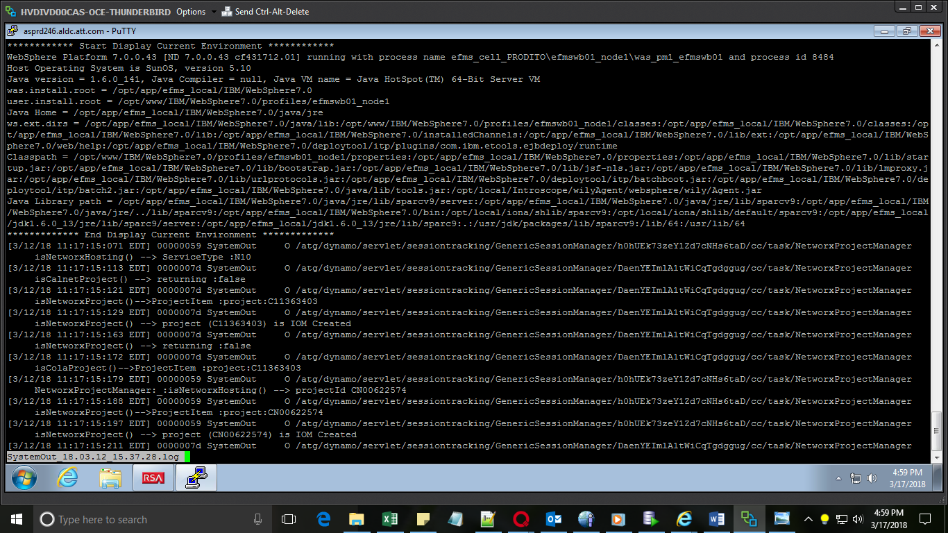

1. :/ CN00597645

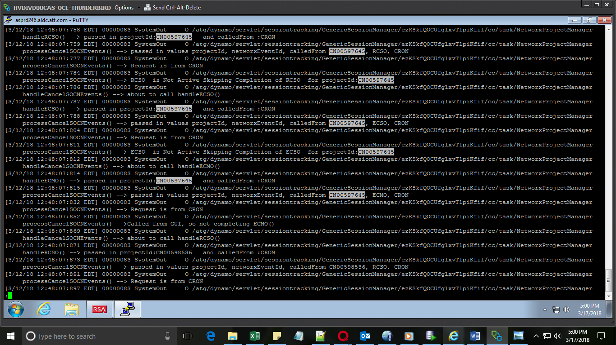

1. Press ‘n’.
2. Search for the error by text i.e /Invalid Input: Field SOCN

