**How to open Client request in MS GUI**

**Step 1:** Copy and paste URL link in Browser.

<http://efmsms.it.att.com:8008/ms>

**Step 2:** Enter user ATTUID and Password in box as shown in image below.

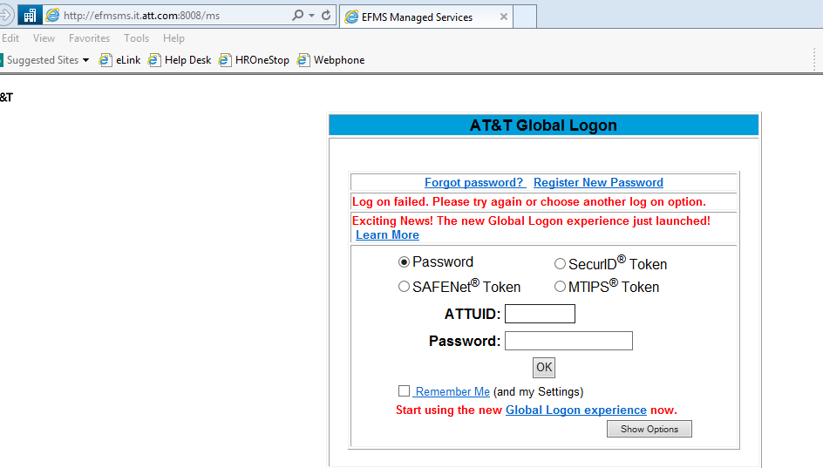

**Step 3:** After entering ATTUID and password in box, press OK button

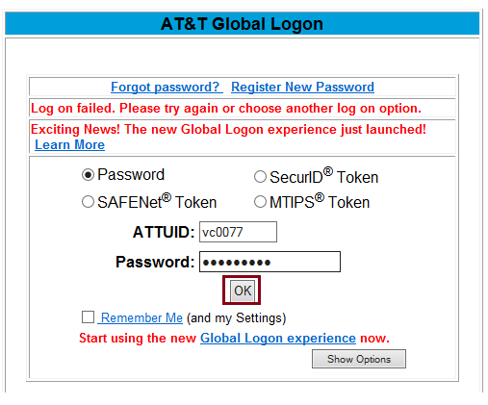

**Step 4:** Front interface of MS GUI will be displayed as shown in below image.

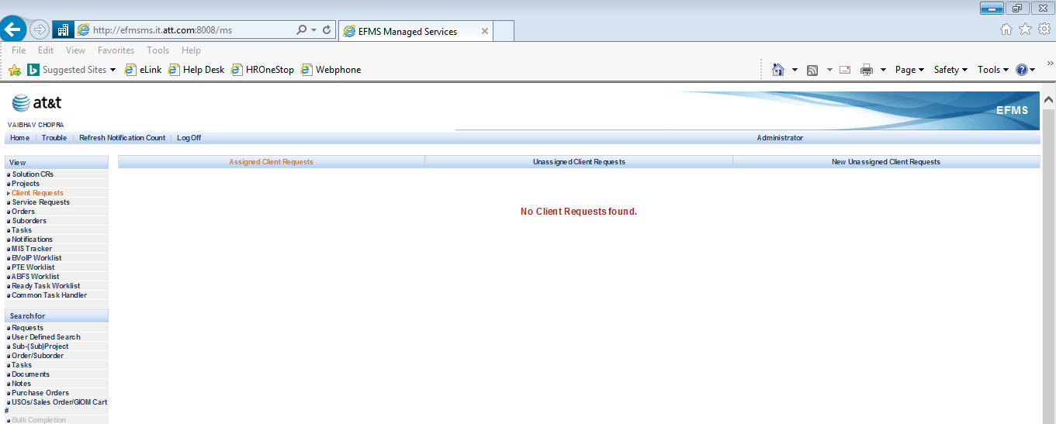

**Step 5:** Click on **User Defined Search**.

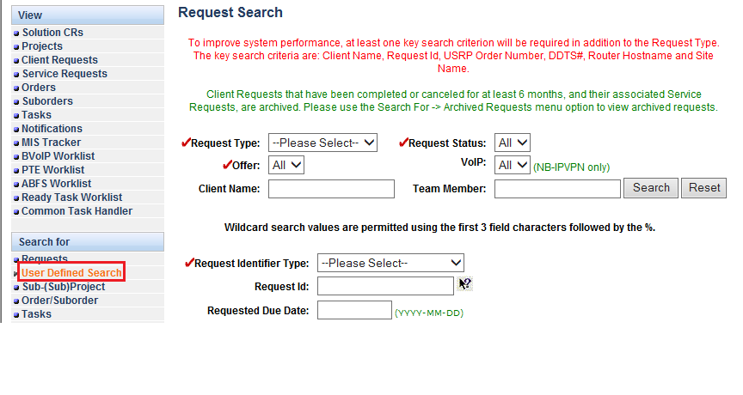

**Step 6:** Click on Request Type option and select **Client Request** option from bar.

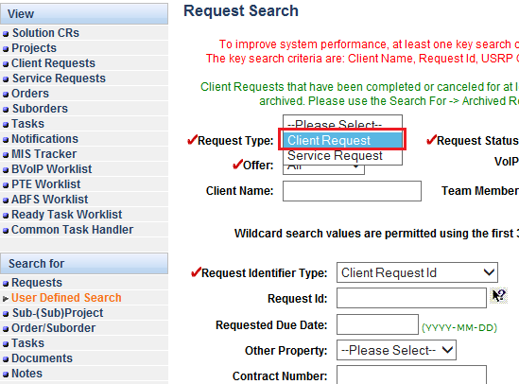

**Step 7:** Write Client request ID no. in **Request Id bar**.

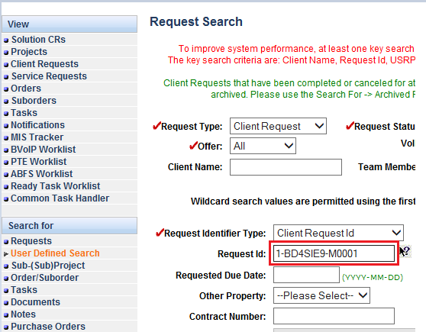

**Step 8**: Click on **Find Requests** tab to open Client request ID.

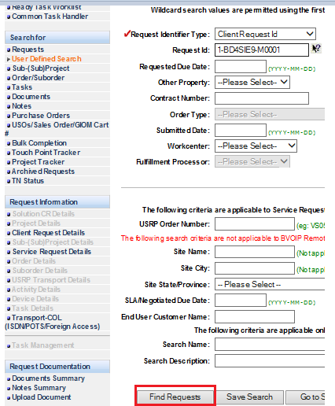

**Step 9:** Client request search results will be displayed, click on **open** tab after **tick** the box to open Client request id.

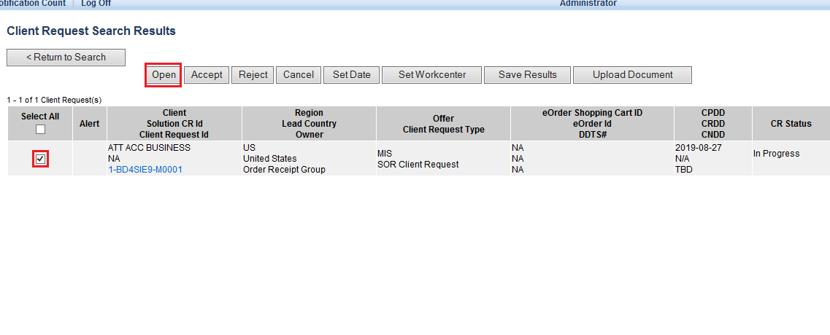

**Step 10:** **Client request ID** will be displayed with all tabs and information.

