Issue:- Cannot "Checkout" order, Error Pop Up; MSAG Address, ZIP is required.

**Sample Ticket –** 268189162, 262626000, 262611595

1. Take cart number from ticket(Ask from user if not provided).Open cart number in GIOM tool and find site id. Below image will be displayed in giom where site id is present.

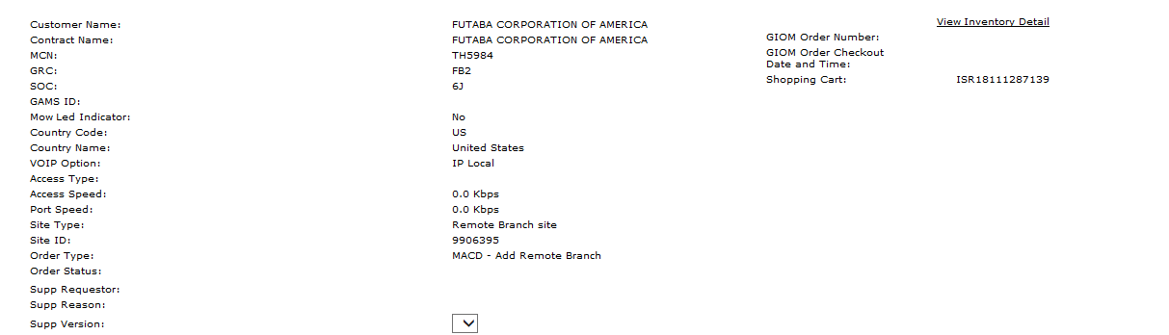

1. Open bvoip select dbor tools and put site id . select transaction (getCustSiteDetail).Click on submit query.

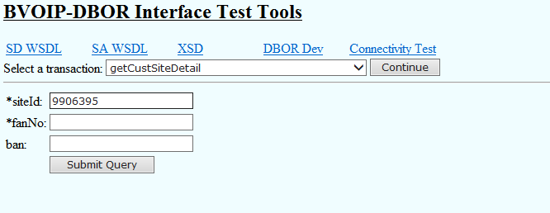

1. On clicking submit query logs will come search “intrado”. You will see below image.

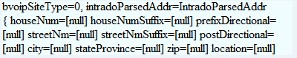

1. We have to update intrado address. By using below details. These details are just above intrado address.



1. By looking at 4 point we can fill these details.
2. houseNum=[1] streetNm=[CASPER] streetNmSuffix=[ST] city=[DANBURY] stateProvice=[CT] zip=[06810] .
3. than we have to create IE to GCP to update intrado in following format.

EDF Team,  
  
Site ID: 999882695  
  
custDialPlanId= 1005545283  
  
Please update intrado parsed address if address is in csi.db  
  
houseNum=[1] streetNm=[CASPER] streetNmSuffix=[ST] city=[DANBURY] stateProvice=[CT] zip=[06810]  
Logs for reference:  
----------------------------------------------------------------------------------------  
Request  
GetCustSiteDetailRequest{ wSHeader=[null] siteId=[999882695] siteStatus=[ALL] fan=[] ban=[] }  
  
Response(See it in XML)  
BvoipCustSiteDetail{ custSummary=[BvoipCustSummary{ primaryCompName=[Mannkind Corporation] custDialPlanId=[1005545283] mainTn=[] tenantRegisCd=[] extenLen=[0] offnetPrefixDigit=[0] centrexPrivateDialPlanPrefix=[] voiceMailPlatform=[] vdnaAsType=[] vdnaAsNodeNAME=[] bdEndUserConfig=[null] vDNARic=[] sharedAccessProviderId=[] sharedAccessProviderName=[] flexReachAsType=[] flexReachAsNodeName=[] flexReachSecondaryAsNodeName=[] vdnaAsReservationNumber=[] flexReachAsReservationNumber=[] }] bvoipCustSite=[BvoipDborCustSite{ customerSite=[BvoipCustomerSite [siteId=999882695, bvoipSiteAlias=null, isBGPRPrimarySite=, isBGPRSecondarySite=, primaryFailoverPriorityLevel=, sharedAccessProviderId=null, sharedAccessProviderName=null, siteCompanyName=Mannkind Corporation, siteAddress=BvoipDborAddress{ floor=[1] room=[TELCO] addr1=[1 CASPER ST] addr2=[null] addr3=[null] city=[DANBURY] stateProvice=[CT] zip=[06810] country=[US] building=[MAIN] timeZone=[] province=[] gatewayCityCode=[] countryCode=[1] }, addNotesComments=, transSvcType=0, siteBillingMcn=SL5146, siteBillingGrc=DND, siteBillingSoc=AC, siteStatus=ACTIVE, slaActiveDt=09/05/2018, firstSvcDt=, siteCreateDt=08/18/2018, siteName=85849145, siteLastUpdatedDt=null, geoCd=, outsideCityInd=N, bvoipSiteType=0, intradoParsedAddr=IntradoParsedAddr{ houseNum=[null] houseNumSuffix=[null] prefixDirectional=[null] streetNm=[null] streetNmSuffix=[null] postDirectional=[null] city=[null] stateProvince=[null] zip=[null] location=[null] streetAddr=[null] }, icorePVCId=, eCRMRowId=NONE, transportStatus=, vpnId=, mowLedIndr=N, bundleType=, fan=, bundleMarketingName=, sbsBundleDef=[BvoipSBSBundleDefinition [bundleDefinitionType=, numberOfConcurrentCalls=, premiumPackageQuantity=, standardPackageQuantity=]], bgprMultPvc=null, opportunityId=, icoreSiteId=]] numConcurCalls=[46] chargeNum=[0000606839] classicVomisApn=[606839] ipPbxDetail=[BvoipIPPbxDetail{ ipPbxVendor=[Any] ipPbxModel=[Any] ipPbxVer=[Any] pbxInterfaceType=[1] pbxEmulation=[1] pbxT1BoardModel=[N/A] csuOnPbxCardInd=[Y] pbxTn=[] arrayOfIPPbxIpAddressDetail=[[BvoipIPPbxIpAddressDetail{ publicIpAddress=[12.67.59.17] pbxIpAddress=[] publicPrefixLength=[] ipAddressType=[SIG] ipPbxAddressSubnetMask=[] custProvPublicAddressIndr=[N] }]] }] ipPbxInd=[N] configurationType=[0] cPEVendor=[BIB] signalingOption=[SIP] priSdIpAddr=[] priPtnii=[] secSdIpAddr=[] secPtnii=[] defaultPsapCallingNum=[] custRouterAddr=[12.118.204.58] accessRouterAddr=[12.118.204.57] arrayOfVoipOption=[[IP_LOCAL, IPLD]] layer3CrossRef=[BvoipLayer3CrossRef{ wanLinkIpAddr=[12.118.204.56] v6VdnaLoopback=[] priPiid=[12603809] secBackupPiid=[] }] otg=[0] siteConfig=[-1] hostRouterNm=[USMANNDXRCT03R] custIdNum=[] aaNumSimulCalls=[null] nonNativeChargeNum=[] isupMimeIndr=[] nativeTRN=[] nonNativeTRN=[] cic=[] upchainIndr=[] routerManagementType=[T] hostRouterNm=[USMANNDXRCT03R] custIdNum=[] seqIPBE=[[BvoipDborIPBEDetails [vlanId=, sdIpAddress=12.194.117.181, sdMediaIpAddress=12.194.117.190, ptnii=ny4ny13sds], BvoipDborIPBEDetails [vlanId=, sdIpAddress=12.194.116.85, sdMediaIpAddress=12.194.116.94, ptnii=ws4dc03sds]]] siteSurvivabilityIndr=[N] ceIpAddress=[] ceIpAddressMask=[] ceIpv6Address=[] ceIpv6PrefixLength=[] ipPbxNatIndr=[] srstCertIndr=[] custMngRouterVendor=[] custMngRouterModel=[] custMngRouterVersion=[] siteAccountNumber=[] voipMarketSegment=[] custBDAdmin=[CustBDAdminType{ firstName=[] lastName=[] emailId=[] telephoneNumber=[] endUserConfiguration=[] newUserIndr=[] existingBDUserId=[] }] leadAccountNumber=[] testAndTurnupDate=[2018-09-05 00:00:00.0] targetVdnaSbDD=[] purchaseDecisionDate=[] attCapabilityDD=[] specAccessApptTimeCode=[] parsedTransportServiceAddress=[ParsedTransportServiceAddressType{ houseNumPrefix=[] houseNum=[] houseNumSuffix=[] streetDirectional=[] streetNm=[] streetThoroughfare=[] streetNmSuffix=[] descriptiveAddress=[] locationDesignations=[[]] city=[] state=[] zip=[] country=[] }] dslWTN=[null] upstreamBandwidth=[null] downstreamBandwidth=[null] vpnName=[] vpnId=[] siteOutboundCodecProfId=[]accessType=[0]accessSpeed=[]portSpeed=[] product=[] mainContractType=[] bIBIndr=[Y] ipxcCIDIndr=[] inboundAlternateSiteId=[] activeDialPlanIndr=[Y] sharedCPEIndr=[N] mrsIndicator=[] mrsRouterHostname=[] campusType=[] managementType=[] redundancyIndr=[] salesChannel=[] wTNIndicator=[] NBFMCIndicator=[] IPTFSIPOptionsIndr=[N] bvoipIpAddrVersion=[IPv4] transportIpAddrVersion=[]tDMGatewayCardIndr=[Y]totalLicenses=[0]licenseRouterType=[]attProvidedVOIPRouterCardFlag=[]siteProcessedBy=[OCX] mIDHAIndr=[null] campusLocationType=[null]thirdPartyCarrierName=[]ituCode=[]languageLine=[]sharedUseFlag=[] }] cpeDeviceMacAddress=[null] directMediaHostDetail=[null] bundleSuiteDetails=[null] }

Thanks,  
GIOM-BOA

8. After edf update run this query to delete cache

delete from iomdbo.site_inventory where site_id = '999983739';

1. Ask user to cancel and retry.