**SPP Tier Error**

SPP Tier Error is created in workflow when provisioning trigger is unsuccessful between EFMS and SPP

Below are the error reasons which can lead to SPP Tier Error:

1. Provision LNS Using SPP

**Use the below query to fetch the task ID**:

/*Suborder Level check for MIS and BVOIP*/

**Inconcert SqL Query:** -

Select ord.purge_IND,ms.ms_task_id,ord.usrp_order_number,sub.order_gate1_status, sub.ms_sub_order_id,sub.wan_link_ip_addr, wf.name, wf.status, wf.job_id, wf.task_id, wf.first_ready_time,wf.ready_time, wf.due_date, wf.done_time, wf.first_ready_time,wf.skipped_time, wf.perform_condition, wf.ITERATE_CONDITION

from ms_order ord, ms_sub_order sub,ms_job j,wf_task wf,wf_job job,ms_task ms

where

Ord.Usrp_Order_Number In

('157512824')and ord.ms_order_id = sub.ms_order_id and ms_sub_order_id = j.entity_id

and wf.job_id= hextoraw(j.wf_job_id) And Wf.Job_Id = Job.Job_Id and wf.task_id= ms.WF_TASK_ID

and j.entity_type=5 and (wf.status in (1));

**mS Updates SQL Query:-**

SELECT usrp_order_number, o.ms_order_id, ms_sub_order_id, t.name, t.status_updated_date , t.status, t.* FROM ms_task t, ms_job j, ms_order o , ms_sub_order so WHERE usrp_order_number IN ( '194943727' ) AND so.ms_order_id = o.ms_order_id AND entity_id = ms_sub_order_id AND entity_type = 5 AND t.wf_job_id = j.wf_job_id and t.status = 1;

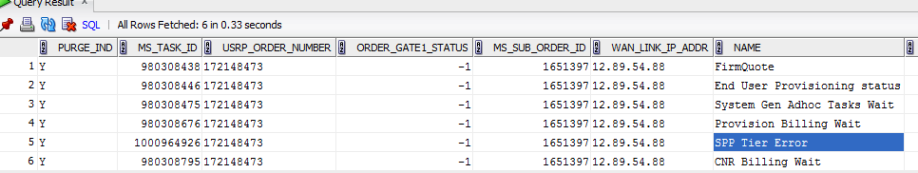

**EFMS GUI** [**URL :-**](URL:-)

[**http://efmsms.it.att.com:8008/MS**](http://efmsms.it.att.com:8008/MS)

**EFMS GUI:**

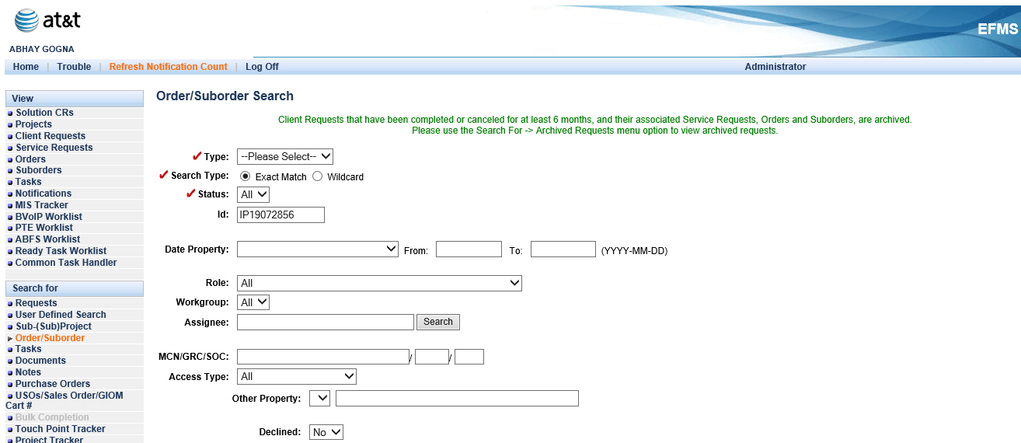

**Order / Sub-Order Level:**

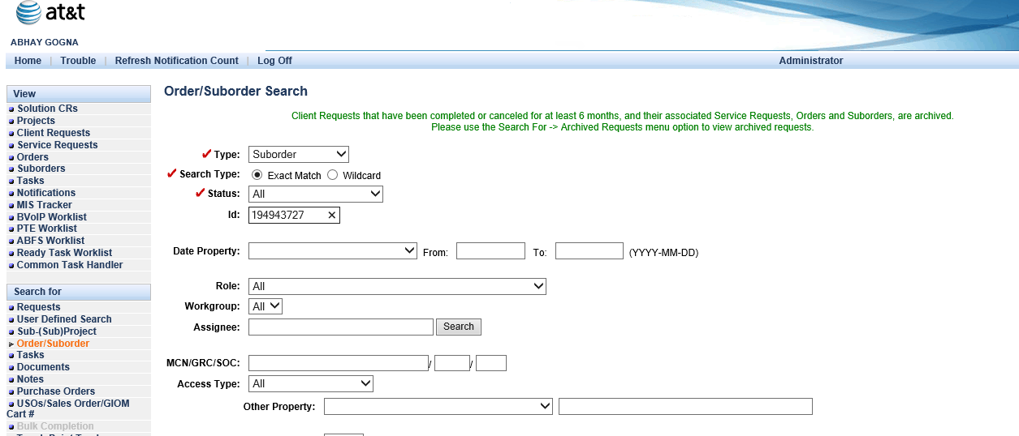

**Task List:**

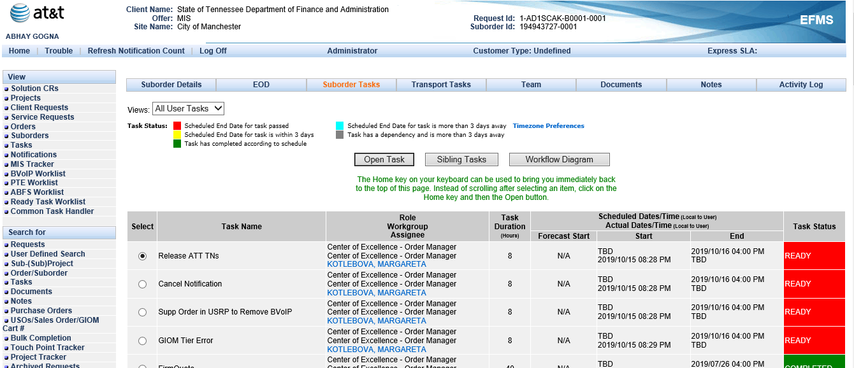

Get the task ID 02000017068E8CFA44E400020001C312 from the same query and force complete the task

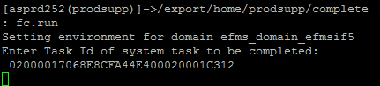

You will get the below screen

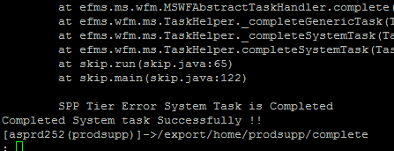

This step will retry the task, if workflow progresses towards completion then close the USH ticket.

**If task comes back then follow the below mentioned steps**:

**Step 1:** Check the Supp version of the order using the below query:

Select last_updated_date,usrp_order_number, order_version_number, last_supp_process_version, spp_transaction_counter from ms_order where usrp_order_number in(172148473’);



Find the erroring task by force completing the SPP Tier Error or by opening the task from EFMS GUI.

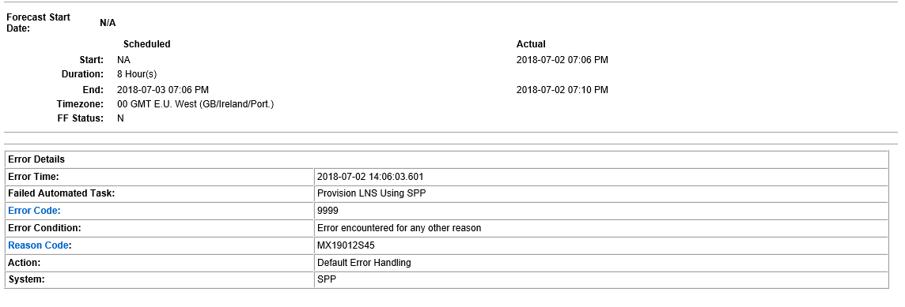

Then reach out to SPP to check and correct the error once error is corrected the force complete “SPP Tier Error”

**Step 2**: To fetch error logs, use wfm command to retrigger task “Provision LNS Using SPP”

Force complete SPP Tier Error

**Note**: Do not use wfm trigger if task status is 0

Once retrigger is complete then login to ssh asprd252.aldc.att.com, under prodsupp

Use the below steps:

1. cd /opt/project/log/bvoip



1. grep ordernumber *spp*

grep 172148473 *spp*



1. cat filename|less

Search the order number using the following command “/ordernumber”

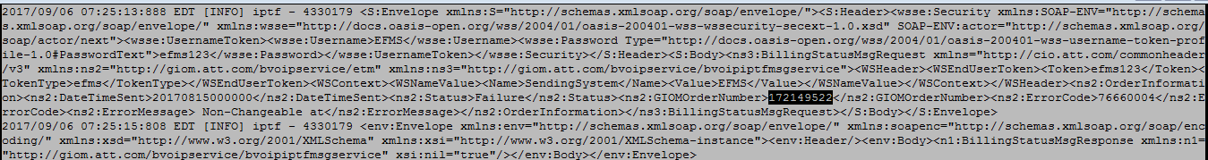

**Note** : Transaction name is EventTriggerRequest

For old days logs use this path “/opt/app/pre_sales_files/oldlogs/LOG/MS_LOG/2017/08/24” [Change the date when the task was retriggered] instead of grep use “gzgrep” and to view file use “gzcat”

**Step 3**: Further engage SPP after checking the error, provide them Supp version along with the erroring task, once error is corrected then complete SPP Tier Error

**Step 4**: Recheck the workflow if order has now progressed then only close the ticket

**Note**: Follow the same steps for the all the provisioning tasks.