MACD is not allowed when Order shows below error

**MACD Service Order not allowed. In-progress IPBE Rehome order found for 010656892**

**Check order SPP GUI**

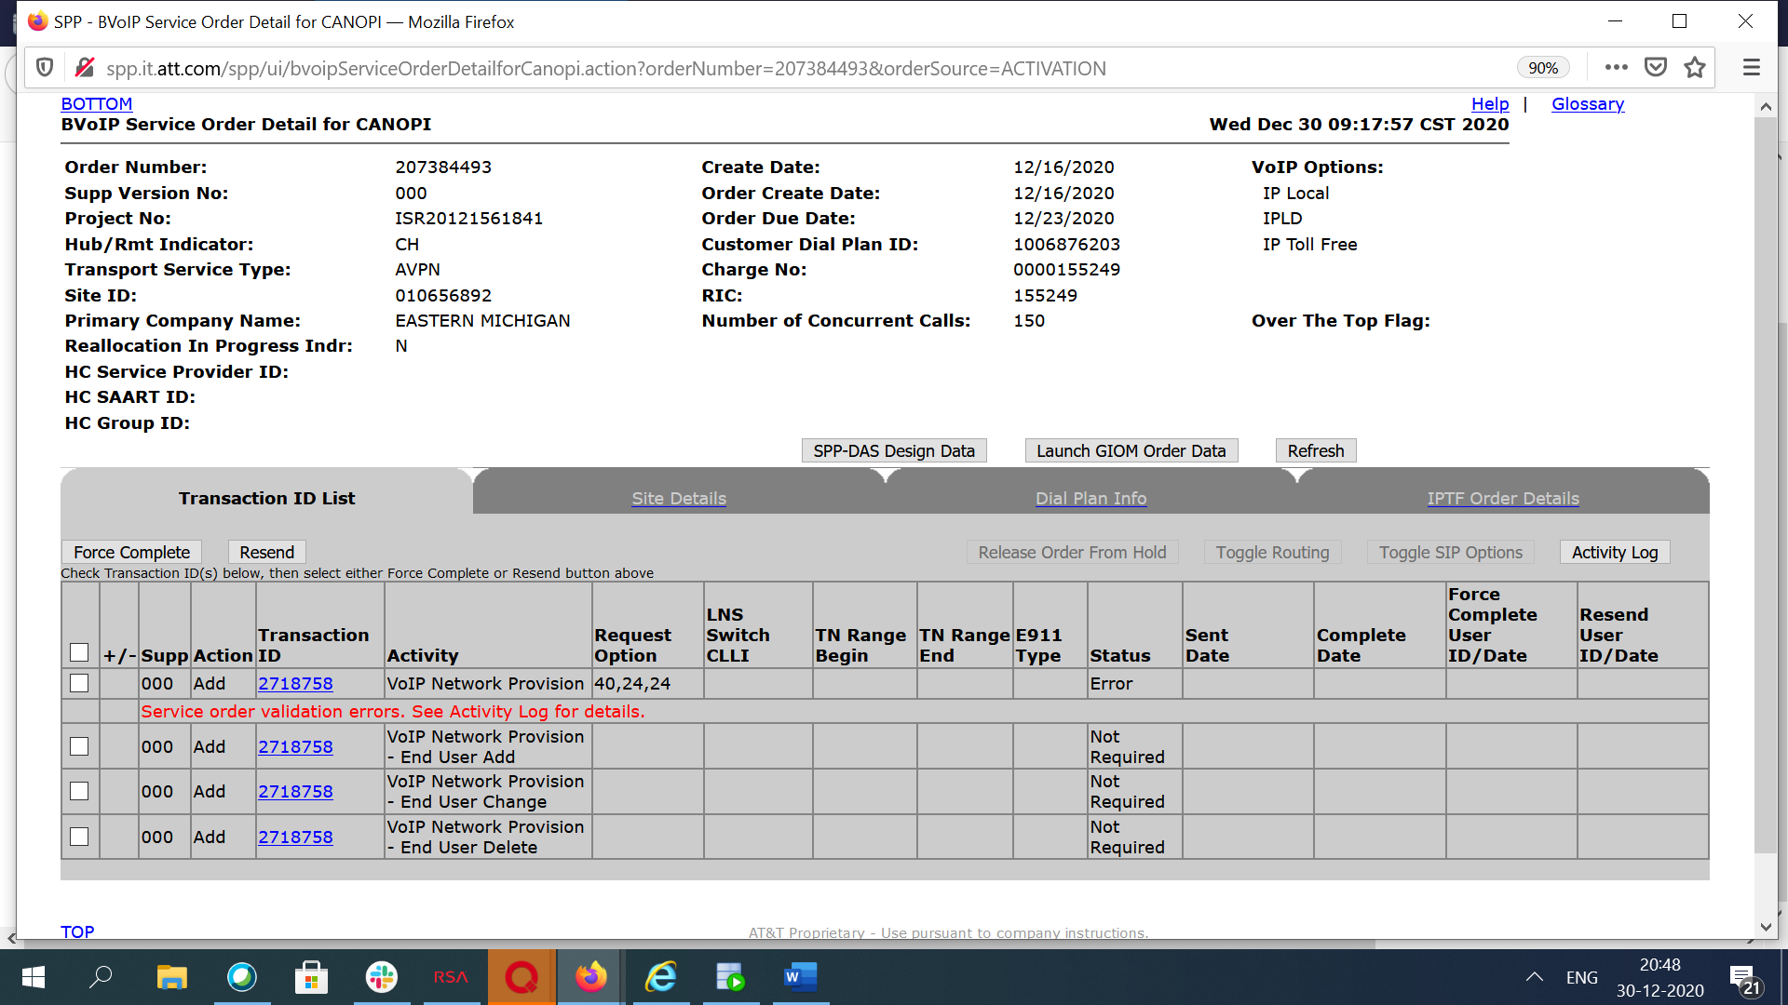

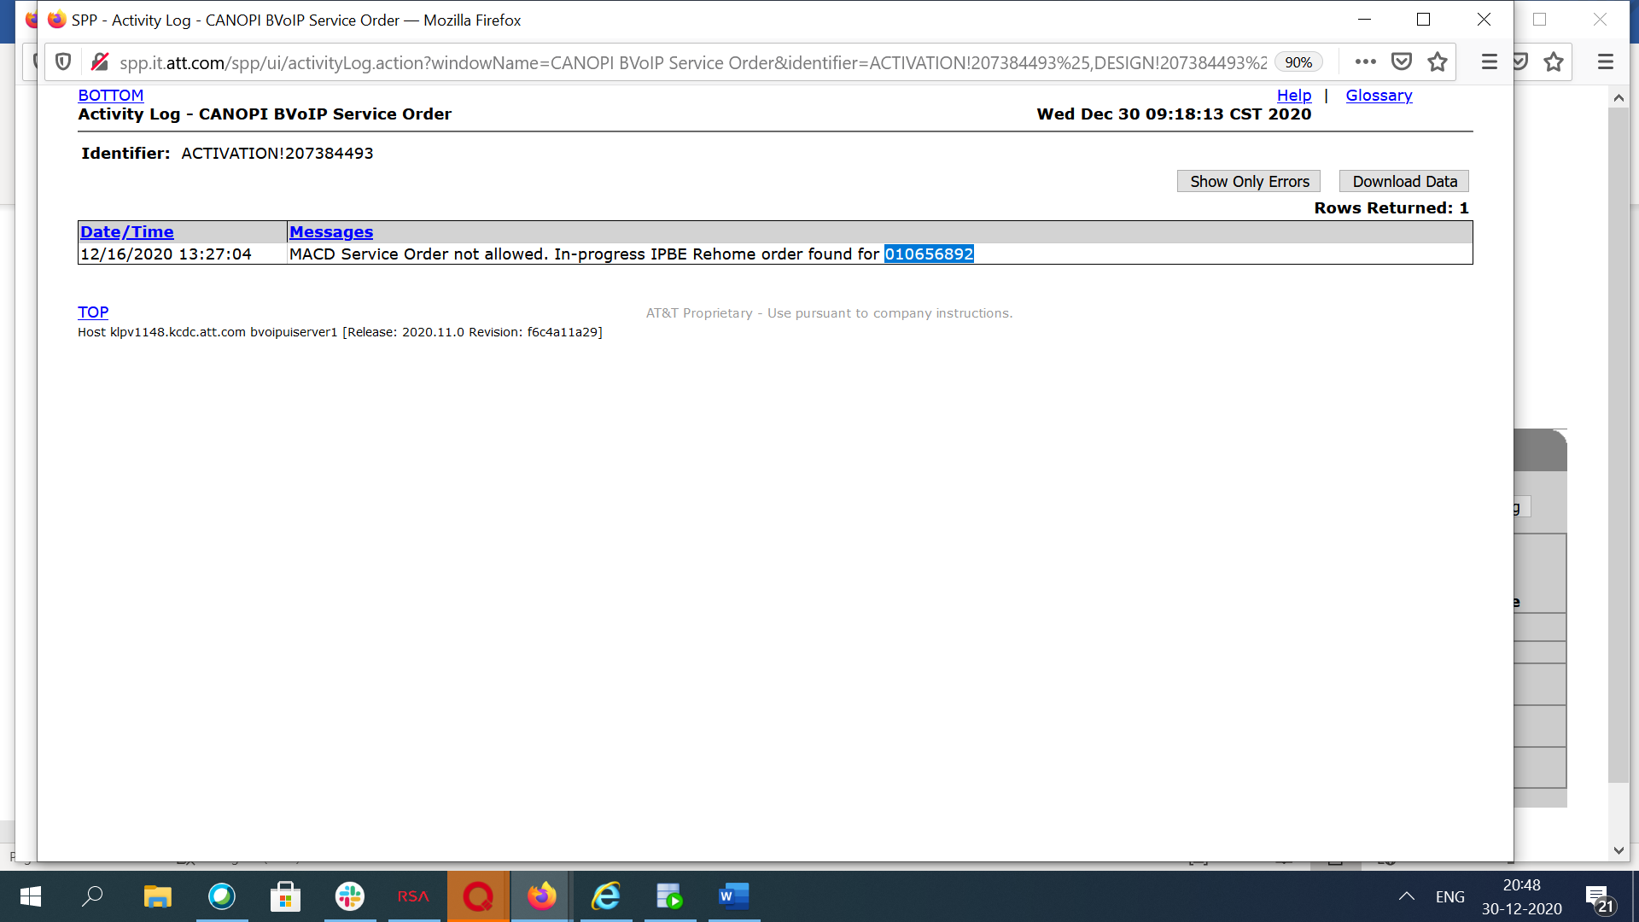

If you search site bvoip service order page it wont show any orders which are in progress

010656892 site id you have to search in “BVoIP IPBE Rehome Order Request” to get order number and status

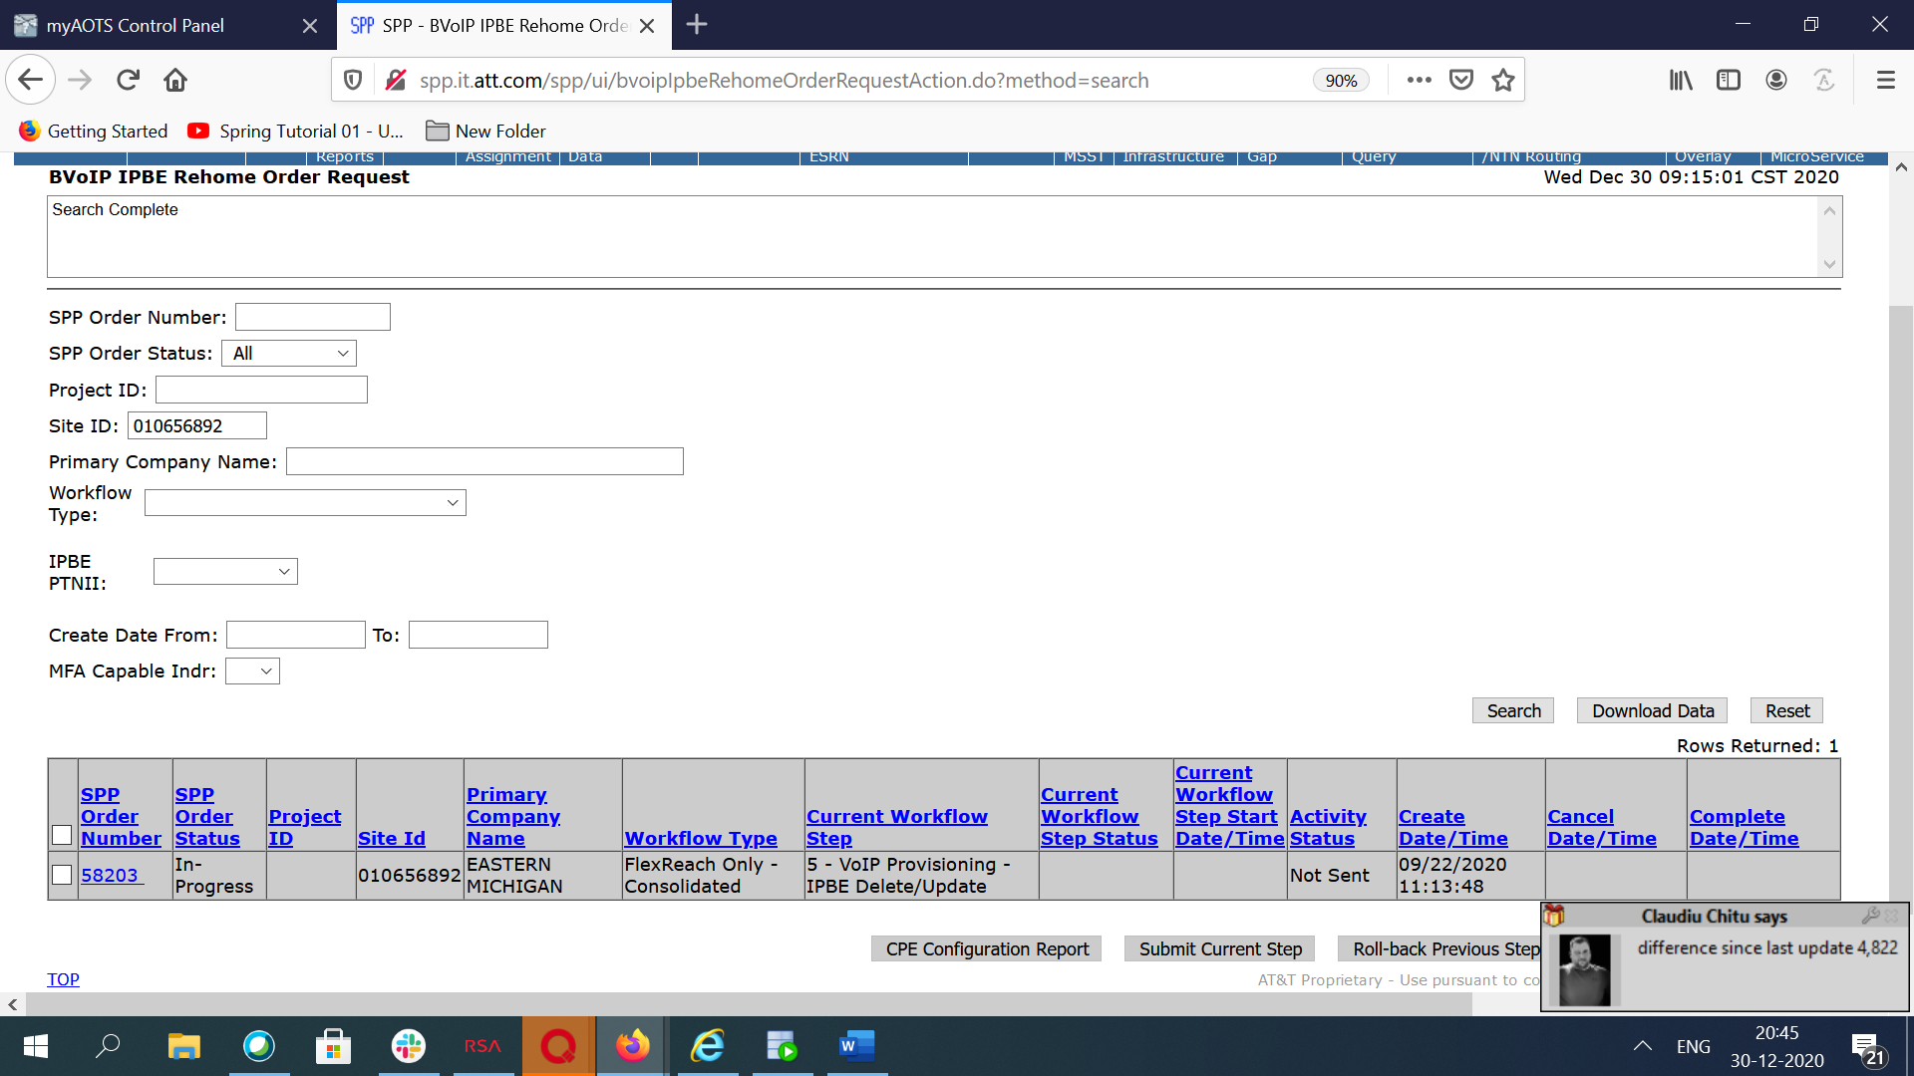

You can update ticket as below

ORDER_NUMBER: 207384493  
Service order validation errors.   
 MACD Service Order not allowed. In-progress IPBE Rehome order found for 010656892   
  
Its a valid error  
Rehome order 58203 still in-progress on site 010656892, user need to work on that first then retry   
  
  
thanks  
Setting ticket to RTC   
SPP-PSO