The purpose and end result of this conversion is to update the ROUTING_LABEL_ID to 'BVOIP_ASGL_RL' on the VNI PSX for each converted TN on the site.

Login to the SPP NK machine, sudo and set your environment and move to waslogs  
  
ssh p1spp1a1.vci.att.com  
sudo su - p1spp1a1  
se

waslogs

The scripts must be executed from the waslogs directory (/opt/app/p1spp1a1/dmgr/logs)

**Please Note: The Step1.sh script is run only once per site ID and the Step2.sh script is run for each TN beginning TN range to convert**

This means is you will only run Step 1 once for a given site ID but you might run the 2nd conversion multiple times for a given site ID depending on how many TN ranges there are to convert.

Run Step 1 for a given Site ID **only once**  
  
convertGlobalNumberFormatStep1.sh [siteId that contains leading zeroes]

Example: convertGlobalNumberFormatStep1.sh 009169784

Execution time is approximately a couple of minutes. When Step 1 is complete you should see “Return value=0” returned to the screen

Log path: /opt/app/p1spp1a1/logs/bvoipBatch_LoadRangesForGNFCPN.log  
  
Run Step 2 for each starting TN range on the site   
  
convertGlobalNumberFormatStep2.sh [siteId that contains two leading zeroes] [gatewayCiteCode(NPA)] [pbxBeginRange]

Example: convertGlobalNumberFormatStep2.sh 009169784 571 2937022  
  
Execution time can vary depending on how many TNs are in the range. It typically takes at least several minutes. When Step 2 is complete you should see “Call to ConvertPsxDestRouteLabelForGNFCPN finished” returned to the screen

Log path: /opt/app/p1spp1a1/logs/bvoipBatch_ConvertPsxDestRouteLabelForGNFCPN.log

To find the NEAM work order(s), go to the logs directory and grep for ‘outWorkOrderNumber’  
  
cd /opt/app/p1spp1a1/logs  
grep outWorkOrderNumber bvoipBatch_ConvertPsxDestRouteLabelForGNFCPN.log  
  
You should see something like:

e in a non-J2EE client or server environment. Throwing ConfigurationException.

Call to ConvertPsxDestRouteLabelForGNFCPN finished

p1spp1a1@alpv1085:/opt/app/p1spp1a1/dmgr/logs

31319 -> logs

p1spp1a1@alpv1085:/opt/app/p1spp1a1/logs

31320 -> grep outWorkOrderNumber bvoipBatch_ConvertPsxDestRouteLabelForGNFCPN.log

20171013 15:18:45.266 INFO [P=880814:O=0:CT] - outWorkOrderNumber[SPPB_p1spp1a1_GNFCFNCONVERSION!009169788!669!2341301!N16126060]

p1spp1a1@alpv1085:/opt/app/p1spp1a1/logs  
  
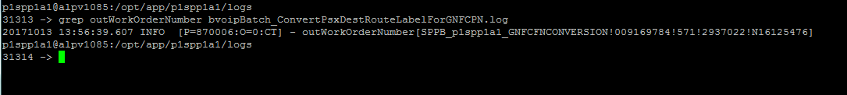

Login to NEAM and check the status of the workorder(s):

Example: SPPB_p1spp1a1_GNFCFNCONVERSION!009169784!571!2937022!N16125476

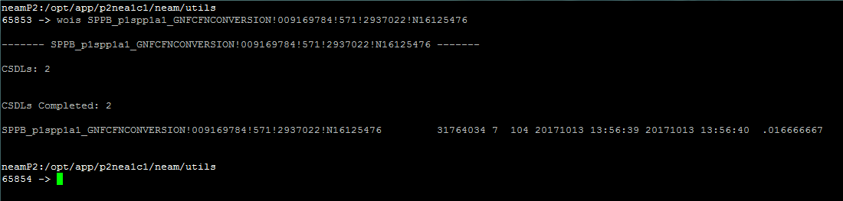

Here is what the work order did in the network:

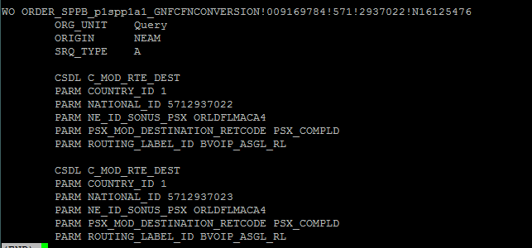

The final verification is to pull back a SPP PSX Subscriber / Destination TN Query report

Login to the SPP Main Page and click on ‘PSX Subscriber/ Destination TN Query’

This brings up the following window:

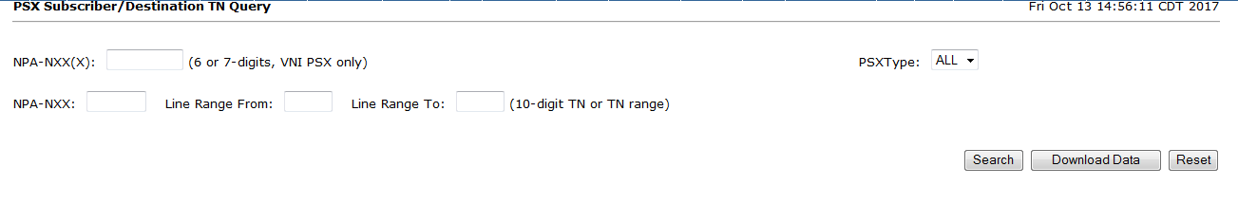

For this example location we need to select the following:

Select ‘VNI’ from the PSXType dropdown

NPA-NXX: Enter in ‘571293’

Line Range From: Enter in 7022

Line Range To: Enter in 7023

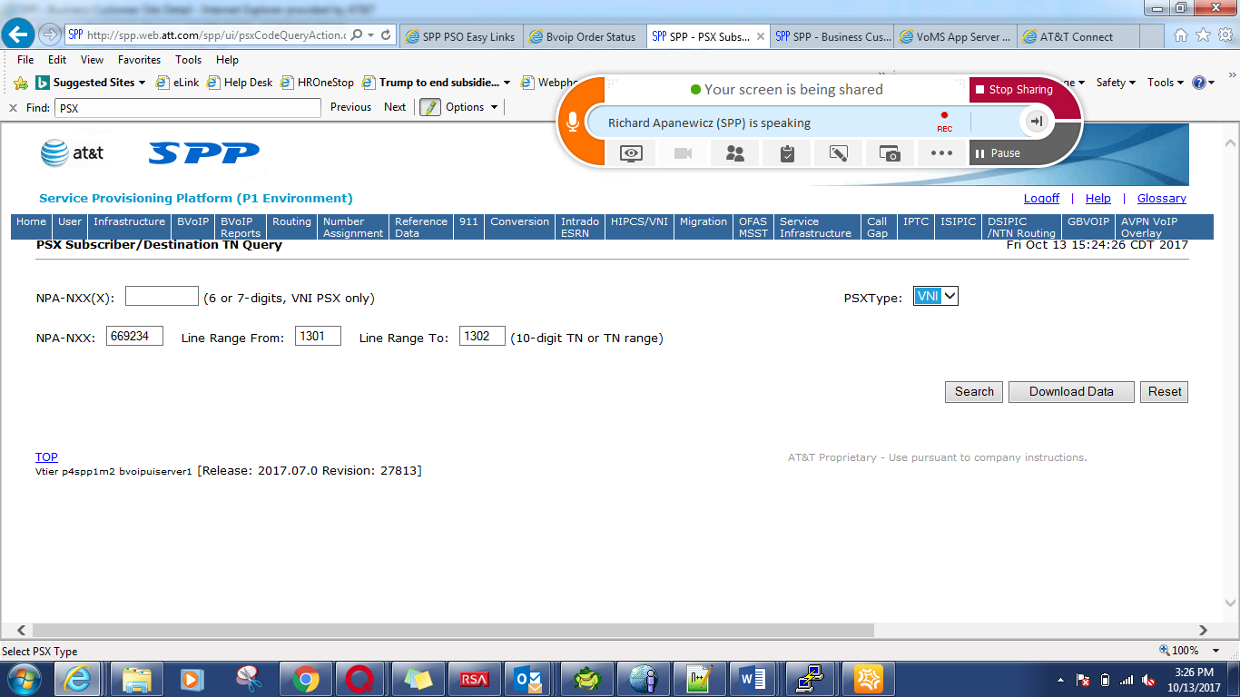

Then click ‘Search’

This will send a query through NEAM and you will receive an email once the order is completed.

To view the results of the search go back to the SPP Home Page and click on the ‘PSX Subscriber/ Destination TN Reports’ link

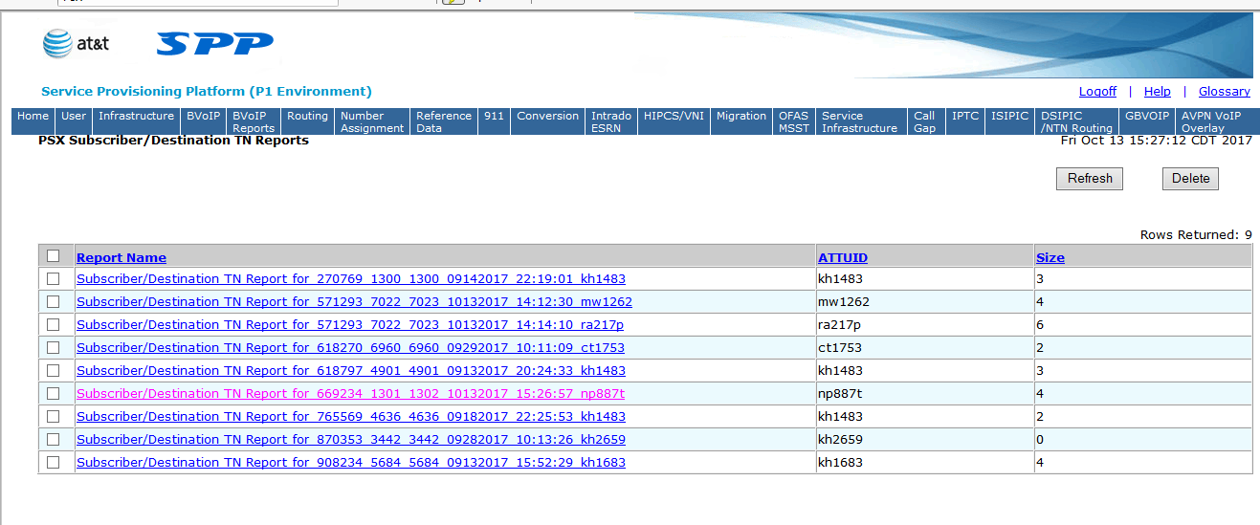

Select the report that you generated. It will open an Excel spreadsheet. You need to verify that the Routing returned on the converted TNs is showing ‘BVOIP_ASGL’

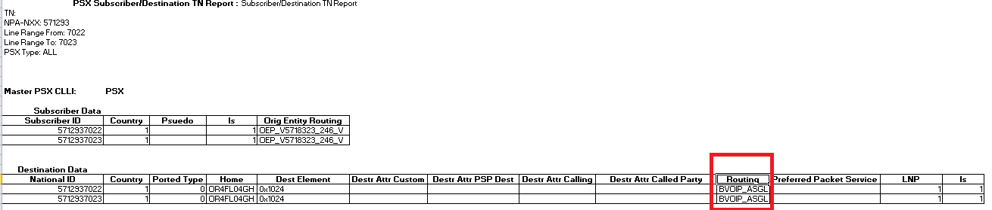

This shows that the script successfully updated the network and the results in the network were verified.