**BVOIP ISSUE**

# Version History

|  |  |  |  |
| --- | --- | --- | --- |
| Version# | Date | Summary of Changes | Author |
| 1.0 | 8/22/18 | Created Document | Ajeet Vishwakarma |

# WHAT IS BVOIP?

BVOIP service is provided by AT&T for **Business** Purpose to exchange/transfer multimedia data (voice/video) ***over the internet*** using TCP/IP protocols. We term it as **V**oice **O**ver **I**nternet **P**rotocolor simply **VOIP.** AT&T provides such a service for Business Purpose hence it’s called as **BVOIP**.

# how to request for bvoip service

Two option to avail BVOIP service:

1. Along with new Internet service (MIS/AVPN)
2. As an Ad-on over the existing Internet service
3. **Along with new Internet service :**

Along with NS order on new port (new port- new bvoip)

Here user need to request for new Internet service by requesting new MIS Order with enabling BVOIP Indicator as “Yes” from USRP.

“New Start Order” would remain as Pending until “*AssignBVOIPIP task*” which comes from “BVOIP Ordering System” gets completed.

Once *AssignBVOIPIP task* completes in LPP, the “New Start Order” also get completed.

1. **As an Ad-on over the existing Internet service**

On existing Active Port via BVoiP Add/Assign order

In this case, there is no BVOIP option/Indicator present over the existing network for the *new*

*start completed* “MIS Order” (as. IPxxxxxxxx). We can even check that in SITE PAGE.

* User need to request for “AddBVOIP Change Order” (to Add BVOIP option/Indicator) over existing MIS Order (which is New Start Completed) from USRP system.
* Now this “AddBVOIP Change Order” would remain as Pending until “*AssignBVOIPIP task*”which comes from “BVOIP Ordering System” gets completed. Once *AssignBVOIPIP task* completed in LPP, the “AddBVOIP Change Order” will be get completed. And then we can say BVOIP service is applied.

*So BVOIP request comes to LPP from “BVOIP Ordering Systems” (GIOM and OCX/OMX) via SPP depending on the order flows:*

**Order Flow:**

Old classic flow: GIOM -> EMFS -> SPP -> LPP

New Halo Flow: OMX -> SPP -> LPP

# ISSUES ENCOUNTERED WITH BVOIP ORDERS

BVOIP orders may fail with any of the below errors:

ERROR MESSAGE:

*Failure-Order stacking is not supported - connection already exists with order status "Pending" or "Cancel InProgress" WAN_IP and 12.244.39.160*

*or*

*Failure-Cannot process AssignBVOIPIpAddress on order with LPP order status being Cancelled*

*or*

*Failure-New Start order is not allowed.*

# ROOT CAUSE

As per design, BVOIP IP ( WAN IP ) can be present on only one order at a time. If it’s already in use, then it needs to be disconnected/unassigned first from existing order, before trying to re-use on new BVOIP order.

So the above error usually occurs when the correct process is not followed.

# ACCESS /info REQUIRED FOR INVESTIGATION

1. Need access to ActiveOS GUI, SPP Design DB, and LPP GUI/DB.  
  
2. USH ticket with one of the below details along with issue description/error message:

1. BVOIP Order number -- GIOM / OMX order number

2. WAN IP -- For MIS order

3. PVC ID -- for AVPN order

# cHECK ERROR/REASON FOR FAILURE

**1. Check order status and error:**

1. ActiveOS

2. SPP Design

3. LPP

**ActiveOS:** Activevos is a workflow. Order first comes to Activevos workflow then goes to the Service Component and Logical Component.

*1.Open ActiveOS*

[*http://lpp.noc.att.com/activevos/active_processes.action?contextLinkId=activeProcessesHome*](http://lpp.noc.att.com/activevos/active_processes.action?contextLinkId=activeProcessesHome)

*2.Search for processes for a bvoip order using below expession:*

*------*

*getIndexedPropertyValue("BvoipOrderNumber") = '303271215'*

*------*

*Type of Requests in AVOS:*

*---*

*1. assignBVOIPIpAddressRequest -- for BVOIP Add order, to assign bvoip*

*2. unassignBVOIPIpAddressRequest -- for disconect order, to unassign bvoip*

*---*

**Check for error in the response and investigate/troubleshoot.**

**SPP Design:**

--check BVOIP service order status in SPP Design

**SELECT** **\*** **FROM** BVOIPSERVICEORDER **WHERE**

WANLINKIPADDRESS **=** '12.250.184.48'

--ORDERNUMBER = '301894154'

--SITEIDENTIFIER = 999919913

**ORDER** **BY** CREATEDATETIME **ASC;**

--Take bvoip order number from above query and Check BVoIP related Activity status using below query.

**SELECT** **\*** **FROM** BVOIPSERVICEORDERACTIVITY

**WHERE** ORDERNUMBER **=** '303295373'

**AND** ACTIVITY **LIKE** '%BVoIP IP%'

**ORDER** **BY** SENTDATETIME**,** COMPLETEDATETIME**;**

**--Based on the error message on Activity, we can take necessary action.**

**So once you find the error message from ActiveOS / SPP, we can troubleshoot them as shown below.**

# resolution/troubleshooting STEPS

*Issue : Disconnect BVOIP order failed to load from SPP into LPP with below error:*

*FAILED Message: INSTAR-LPP Error: Error Message = Order stacking is not supported - connection already exists with order status 'Pending' or 'Cancel InProgress' WAN_IP and 12.126.186.12*

As per design, for a disconnect order to work, we need to have all existing orders for the BVOIP in completed/cancelled status in LPP. If there is any open/pending order in LPP then disconnect fails to load to LPP.

**Step 1:**   
Take WAN IP from the error message and check in SPP Design for all BVOIP requests for the WAN:

SELECT * FROM BVOIPSERVICEORDER WHERE WANLINKIPADDRESS = '12.126.186.12'

ORDER BY CREATEDATETIME ASC;



We can see, WAN '12.126.186.12' is currently Active on ASSIGN BVOIP order **300948609** since **10/4/2016 5:38:31 PM.**

User placed another BVOIP NS order **303432936** for the same WAN at 8/7/2018 **7:52:34 AM.**

But it failed with below error as WAN was already busy on order 300948609:

SELECT * FROM BVOIPSERVICEORDERACTIVITY WHERE ORDERNUMBER = '303432936'

and ACTIVITY LIKE '%BVoIP IP%';



User realized that and tried to place disconnect order 183911813 to disconnect existing BVOIP order to release WAN, but it also failed with below error:

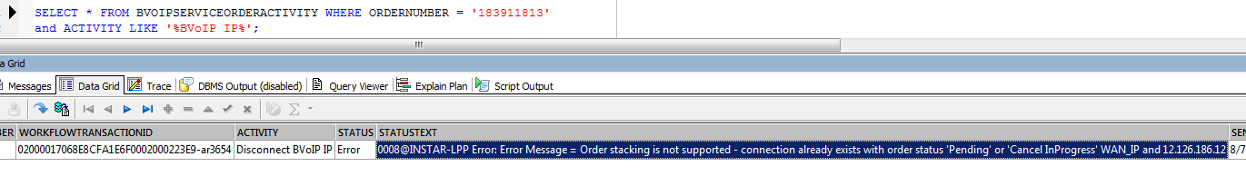

As per the error message, WAN already has some Pending/”Cancel InProgress” order in LPP.

Now need to verify whether the error message is valid or not.

**Step 2.**   
We will take the new BVOIP NS order which failed in SPP and will check its status in LPP**.**

SELECT * FROM WORKFLOW_DBA.LPP_ORDER O WHERE O.ORDER_ENTITY_ID IN ('303432936'); *--BVOIP ORDER NUMBER*



As we can see BVOIP NS order in Pending status in LPP hence the error message is valid.

Now we need to check its task summary if something is not completed yet.

Will take order id from above query and check task summary using below query:

SELECT *

FROM WORKFLOW_DBA.ORDER_TASK_STATE

WHERE ORDER_VERSION_ID=( SELECT MAX(ORDER_VERSION_ID) FROM WORKFLOW_DBA.ORDER_VERSION WHERE ORDER_ID=1001795400 ) *-- lpp order id*

ORDER BY STATUS_DATE DESC ;



We can see AssignBVOIPIP has failed because the BVOIP IP (WAN ) is already in use on an active order 300948609.

But this task cannot be completed unless BVOIP IP is released from existing order by disconnecting it.

Had user followed correct process i.e. DISCONNECT EXISTING BVOIP ORDER FIRST and THEN PLACE NEW ASSIGN ORDER, it would not have resulted in failure.

**Step 3:**   
Now we will have to complete disconnect order first.

For that we will first cancel the pending NS order in LPP because as per design if it remains in Pending status then disconnect won’t load to LPP.

UPDATE WORKFLOW_DBA.LPP_ORDER SET STATUS = *'Cancelled'* ,MODIFIED_DATE=sysdate

WHERE ORDER_ID = '303432936';

**Step 4 :**   
Once the new NS order is cancelled in LPP, EFMS needs to retrigger the failed task ‘**R**eserve **IP** **A**ddresses in **C**ANOPI design’ (RIPAC).

This will retrigger the Activity “Disconnect BVoIP IP” in SPP and the disconnect order gets loaded to ICORE.

We can check order status and task summary:  
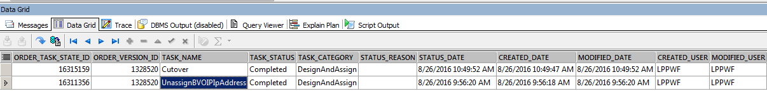

Once UnassignBVOIPIpAddress and Cutover task complete, the order also complete.

And its status will change to “In-Effect Active” in SPP.

Now the WAN is free for re-use.

**Step 5:**   
Now we need to again change BVOIP NS order status from “Cancelled” to “Pending” and retrigger the failed/Ready task from the OMX/EFMS.

If we don’t change its status to Pending then it will again fail with below error message :

*Failure-Cannot process AssignBVOIPIpAddress on order with LPP order status being Cancelled*

Once ready/failed task is retriggered from OMX/EFMS, AssignBVOIPIP task will retrigger and complete in LPP.



And the IP data get fed to the below logical component tables of LPP in the given sequence.

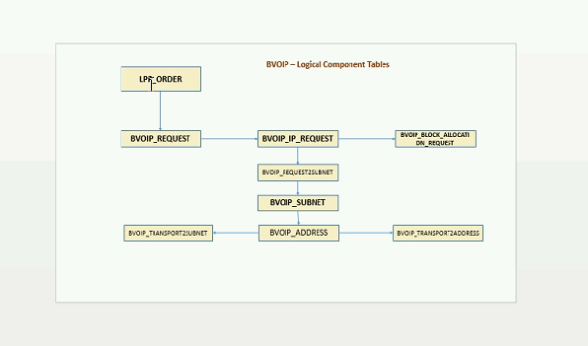

# SUMMARY

1. BVOIP service is provided by AT&T for **Business** Purpose to exchange/transfer multimedia data (voice/video) ***over the internet*** using TCP/IP protocols.
2. User can avail BVOIP service Along with new Internet service (MIS/AVPN) or As an Ad-on over the existing Internet service
3. To get BVOIP service, need to place BVOIP NS order from *“BVOIP Ordering Systems” (GIOM and OCX/OMX)*
4. To disconnect, need to place DELETE/DISCONNECT order.
5. We need to have one of the below details to investigate BVOIP issue:

1. BVOIP Order number -- GIOM / OMX order number

2. WAN IP -- For MIS order

3. PVC ID -- for AVPN order

1. Ways to disconnect BVOIP service:

1. Disconnect BVOIP alone

2. BVOIP and port together.

1. BVOIP order request:

AssignBVOIPIP -- to assign BVOIP IP Addresses

UnassignBVOIPIpAddress -- to unassign BVOIP IP Addresses

1. We can check for reason/error message for BVOIP order failure in ActiveOS/ SPP Desgin DB
2. Common Errors:

*1.FAILED Message: INSTAR-LPP Error: Error Message = Order stacking is not supported - connection already exists with order status 'Pending' or 'Cancel InProgress' WAN_IP and 12.126.186.12*

*This error occurs for a disconnect order if any of the orders placed before the disconnect order are in Pending status. As per design, all existing orders must be in Completed or Cancelled status.*

*Solution🡪Need to cancel/complete existing BVOIP NS order in LPP and then retrigger RIPAC from EFMS*

*2.Failure-Cannot process AssignBVOIPIpAddress on order with LPP order status being Cancelled.*

*This error occurs when we retrigger failed/ready task for a BVOIP NS order which is in Cancelled status in LPP.*

*Solution🡪 Need to mark order status as Pending in LPP before retriggering task from EFMS/OMX*

*3.Failure-New Start order is not allowed.*

*This error occurs if BVOIP IP is already in use and we place another NS order for the same BVOIP IP.*

*Solution🡪Need to disconnect BVOIP from existing order before placing another NS order for the WAN.*