**CVoIP**

The **SPP CVoIP** provisioning covers the provisioning of Uverse CVoIP TNs in IMS, CMS, and UM. SPP supports the capacity management, load balancing, network assignment rules and TN rehoming for the IMS NEs and S/BCs.

**CVOIP**

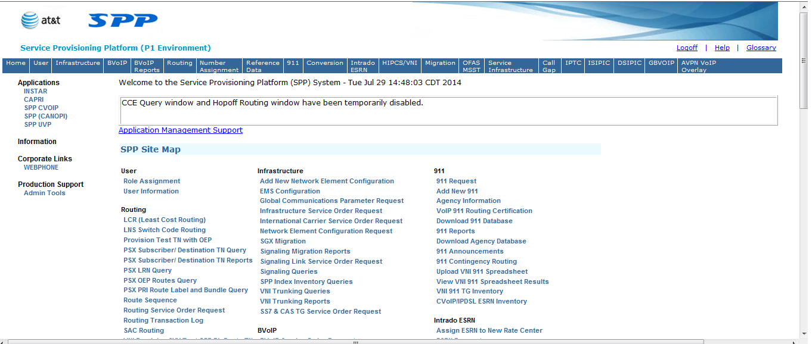

**Click CVOIP SPP**

1. The main interface of CVOIP is shown below:

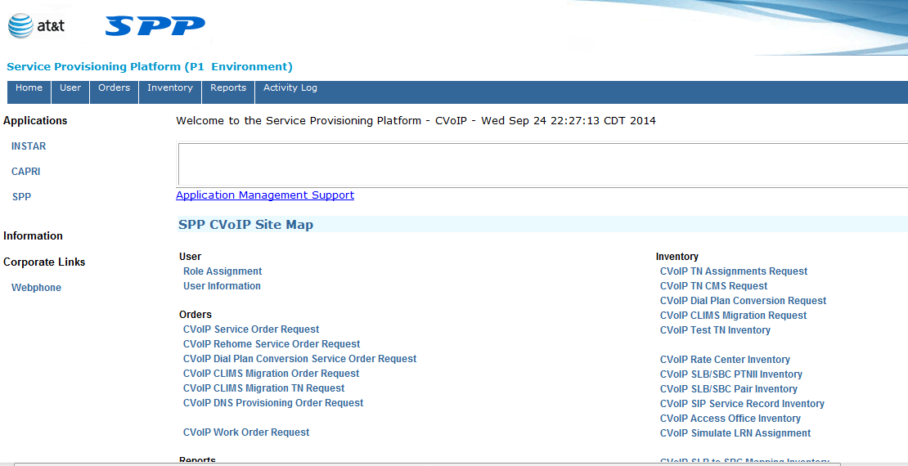

**Click CVOIP SERVICE ORDER REQUEST**

1. After 4th step you are able to see CVOIP service order request window and BY putting the any of the column weather TN, ORDER Number and Account Id (BAN). You are able to see detail of a particular order, As shown below in 2 screen shots.

(A)

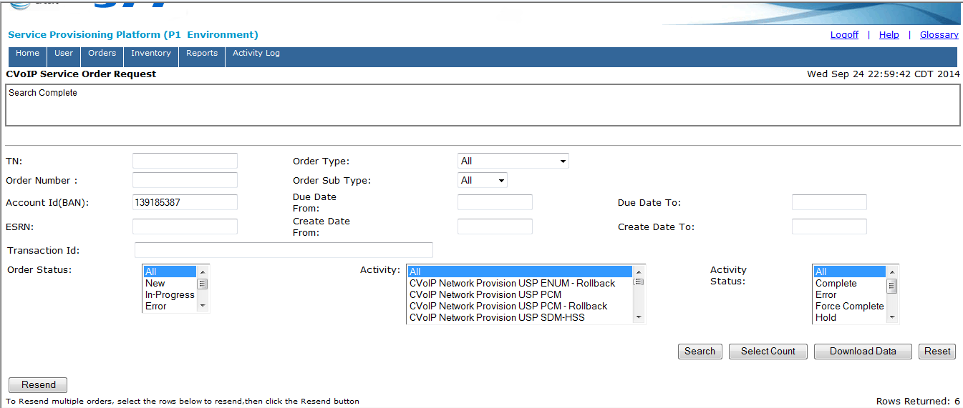

Detail of an order by putting its BAN Number in first (A) Screen shot.

(B) 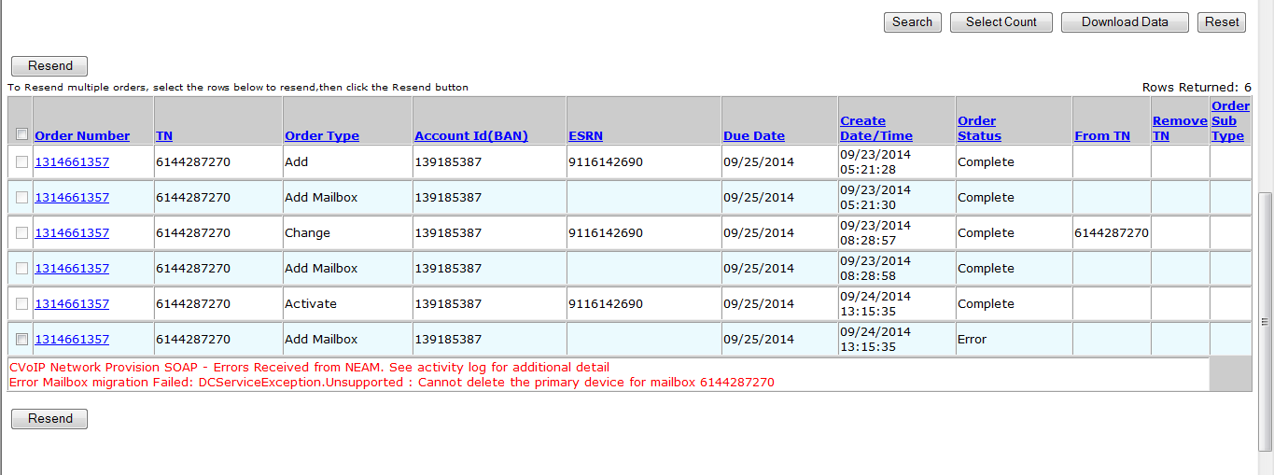

Click on order Number

1. After click on order number, you are able see the all activities done on Error order by clicking on Activity log. As shown below.

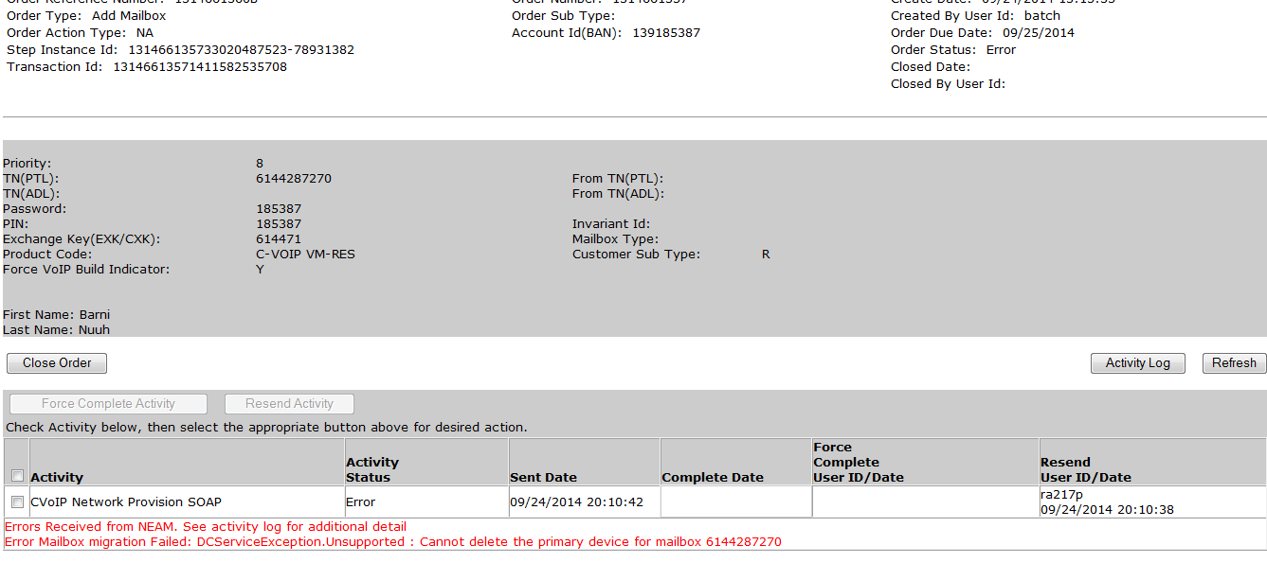

1. After click on Activity log, we can see the all activities logs of an order.

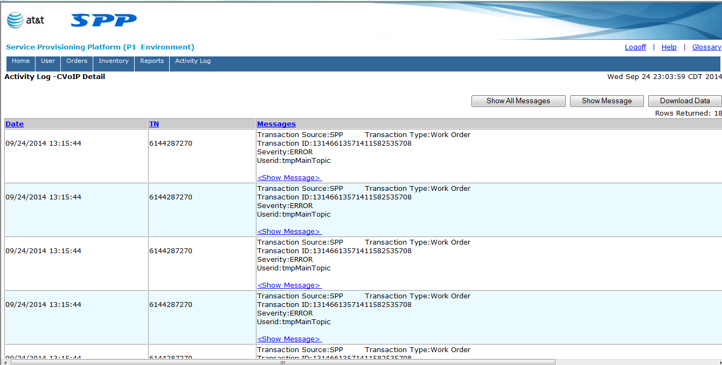

**NOTE:**

1. **When each status of each order is COMPLETE then it means that order is Error free.**
2. **We can also see the CVOIP error through CVOIP GUI and through Exception Manager as well. But we can’t see the BVOIP Errors in Exception Manager they come in it.**
3. **The In-Progress status of any order means the order is In-Progress.**
4. **When the order status on any order is in Error then you can check the Error details of that order by clicking on Activity logs.**

***2.3* HOW to see CVOIP Error in Exception Manager**

1. Go to <https://lsprod.it.att.com/exmgr-lsprod>

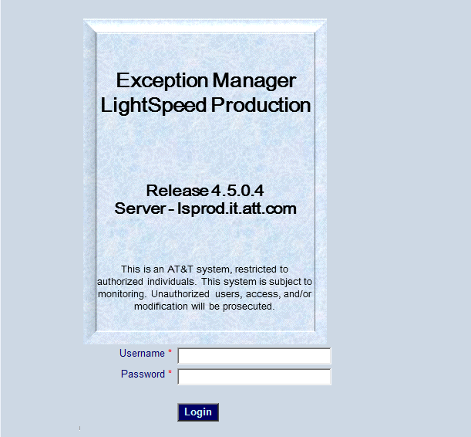

1. Put IT-Servies username and password, then you will see the shown below picture. And From here go to Admin and then click Worklist Manager.

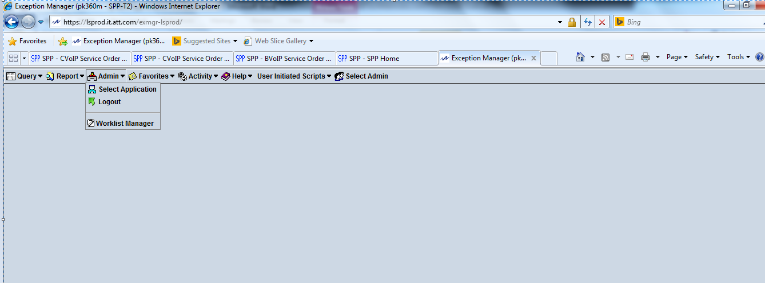

1. After 3rd step go to the Arrow mention Sign and click on Open Custom View.

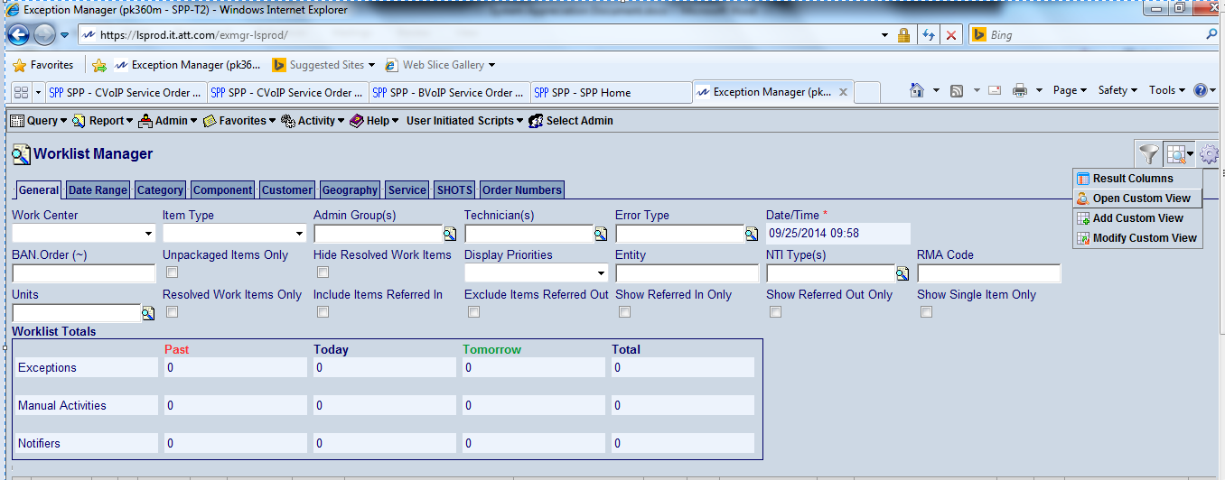

1. From here click on your id ID and press OPEN.

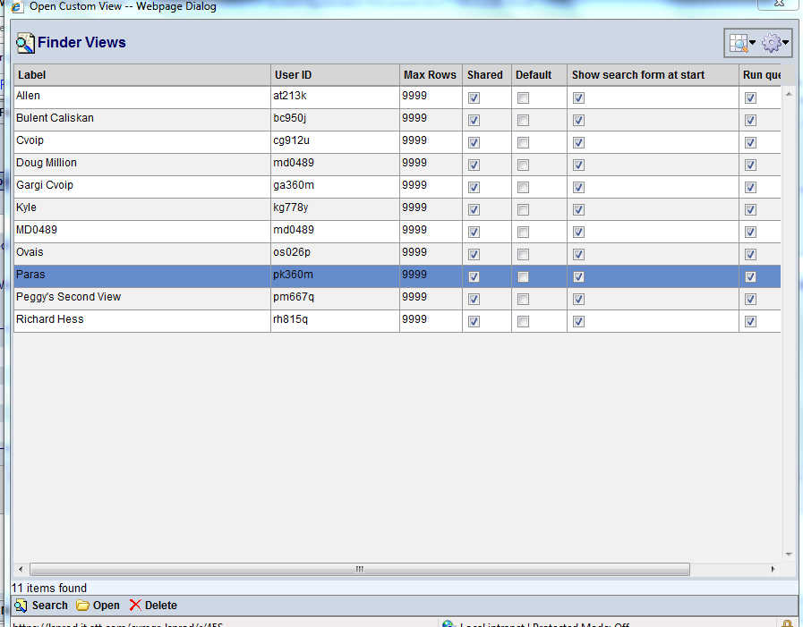

1. After the all 4 steps you are able to see tickets of CVOIP issue, As shown below.

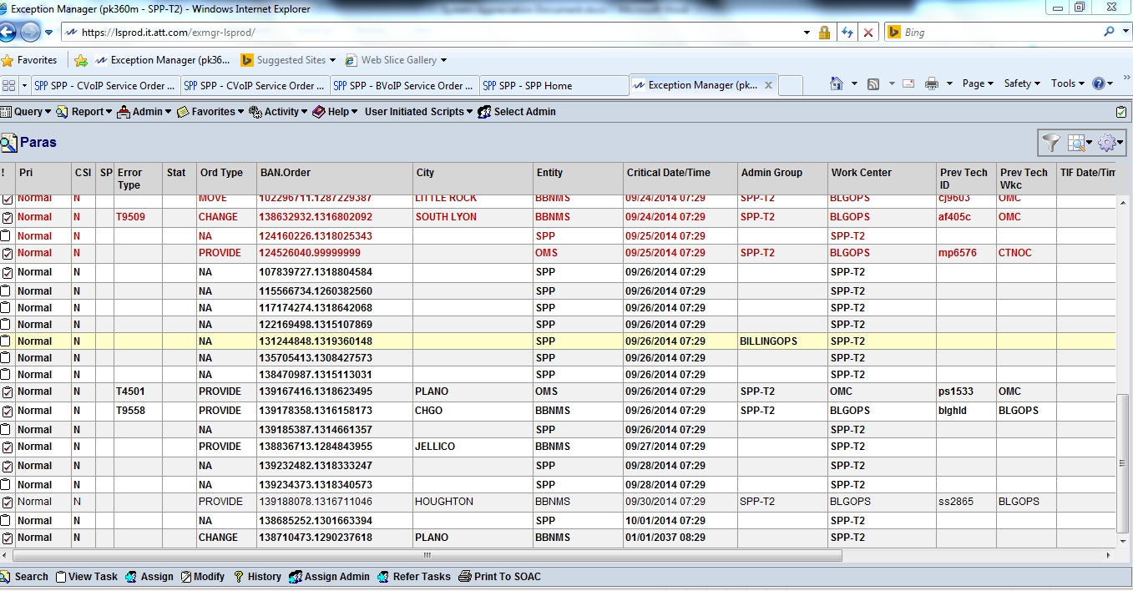

1. From Here click on any ticket and then press View task from the Bottom bar then you are able to see the Error for that particular BAN,Order.

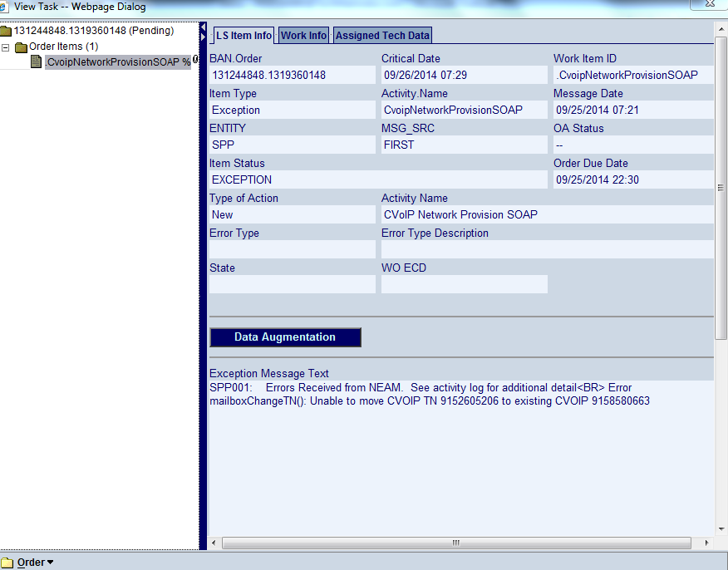

**CVoIP Provisioning**

The SPP CVoIP provisioning covers the provisioning of Uverse CVoIP TNs in IMS, CMS, and UM. SPP supports the capacity management, load balancing, network assignment rules and TN rehoming for the IMS NEs and S/BCs.

SDP currently sends the following CVOIP orders to SPP. Up to 2 TNs for a BAN can be on a given order. SPP will validate the transaction and either accept or reject the transaction to SDP (if there are multiple TNs on the order SPP could accept one and reject the other). SPP will process each TN on an order independently, and not respond to SDP until the provisioning is complete for the TN.

**TN Adds**

Add Native TN – adds HSS, ENUM, FS5K, LCM and CMS

Add Ported in TN – adds HSS, FS5K, LCM and CMS

**TN Activations**

Activation of Ported In TN – adds ENUM

**TN Changes**

Change attribute of a TN, e.g. IPTV Indr, Caller Id Name, Block Caller Id Indr, Port # - updates HSS, FS5K, LCM and/or CMS

TN Swaps – delete TN and add in new TN

Swaps – swap ports between PTL and ADL – coordinated delete and add of CMS for both TNs

**TN Intercept Referrals**

Intercept Referrals for non-Port Out – updates FS5K to provide an announcement for a ceased TN (non-port out)

**TN Deactivations**

Deactivates for Port Out – deletes ENUM

**TN Deletes**

TN Delete (aged in SDP prior to delete) – deletes HSS, ENUM, FS5K, LCM and CMS

**TN Suspends**

Soft Suspends (dial plan update) – updates HSS

Hard Suspends (also removes IPTV indr) - updates HSS and FS5K

**TN Restores**

Soft Restores (dial plan update) – updates HSS

Hard Restores (also restores IPTV indr) - updates HSS and FS5K

**TN Move Deletes (F&T) – F&T not currently being used**

No IMS / CMS updates are done on a TN Move Delete

**TN Move Provides (F&T) – F&T not currently being used**

TN Move Provide treated as a Change – deletes / adds CMS, updates HSS

**Toggle CMS ATA Enable Flag (synchronous transaction)**

TNs using an INID are initially disabled and enabled at activation– updates CMS

**Add CVOIP Voice Mailbox**

Creates a VoIP Mailbox or Moves a TDM Mailbox to VoIP in UM – Adds/Moves UM via SOAP

**Change CVOIP Voice Mailbox**

Chg PTL, Swap PTL / ADL, Add, Chg, Remove ADL in UM – Updates UM via SOAP

**Delete CVOIP Voice Mailbox**. Deletes the Mailbox in UM – Deletes UM via SOAP

**R12 – Change Call Features (synchronous from ESSD-SDP)**

Portal initiated change -- updates FS5K call features

**CVOIP Issues**

***ISSUE 1***

We have to change the mailbox for BAN No. 134678161 having current TN 7082655542.

Error message: Unable to move CVOIP TN 7087541437 to existing CVOIP 7082655542 which means that ….437 TN has already got a mailbox in it.

**RESOLUTION:**

**Step 1:**

Go to CVOIP GUI and check the error for this BAN.

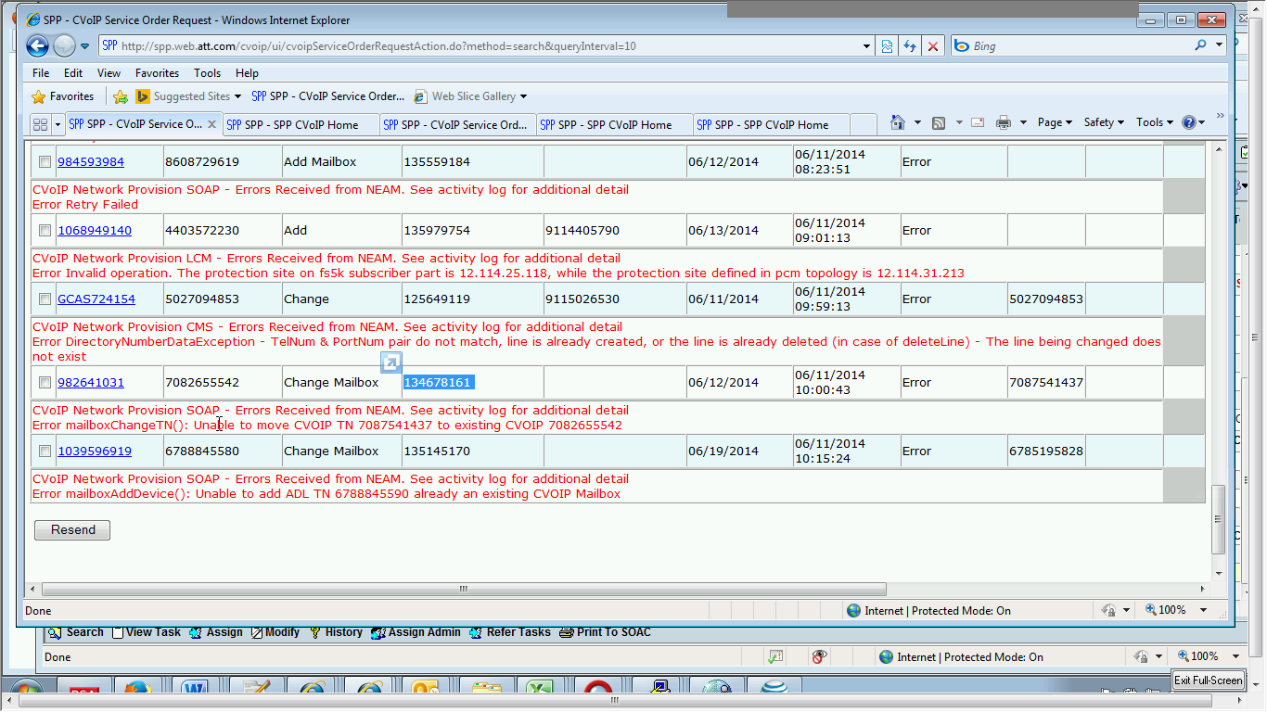

**Step 2:**

Go to CVOIP service order request details and put in the BAN No. over there, select the order status and select the activity and you will see all the order types corresponds to this BAN No. what has been done earlier with this BAN. As shown below order status showing error in change mailbox.

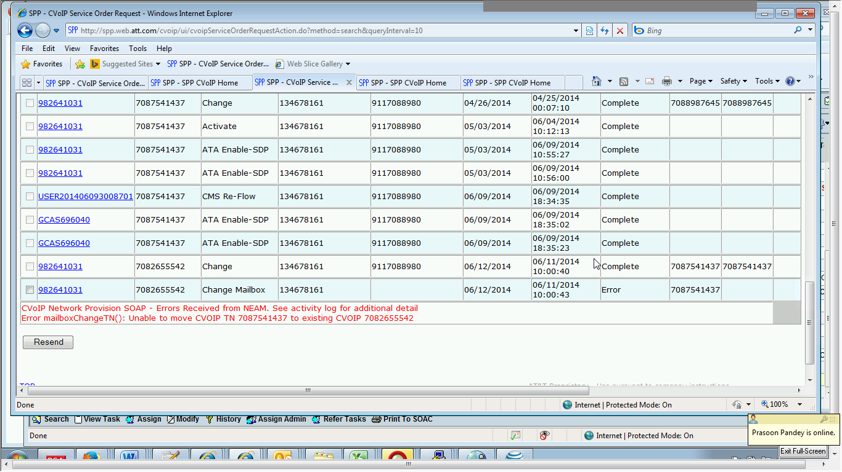

**Step 3:**

Now, when we have checked the details of error in the activity log, there we came to know that mailbox in previous TN has not been deleted yet, hence it is showing error in change mailbox in this TN ….5542. So, in order to remove the error we have to send request to BILLINGSOPS who will handle the further process and they will delete the mailbox from previous TN and then add it back. While assigning the task to BILLINGOPS we attach a note

“Please rebuild the mailbox for BAN ….8161 Thank you. Order is TIF”.

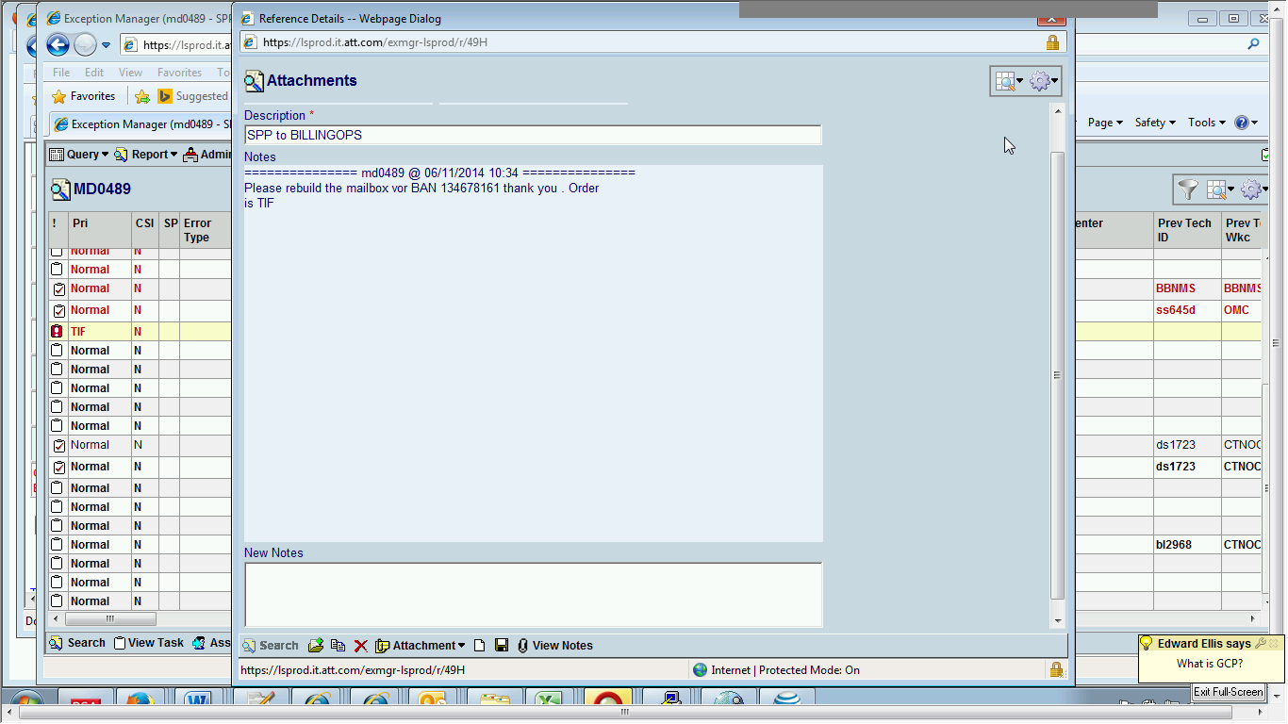

**Step 4:**

At last we assign a task to BILLINGOPS by selecting through admin group as shown below.

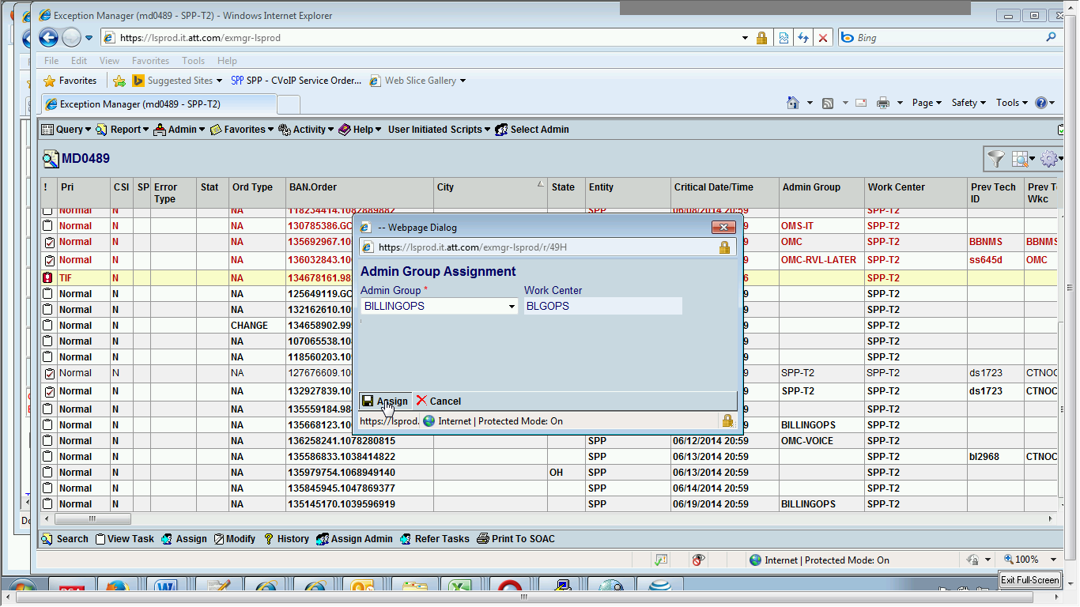

***ISSUE 2***

For BAN No. 127285140 we have to delete the mailbox which has primary TN No. as shown below.

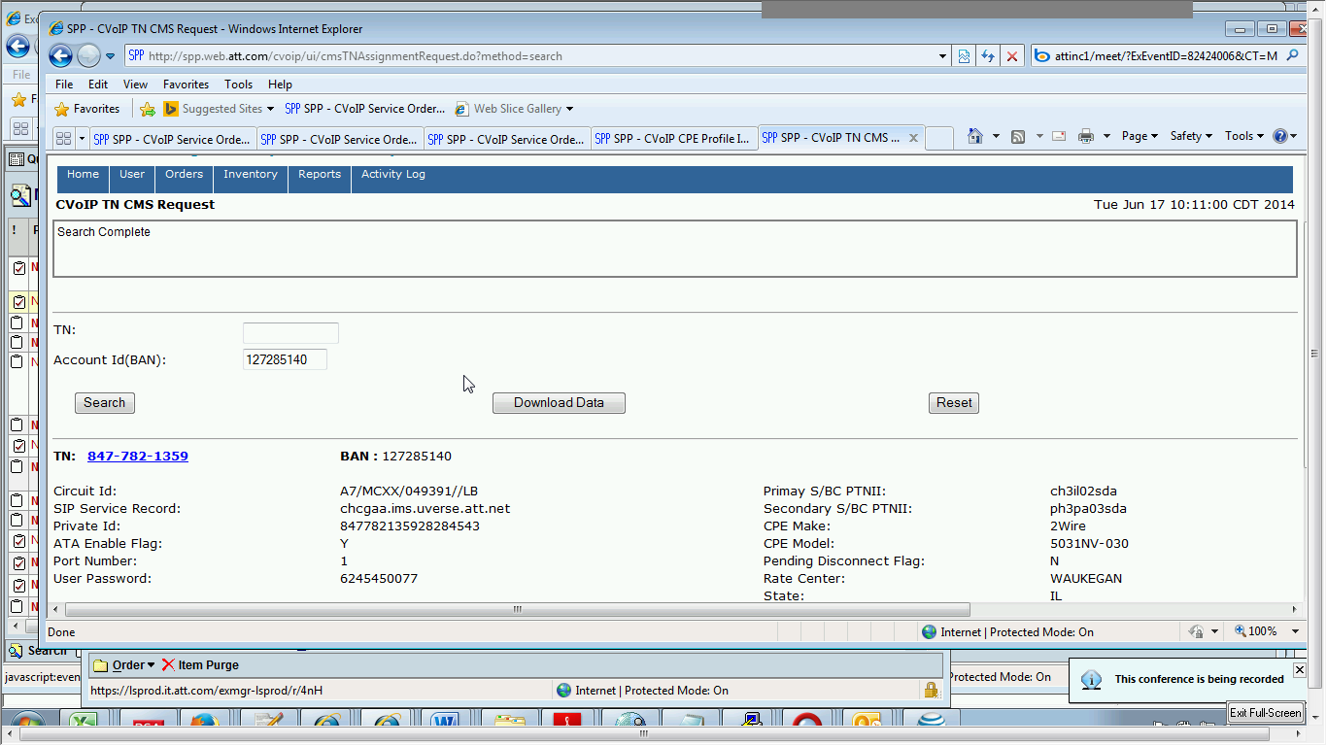

**RESOLUTION**

**Step1.**

First go to CVOIP GUI and search for this BAN No. as shown above.

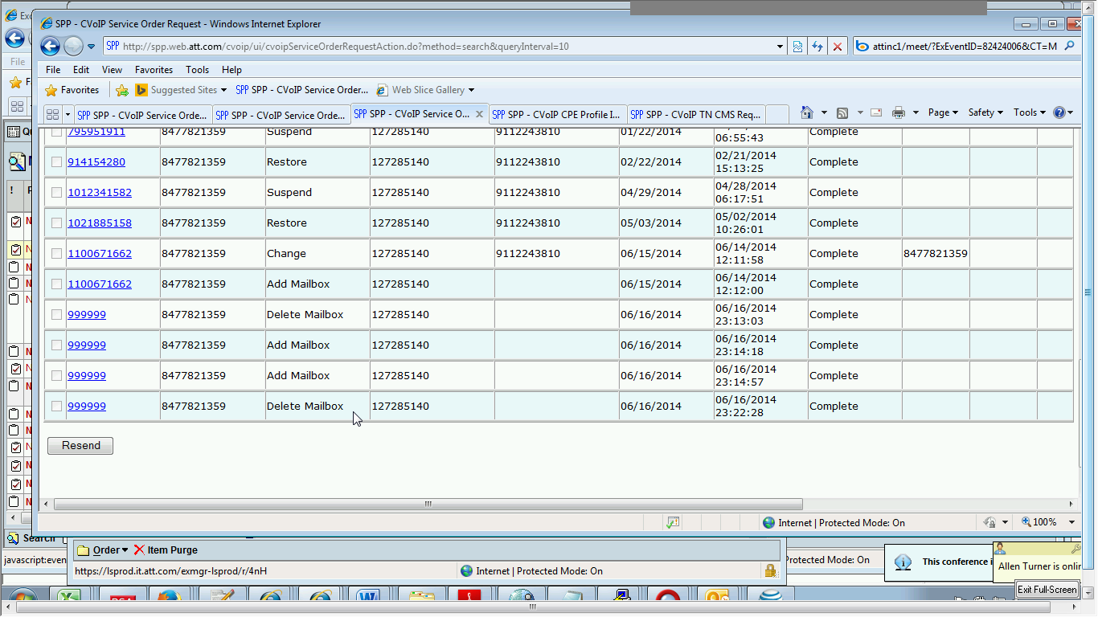

**Step2**.

Then check the details of that TN whether it has any mailbox in order to delete it. In CVOIP service order request details.

**Step3**.

But this particular BAN does not have a Mailbox to delete, so we are not going to close this.

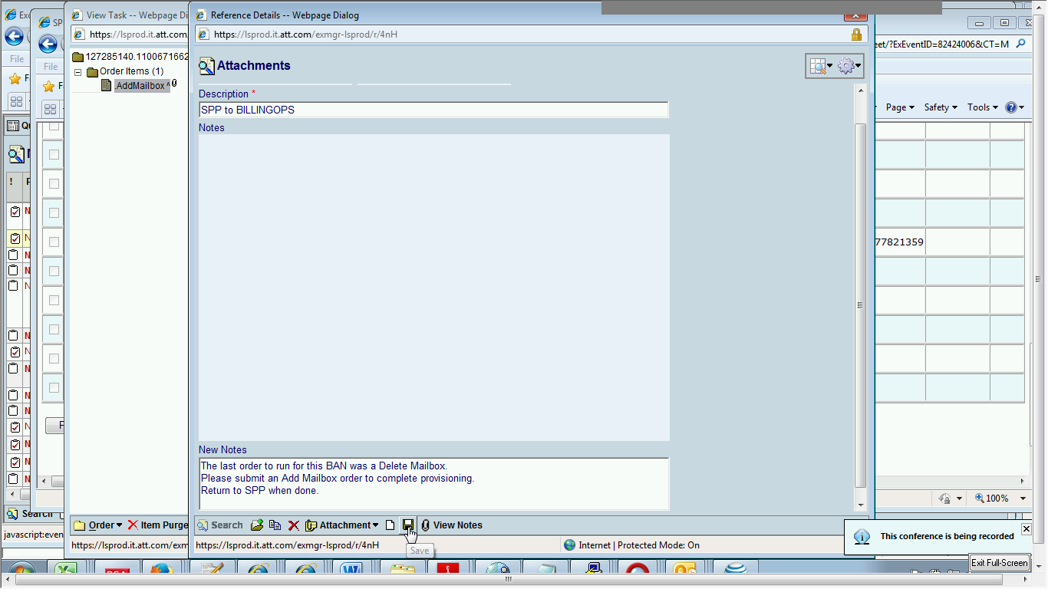

So we just send the request to BILLINGOPS and add notes that the “The last order for this BAN was a delete mailbox. Please submit an add mailbox order to complete provisioning. Return to SPP when done. “ as shown above.