**Steps to Check Order in NEAM**

1. Login to ‘p2nea1c1.vci.att.com’ using RSA token

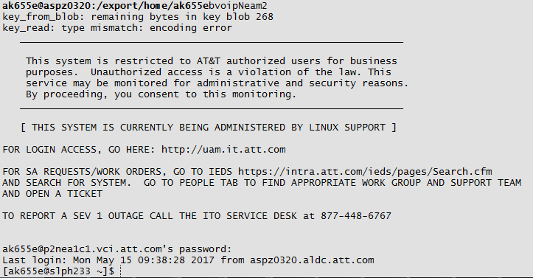

1. Do ‘sudo -iu p2nea1c1’ to login as super user



1. Do ‘ts’ to go to NEAM path

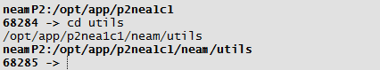

1. ‘searchWO order_number’ to check for WO for specific

Ex. searchWO 171616528

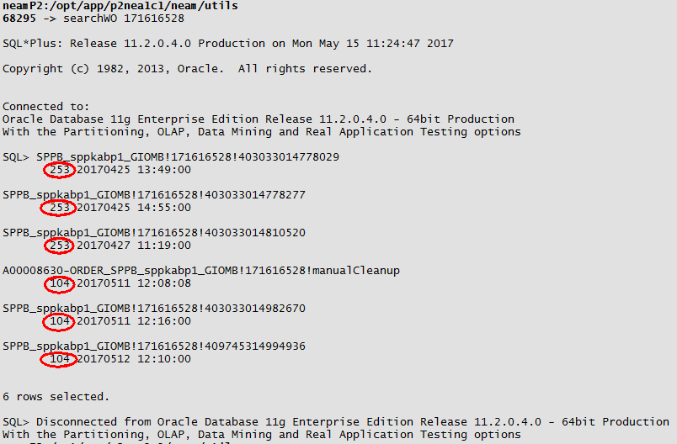

SPPB_sppkabp1_GIOMB!171616528!409745314994936 – is work order

1. Do ‘woInfo work_order’ to check CSDL status, if they are complete or not

Example : woInfo SPPB_sppkabp1_GIOMB!171616528!409745314994936

