**TN Conflict**

For a say, user came up we the order from the BVOIP Chatroom or from the ticket in AOTS with the request that SPP team please check he/she is unable to Supp as there’s an SPP error that is prohibiting it to progress.

In this example we got the GIOM order# 158661736

Step 1: Simply search for that order with its GIOM order # in SPP GUI (BVOIP>BVOIP Service Order Request) to pull its details.

Below is the image that how it looks like :  
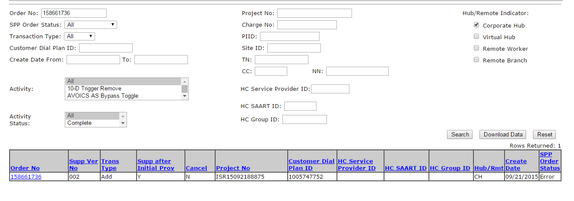Now click on the hyperlink on the “Order No” which is in blue and the first element in the first column in the table:

Step 2: The end of the step 1 will direct us to the another window exactly like the below image :

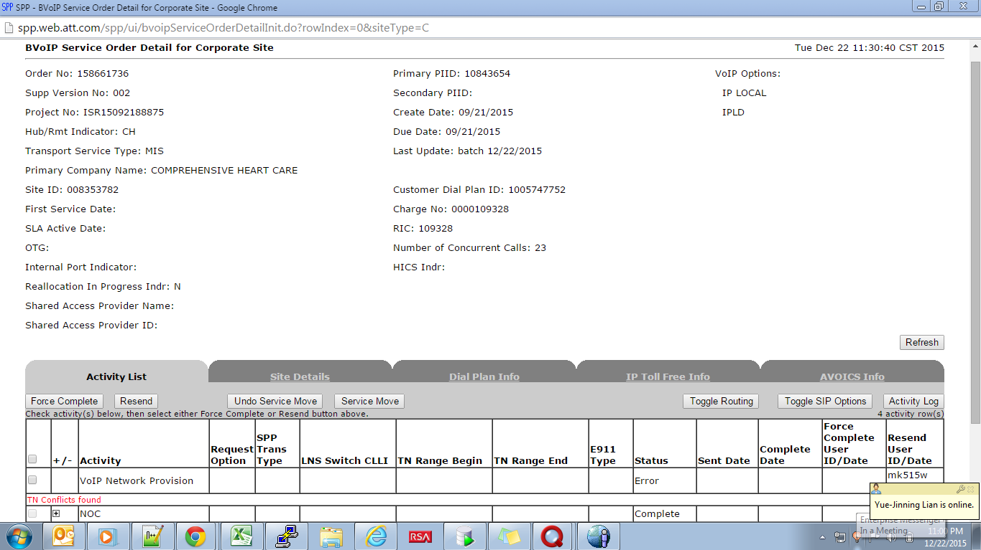

Step 3: Now pay attention to the Activity List at the bottom of this page, error is clearly visible below the VOIP Network Provision –“TN Conflicts found” marked in red thus confirming the case.

Step 4: Click to the activity log now:   
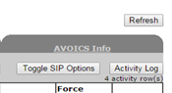

Step 5: Step 4 will direct us to the below page:   
  
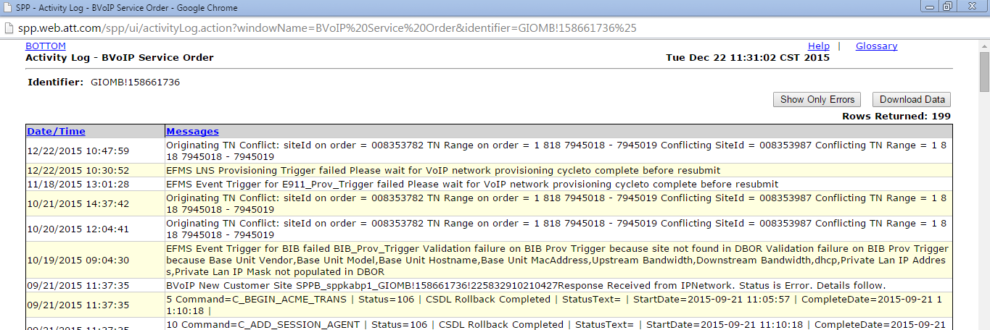

Step 6 : Check the message in the Activity log that is stating what Tn is conflicting on what site Id, here in the very first message showing the details of the conflicting TNs  
  


Here the message states that the TN range starting with 1818 7945018 – 7945019 on the order with the site Id = 008353782 also exits on the another site id = 008353987 thus leading to the TN Conflict, thus the error is valid but we also need to validate the error.

Step 7: Check the Dial Plan info and search for this TN Range 1818 7945018 – 7945019 :

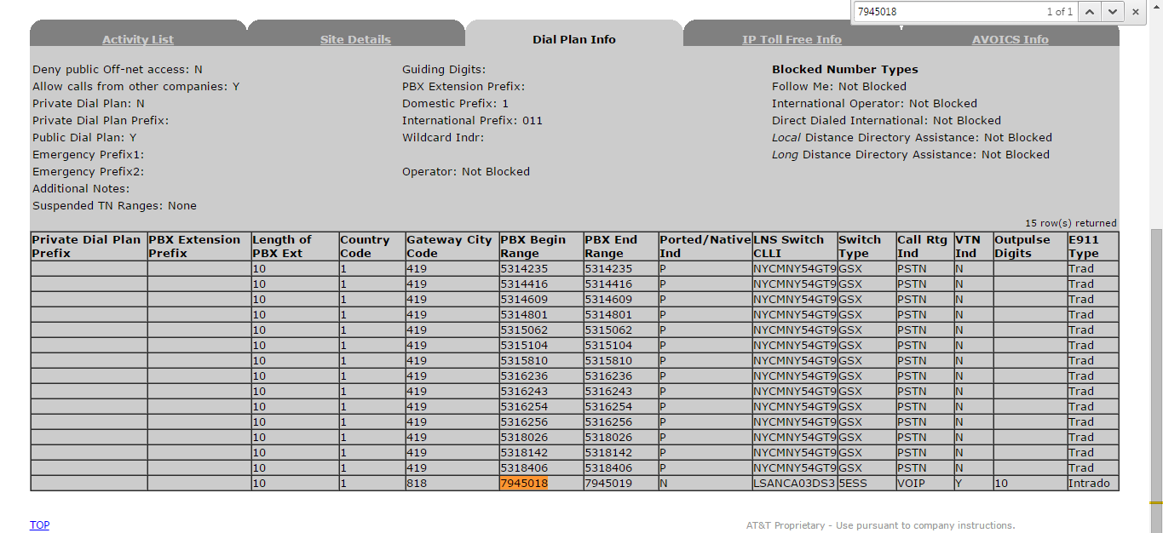

This particular Tn range in the dial plan seems to VOIP as you can see that’s indicating that the particular TN range is already in use.

Step 8 : Now all we need is to switch to the GCP GUI (BVOIP>BUSINESS CUSTOMER SITE REQUEST)

Step 9 : Here in GCP we will search with the second site Id i.e 008353987 and we will get this :

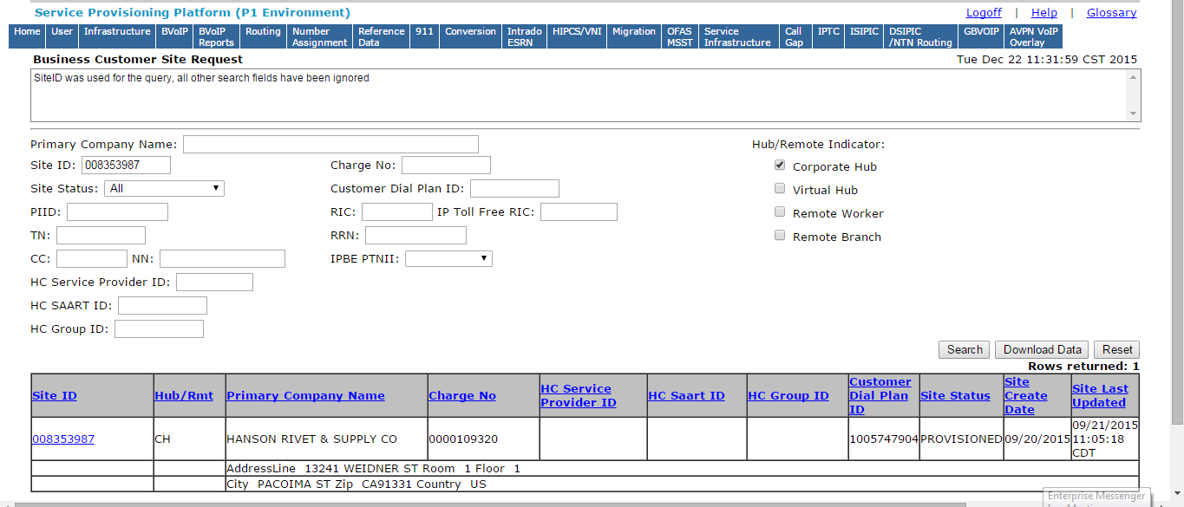

Now click on the hyper link for the Site ID marked in blue at the bottom, it will direct us to the another window

Step 10: Now go to the Dial Plan Info :  
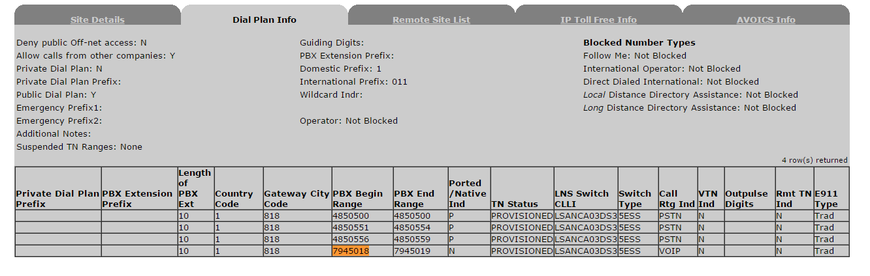

We see the same Tn range 1818 7945018 – 7945019 on this site ID 008353987 thus the error is valid.

Step 11 :  
Resolution- Now simply update the user that please check the availability of the conflicting Tn range 1818 7945018 – 7945019 on the desired Site ID as currently it’s residing on the two different SITE ID’s.

Same TN cannot be added to two different Site’s.