**ASR item id got changed**

|  |  |  |
| --- | --- | --- |
| Date | Prepared by | Reviewed by |
| 11/15/2019 | Ritika Kalra(rk234f) |  |

**Issue: User creates ticket asking to change the asr item id to previous value**

**Step 1 :** Check what is the value of ASR item id in sales solution summary file in version 1 .

Sales solution summary file will be found in Solution tab of PricerD

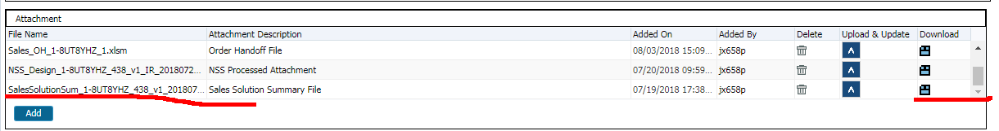

 Download and check what is the value of the asr item id in Sales solution summary file in port tab

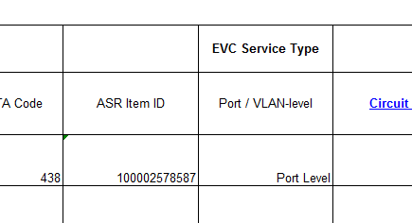

**Step 2 :** Then download the latest version of sales solution summary file from the same solution tab and check what the value in it is

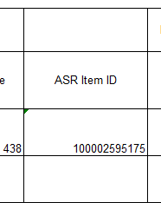

**If both the values are different, then WA has to be provided**

1. Run the below query and take the corresponding site id

select * from adopt.ad_lead_site where lead_design_id=1667279



1. Then update the asr item id and site id in below query

update ad_lead_site set asr_item_id='100002578587' where Site_id=99996609418;

RC : MACD type was changed by user , so ASR item was changed which was provisioned in NSS .  
User error

Send script for approval. Once it is approved, execute it and ask user to check

If user wants the asr item to be updated in rome , ask user to click on save changes in solution screen and then ask user to remove and add sites back in SOR.