BUSINESS OBJECT ACCESS REQUEST THROUGH UPSTART

Please refer the below image.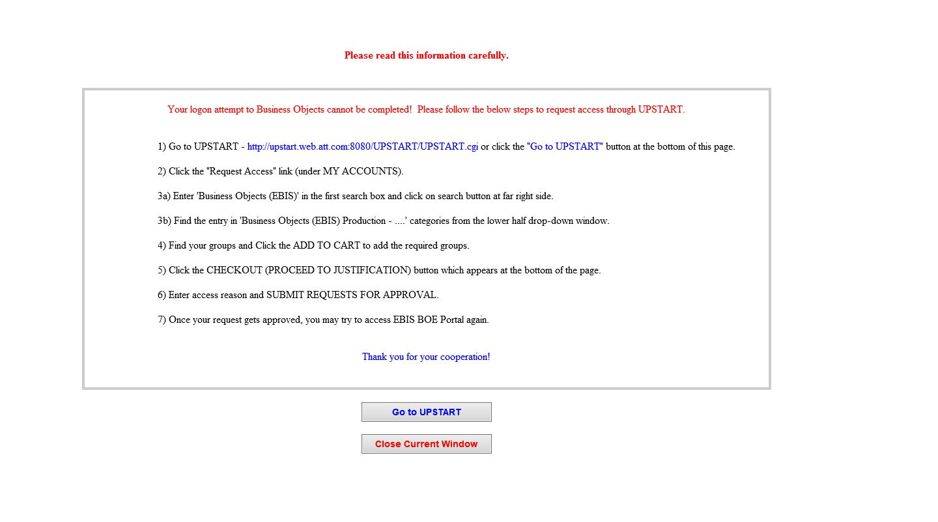

Link of BOE Portal:

<http://esarprd.it.att.com/BOEPortal/logon.jsp>

Groups for access in EBIS:

[Business Objects (EBIS) Production - Business Objects Rich Client](https://amdocs-my.sharepoint.com/personal/nikitaji_amdocs_com/Documents/Haloo/Imp%20Documents/UPSTART_REQUEST.cgi?AOAlEqEACYERBMErEfAEEUDnDGDlEPCvBNAiCJCTErDLAOCcAXAkBfDJDDEeEcCmESDDDDEaEvyYBjCrDavVEYDNBFAqEvAIByERAxBVEAAEAaBiAODI~Business+Objects+(EBIS)+Production+-+Business+Objects+Rich+Client~V~~Business+Objects+(EBIS)+Production~~~V~)

[Business Objects (EBIS) Production - ESAR-EDS Power Users](https://amdocs-my.sharepoint.com/personal/nikitaji_amdocs_com/Documents/Haloo/Imp%20Documents/UPSTART_REQUEST.cgi?AOAlEqEACYERBMErEfAEEUDnDGDlEPCvBNAiCJCTErDLAOCcAXAkBfDJDDEeEcCmESDDDDEaEvyYBjCrDavVEYDNBFAqEvAIByERAxBVEAAEAaBiAODI~Business+Objects+(EBIS)+Production+-+ESAR-EDS+Power+Users~V~~Business+Objects+(EBIS)+Production~~~V~)

[Business Objects (EBIS) Production - ESAR-SQM Power Users](https://amdocs-my.sharepoint.com/personal/nikitaji_amdocs_com/Documents/Haloo/Imp%20Documents/UPSTART_REQUEST.cgi?AOAlEqEACYERBMErEfAEEUDnDGDlEPCvBNAiCJCTErDLAOCcAXAkBfDJDDEeEcCmESDDDDEaEvyYBjCrDavVEYDNBFAqEvAIByERAxBVEAAEAaBiAODI~Business+Objects+(EBIS)+Production+-+ESAR-SQM+Power+Users~V~~Business+Objects+(EBIS)+Production~~~V~)

[Business Objects (EBIS) Production - ESAR-TM Power User](https://amdocs-my.sharepoint.com/personal/nikitaji_amdocs_com/Documents/Haloo/Imp%20Documents/UPSTART_REQUEST.cgi?AOAlEqEACYERBMErEfAEEUDnDGDlEPCvBNAiCJCTErDLAOCcAXAkBfDJDDEeEcCmESDDDDEaEvyYBjCrDavVEYDNBFAqEvAIByERAxBVEAAEAaBiAODI~Business+Objects+(EBIS)+Production+-+ESAR-TM+Power+User~V~~Business+Objects+(EBIS)+Production~~~V~)

[Business Objects (EBIS) Production - ESAR-ATTITAPPSERV Power User](https://amdocs-my.sharepoint.com/personal/nikitaji_amdocs_com/Documents/Haloo/Imp%20Documents/UPSTART_REQUEST.cgi?AOAlEqEACYERBMErEfAEEUDnDGDlEPCvBNAiCJCTErDLAOCcAXAkBfDJDDEeEcCmESDDDDEaEvyYBjCrDavVEYDNBFAqEvAIByERAxBVEAAEAaBiAODI~Business+Objects+(EBIS)+Production+-+ESAR-ATTITAPPSERV+Power+User~V~~Business+Objects+(EBIS)+Production~~~V~)

[Business Objects (EBIS) Production - ESAR-CB PSO Power User](https://amdocs-my.sharepoint.com/personal/nikitaji_amdocs_com/Documents/Haloo/Imp%20Documents/UPSTART_REQUEST.cgi?AOAlEqEACYERBMErEfAEEUDnDGDlEPCvBNAiCJCTErDLAOCcAXAkBfDJDDEeEcCmESDDDDEaEvyYBjCrDavVEYDNBFAqEvAIByERAxBVEAAEAaBiAODI~Business+Objects+(EBIS)+Production+-+ESAR-CB+PSO+Power+User~V~~Business+Objects+(EBIS)+Production~~~V~)