**Update Attribute and Retrigger the Activity**

**From OMX If any Request for the activity is not sending the correct value or missing value to IM – then we have to do the WA to complete the activity . For this we have to follow the below process in the HALO Automation process tool – Free flow.**

**Example** : Billing date Update and trigger the Billing task

**PROB_DETAILS: Order has been stuck at CNR . Error code BGW 1000 Invalid billing effective date.**

**Request to fix the issue**

Correct to bill start date 12/2/2019 and retriggered to billing gateway

**Order details in the OMX :**

OMX –PND :

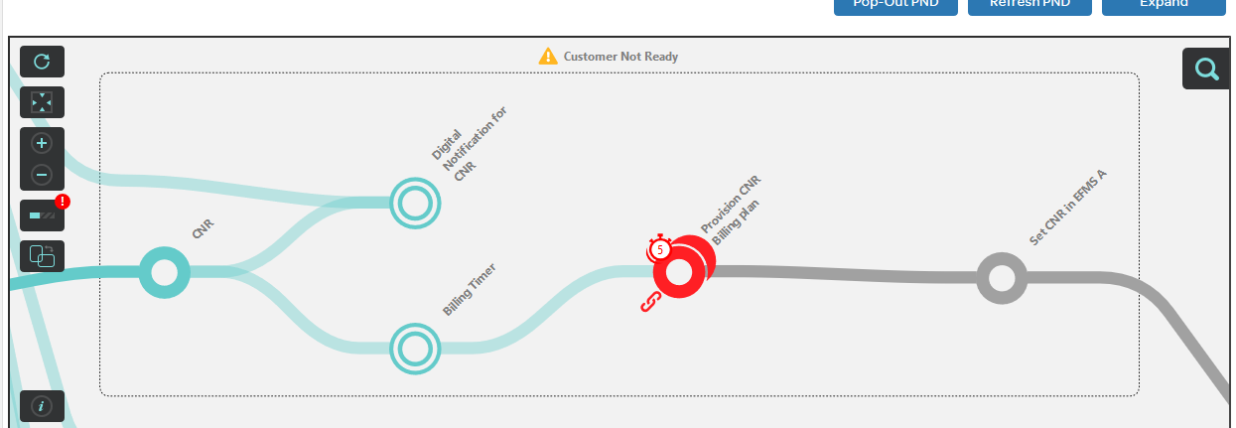

OMX Task

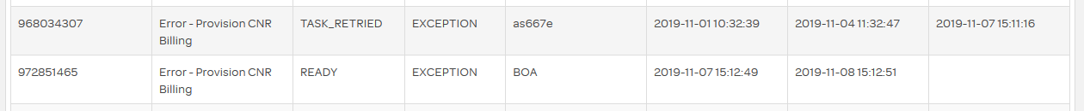

**For the above scenario : We have to follow the below steps**

1. Update the Attribute value in the attribute store - billing Date :
2. For MIS order 🡪 ACT.EffectiveBillingdate – Year-Month-Date Format (2019-12-04T09:59:00)

* AVPN orders - Invalid BillingEffectiveDate error

Trigger Provision CNR Billing manually with date = Order Due Date +1 or with Billing Start Date .

1. Go to Process order
   1. Search the Order ID
   2. Select the activity – Provision CNR billing
   3. Click on Error Resolve
   4. Click on the Retry activity
2. Verify the order progressed in the PND .

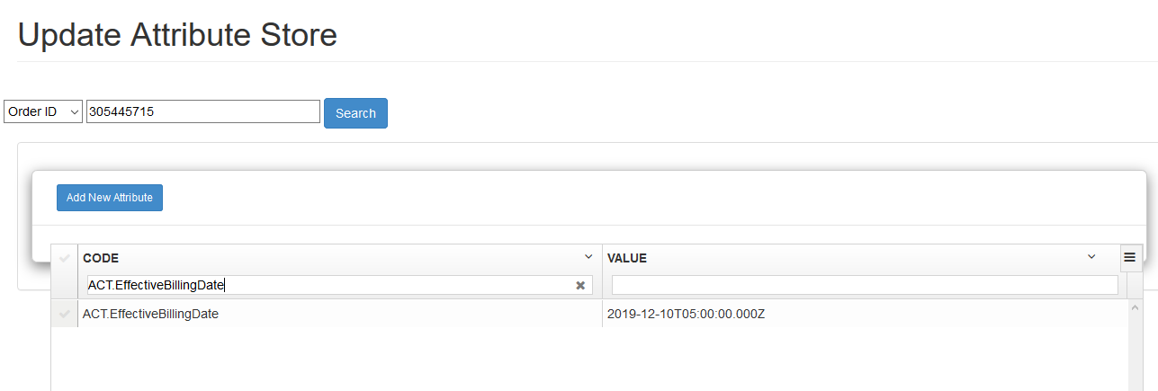

S 