

Service url : <http://esgw01.cif.att.com:9401/dppqcWSv2/ProjectQuery.jws>

Regards

**Aanjo Premlal**

Software Development Specialist

Production Services Group, AT&T Division

+1.972.207.2351 (mobile)  
+1.972.308.3293 (office)

amdocs-a

Follow us on [Facebook](https://urldefense.proofpoint.com/v2/url?u=http-3A__www.facebook.com_amdocs_&d=DwMFAg&c=LFYZ-o9_HUMeMTSQicvjIg&r=0uFu1B4GO_aRIDW9mQkDzMP0UGwY_shthoUAqaZ1qk4&m=U6xPuwPq-uf78UPZ-M2UO5gP4apKl0aOeq5OlmJD4-c&s=DfCuJ9laXrnX6V8rANSiB06vpL6lIe77laTAmsYjJ1s&e=), [Twitter](https://urldefense.proofpoint.com/v2/url?u=http-3A__twitter.com_amdocs&d=DwMFAg&c=LFYZ-o9_HUMeMTSQicvjIg&r=0uFu1B4GO_aRIDW9mQkDzMP0UGwY_shthoUAqaZ1qk4&m=U6xPuwPq-uf78UPZ-M2UO5gP4apKl0aOeq5OlmJD4-c&s=QdGIqz9Fe2DD3cGeI3PLG-cFfdgAbpUTYq-h-a5QKuU&e=), [LinkedIn](https://urldefense.proofpoint.com/v2/url?u=http-3A__www.linkedin.com_company_amdocs&d=DwMFAg&c=LFYZ-o9_HUMeMTSQicvjIg&r=0uFu1B4GO_aRIDW9mQkDzMP0UGwY_shthoUAqaZ1qk4&m=U6xPuwPq-uf78UPZ-M2UO5gP4apKl0aOeq5OlmJD4-c&s=DfjBt-QgnqosqWDYx3J4tkiMrjoCNxrAf3B7L0ZbDog&e=), [YouTube](https://urldefense.proofpoint.com/v2/url?u=http-3A__www.youtube.com_amdocsinc&d=DwMFAg&c=LFYZ-o9_HUMeMTSQicvjIg&r=0uFu1B4GO_aRIDW9mQkDzMP0UGwY_shthoUAqaZ1qk4&m=U6xPuwPq-uf78UPZ-M2UO5gP4apKl0aOeq5OlmJD4-c&s=kxVdu0RBW3cWVQ5ch4SgRPZebjGZn3ig3XsMIJBOyf0&e=), [Google+](https://urldefense.proofpoint.com/v2/url?u=https-3A__plus.google.com_105657940751678445194&d=DwMFAg&c=LFYZ-o9_HUMeMTSQicvjIg&r=0uFu1B4GO_aRIDW9mQkDzMP0UGwY_shthoUAqaZ1qk4&m=U6xPuwPq-uf78UPZ-M2UO5gP4apKl0aOeq5OlmJD4-c&s=7MyHSPp3B-ogffcl9gIJdbWZoULJth73cevCC4dF9IE&e=) and the [Amdocs blog network](https://urldefense.proofpoint.com/v2/url?u=http-3A__blogs.amdocs.com_&d=DwMFAg&c=LFYZ-o9_HUMeMTSQicvjIg&r=0uFu1B4GO_aRIDW9mQkDzMP0UGwY_shthoUAqaZ1qk4&m=U6xPuwPq-uf78UPZ-M2UO5gP4apKl0aOeq5OlmJD4-c&s=xJUgHX-RU4UY-gWkaMLozT2dOi8hSFJ__b94myXEzto&e=).

**From:** Aanjo Thaivallapil   
**Sent:** Friday, January 10, 2020 3:16 PM  
**To:** 'NextGenBOAHalo@list.att.com' <[NextGenBOAHalo@list.att.com](mailto:NextGenBOAHalo@list.att.com)>  
**Cc:** MAYO, DAVID <[dm7316@att.com](mailto:dm7316@att.com)>  
**Subject:** Getting GetPP Logs

Hi

1. Run below query in OMX DB.

select sc.*,oas.*

from

affuser_halo.oss_attribute_store oas,

affuser_halo.sc_project_order_instance sc

where

oas.PARENT_ID=sc.OBJID

and sc.name like '%SOR%'

and oas.code ='SORID'

and oas.value='1-C6RIC6Z'

;

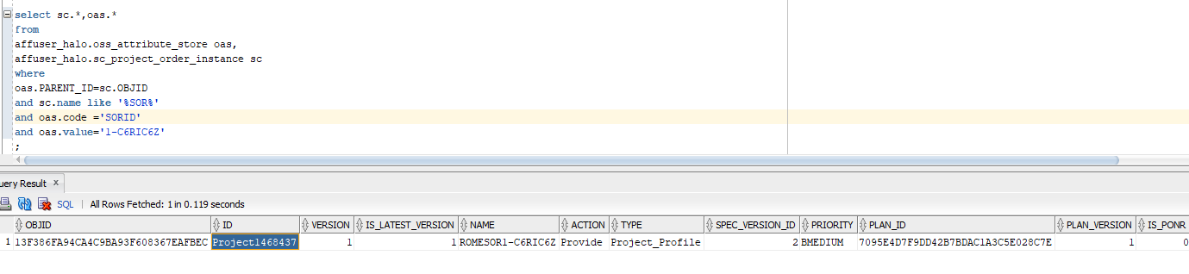

1. Run below REST from SOAP UI : Populate below highlighted values.

Endpoint : <http://zltv9976.vci.att.com:41700>

Resource : /HSim/ContactBGW/generic/client

Request:

<soapenv:Envelope xmlns:soapenv="[http://schemas.xmlsoap.org/soap/envelope/](https://urldefense.proofpoint.com/v2/url?u=http-3A__schemas.xmlsoap.org_soap_envelope_&d=DwMFAg&c=LFYZ-o9_HUMeMTSQicvjIg&r=0uFu1B4GO_aRIDW9mQkDzMP0UGwY_shthoUAqaZ1qk4&m=U6xPuwPq-uf78UPZ-M2UO5gP4apKl0aOeq5OlmJD4-c&s=qqE09bGM_6-NJkBWg3x5qoPVUXq38SjCsddizqvchBY&e=)" xmlns:v2="<http://edb.att.com/dppco/ProjectQuery/v2>" xmlns:v3="<http://cio.att.com/commonheader/v3>">

   <soapenv:Header>

      <wsse:Security soapenv:mustUnderstand="1" xmlns:wsse="[http://docs.oasis-open.org/wss/2004/01/oasis-200401-wss-wssecurity-secext-1.0.xsd](https://urldefense.proofpoint.com/v2/url?u=http-3A__docs.oasis-2Dopen.org_wss_2004_01_oasis-2D200401-2Dwss-2Dwssecurity-2Dsecext-2D1.0.xsd&d=DwMFAg&c=LFYZ-o9_HUMeMTSQicvjIg&r=0uFu1B4GO_aRIDW9mQkDzMP0UGwY_shthoUAqaZ1qk4&m=U6xPuwPq-uf78UPZ-M2UO5gP4apKl0aOeq5OlmJD4-c&s=oFW1mcp5LeqLsVKGolrtzeZ_Mu25ePj4SDfObFdpyZQ&e=)">

         <wsse:UsernameToken wsu:Id=" UsernameToken-1" xmlns:wsu="[http://docs.oasis-open.org/wss/2004/01/oasis-200401-wss-wssecurity-utility-1.0.xsd](https://urldefense.proofpoint.com/v2/url?u=http-3A__docs.oasis-2Dopen.org_wss_2004_01_oasis-2D200401-2Dwss-2Dwssecurity-2Dutility-2D1.0.xsd&d=DwMFAg&c=LFYZ-o9_HUMeMTSQicvjIg&r=0uFu1B4GO_aRIDW9mQkDzMP0UGwY_shthoUAqaZ1qk4&m=U6xPuwPq-uf78UPZ-M2UO5gP4apKl0aOeq5OlmJD4-c&s=R-B1aq1FmMmyYVKpWof1Te8gzGmfRYFmeZcRWbyICJw&e=)">

            <wsse:Username>gcp_user</wsse:Username>

            <wsse:Password Type="[http://docs.oasis-open.org/wss/2004/01/oasis-200401-wss-username-token-profile-1.0#PasswordText](https://urldefense.proofpoint.com/v2/url?u=http-3A__docs.oasis-2Dopen.org_wss_2004_01_oasis-2D200401-2Dwss-2Dusername-2Dtoken-2Dprofile-2D1.0-23PasswordText&d=DwMFAg&c=LFYZ-o9_HUMeMTSQicvjIg&r=0uFu1B4GO_aRIDW9mQkDzMP0UGwY_shthoUAqaZ1qk4&m=U6xPuwPq-uf78UPZ-M2UO5gP4apKl0aOeq5OlmJD4-c&s=UtTGtA0ZLI9LsK1PjkgAIfu4bjurF3J82nSdl3kl14E&e=)">gcp_password</wsse:Password>

         </wsse:UsernameToken>

      </wsse:Security>

   </soapenv:Header>

   <soapenv:Body>

      <v2:ProjectPackageReadRequest>

         <v3:WSHeader>

            <v3:WSEndUserToken>

               <v3:Token>Asmsa1</v3:Token>

               <v3:TokenType>ATTUID</v3:TokenType>

            </v3:WSEndUserToken>

            <v3:WSContext>

               <v3:FromAppId>OCX</v3:FromAppId>

               <v3:ToAppId>GCP</v3:ToAppId>

               <v3:Version>

                  <v3:major>2</v3:major>

                  <v3:minor>2</v3:minor>

               </v3:Version>

               <v3:WSNameValue>

                  <v3:Name>Application Name</v3:Name>

                  <v3:Value>OCX</v3:Value>

               </v3:WSNameValue>

            </v3:WSContext>

            <v3:WSConversationId>tGQAAPtpxFMK6KflH0g</v3:WSConversationId>

         </v3:WSHeader>

         <v2:Projecid>Project1468437</v2:Projecid>

         <v2:SORId>1-C6RIC6Z</v2:SORId>

      </v2:ProjectPackageReadRequest>

   </soapenv:Body>

</soapenv:Envelope>

1. You should have the GetPP log

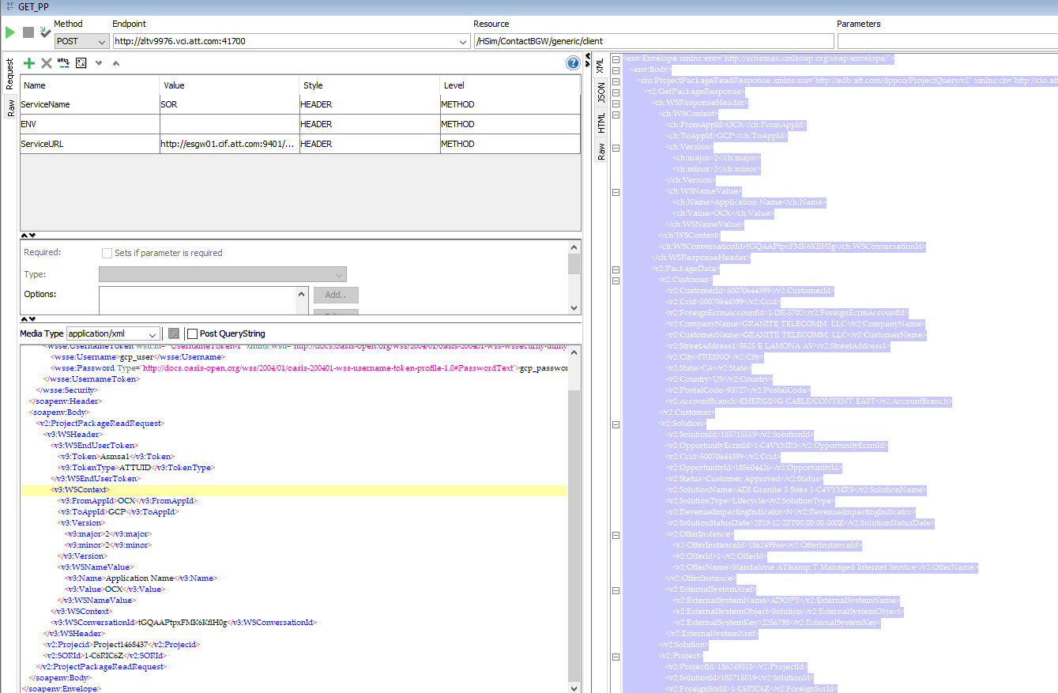

Regards

**Aanjo Premlal**

Software Development Specialist

Production Services Group, AT&T Division

+1.972.207.2351 (mobile)  
+1.972.308.3293 (office)

amdocs-a

Follow us on [Facebook](https://urldefense.proofpoint.com/v2/url?u=http-3A__www.facebook.com_amdocs_&d=DwMFAg&c=LFYZ-o9_HUMeMTSQicvjIg&r=0uFu1B4GO_aRIDW9mQkDzMP0UGwY_shthoUAqaZ1qk4&m=U6xPuwPq-uf78UPZ-M2UO5gP4apKl0aOeq5OlmJD4-c&s=DfCuJ9laXrnX6V8rANSiB06vpL6lIe77laTAmsYjJ1s&e=), [Twitter](https://urldefense.proofpoint.com/v2/url?u=http-3A__twitter.com_amdocs&d=DwMFAg&c=LFYZ-o9_HUMeMTSQicvjIg&r=0uFu1B4GO_aRIDW9mQkDzMP0UGwY_shthoUAqaZ1qk4&m=U6xPuwPq-uf78UPZ-M2UO5gP4apKl0aOeq5OlmJD4-c&s=QdGIqz9Fe2DD3cGeI3PLG-cFfdgAbpUTYq-h-a5QKuU&e=), [LinkedIn](https://urldefense.proofpoint.com/v2/url?u=http-3A__www.linkedin.com_company_amdocs&d=DwMFAg&c=LFYZ-o9_HUMeMTSQicvjIg&r=0uFu1B4GO_aRIDW9mQkDzMP0UGwY_shthoUAqaZ1qk4&m=U6xPuwPq-uf78UPZ-M2UO5gP4apKl0aOeq5OlmJD4-c&s=DfjBt-QgnqosqWDYx3J4tkiMrjoCNxrAf3B7L0ZbDog&e=), [YouTube](https://urldefense.proofpoint.com/v2/url?u=http-3A__www.youtube.com_amdocsinc&d=DwMFAg&c=LFYZ-o9_HUMeMTSQicvjIg&r=0uFu1B4GO_aRIDW9mQkDzMP0UGwY_shthoUAqaZ1qk4&m=U6xPuwPq-uf78UPZ-M2UO5gP4apKl0aOeq5OlmJD4-c&s=kxVdu0RBW3cWVQ5ch4SgRPZebjGZn3ig3XsMIJBOyf0&e=), [Google+](https://urldefense.proofpoint.com/v2/url?u=https-3A__plus.google.com_105657940751678445194&d=DwMFAg&c=LFYZ-o9_HUMeMTSQicvjIg&r=0uFu1B4GO_aRIDW9mQkDzMP0UGwY_shthoUAqaZ1qk4&m=U6xPuwPq-uf78UPZ-M2UO5gP4apKl0aOeq5OlmJD4-c&s=7MyHSPp3B-ogffcl9gIJdbWZoULJth73cevCC4dF9IE&e=) and the [Amdocs blog network](https://urldefense.proofpoint.com/v2/url?u=http-3A__blogs.amdocs.com_&d=DwMFAg&c=LFYZ-o9_HUMeMTSQicvjIg&r=0uFu1B4GO_aRIDW9mQkDzMP0UGwY_shthoUAqaZ1qk4&m=U6xPuwPq-uf78UPZ-M2UO5gP4apKl0aOeq5OlmJD4-c&s=xJUgHX-RU4UY-gWkaMLozT2dOi8hSFJ__b94myXEzto&e=).

**This email and the information contained herein is proprietary and confidential**