Decomposition - IOD Clean up

Process flow for the Decomposition Issue

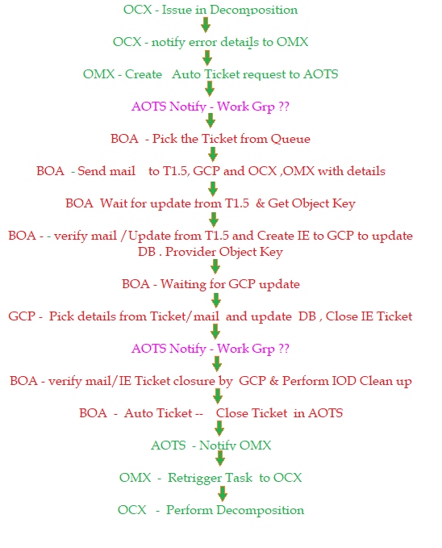

Query to perform IOD clean up :

delete from OCX_SVCS.IOD_TYPE_MAP where entity_id in (select order_action_number from OCX_SVCS.IOD_ORDER_ACTION_DETAILS where SOR_ID in ('1-BYL1YLP'));

delete from OCX_SVCS.IOD_TYPE_MAP where entity_id in (select service_group_id from OCX_SVCS.IOD_SERVICE_GROUP_DETAILS where SOR_ID in ('1-BYL1YLP'));

delete from OCX_SVCS.IOD_TYPE_MAP where entity_id in (select ocx_project_id from OCX_SVCS.IOD_PROJECT_DETAILS where FORIEGN_SOR_ID in ('1-BYL1YLP'));

-- 2) Clean up IOD_PROJECT_DETAILS table

delete from OCX_SVCS.IOD_PROJECT_DETAILS where FORIEGN_SOR_ID in ('1-BYL1YLP');

--3) Clean up IOD_SERVICE_GROUP_DETAILS table

delete from OCX_SVCS.IOD_SERVICE_GROUP_DETAILS where SOR_ID in ('1-BYL1YLP');

--4) Clean up IOD_ORDER_ACTION_DETAILS table

delete from OCX_SVCS.IOD_ORDER_ACTION_DETAILS where SOR_ID in ('1-BYL1YLP');

--5) Clean up IOD_PROJECT_HIERARCHY table

delete from OCX_SVCS.IOD_PROJECT_HIERARCHY where FOREIGN_SOR_ID in ('1-BYL1YLP');

commit;