1. Initiate Supp for the order from OCX CRM UI

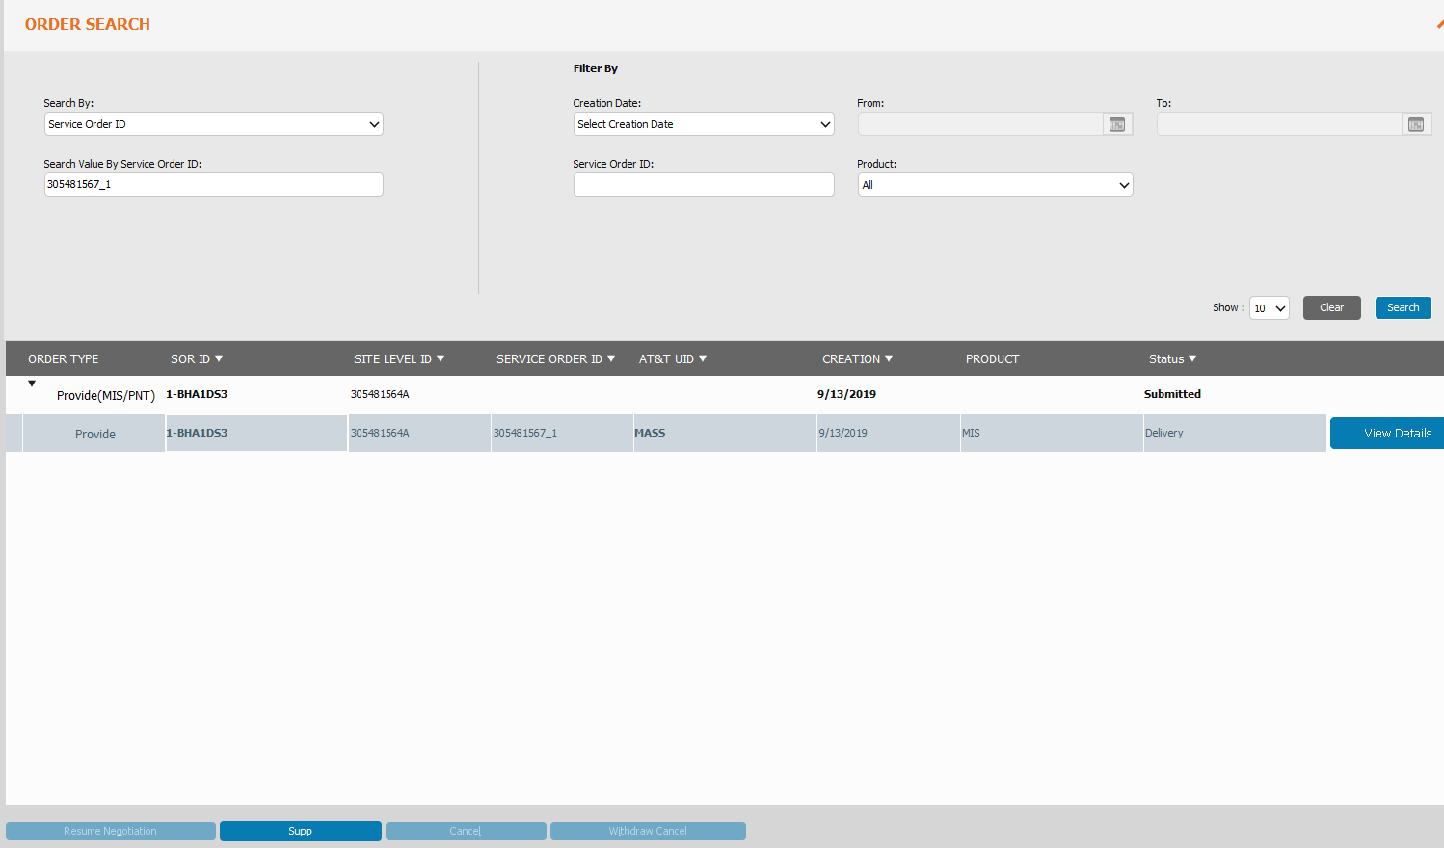

1. Click on Connection Tab and add notes in CPE. This is important for the order to flow properly in CAMO.

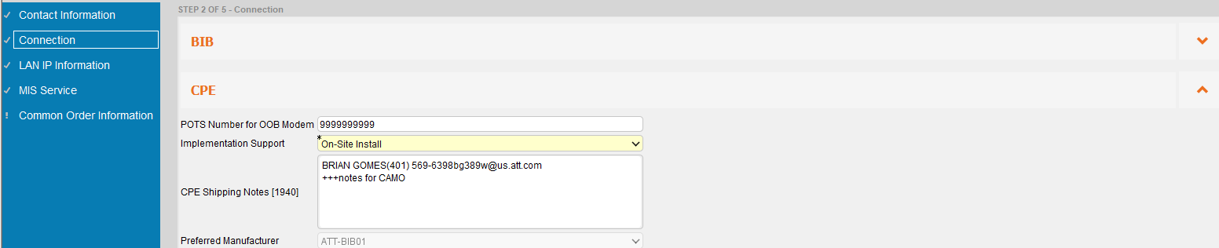

Note: Don’t make changes to existing notes. Just add notes .

1. Run Below query in OCX OMS DB:

select order_action_id,status,state,service_type,POCX_OMSOWN.GET_ATR_VALUE(ITEM_ATRS_LIST,'accountNumber'),item_def_id,item_atrs_list, t.*

from POCX_OMSOWN.tbap_item t

where

order_action_id in (select order_unit_id from POCX_OMSOWN.tborder_Action

where order_id in ('305481564') ---This is order_id and not order_number

)

and upper(t.ITEM_ATRS_LIST) like '%MOBILITY%';

(MOBILITY is part of the Customer Name that’s long)

/* ITEM_ATRS_LIST

effectiveDate++DT;contractEndDate++DT;contractedBusinessName+AT&T Mobility formerly known as Cingular Wireless ad Delaware limited liability;contractIdentifier+;accountBranch+;leadCountry+;customerType+Domestic;contractTerm+;ctNumber+MIS418607;contractStartDate++DT;documentId+

leadCountry+;contractedBusinessName+AT&T Mobility formerly known as Cingular Wireless ad Delaware limited liability;contractEndDate++DT;effectiveDate++DT;contractStartDate++DT;contractIdentifier+;contractTerm+;customerType+Domestic;documentId+;accountBranch+;ctNumber+MIS418607

*/

1. Run below update:

set define off;

update POCX_OMSOWN.TBAP_ITEM set ITEM_ATRS_LIST=replace(ITEM_ATRS_LIST,'AT&T Mobility formerly known as Cingular Wireless ad Delaware limited','AT&T Mobility Cingular Wireless Delaware Ltd')

where

order_action_id in (select distinct order_unit_id from POCX_OMSOWN.tborder_action

where order_id ='305481564')

and ITEM_ATRS_LIST like '%AT&T Mobility formerly known as Cingular Wireless ad Delaware limited%';

commit;

Highlighted part should be meaningful Customer Name that is less than 64 chars.

1. Submit the order from OCX CRM UI.

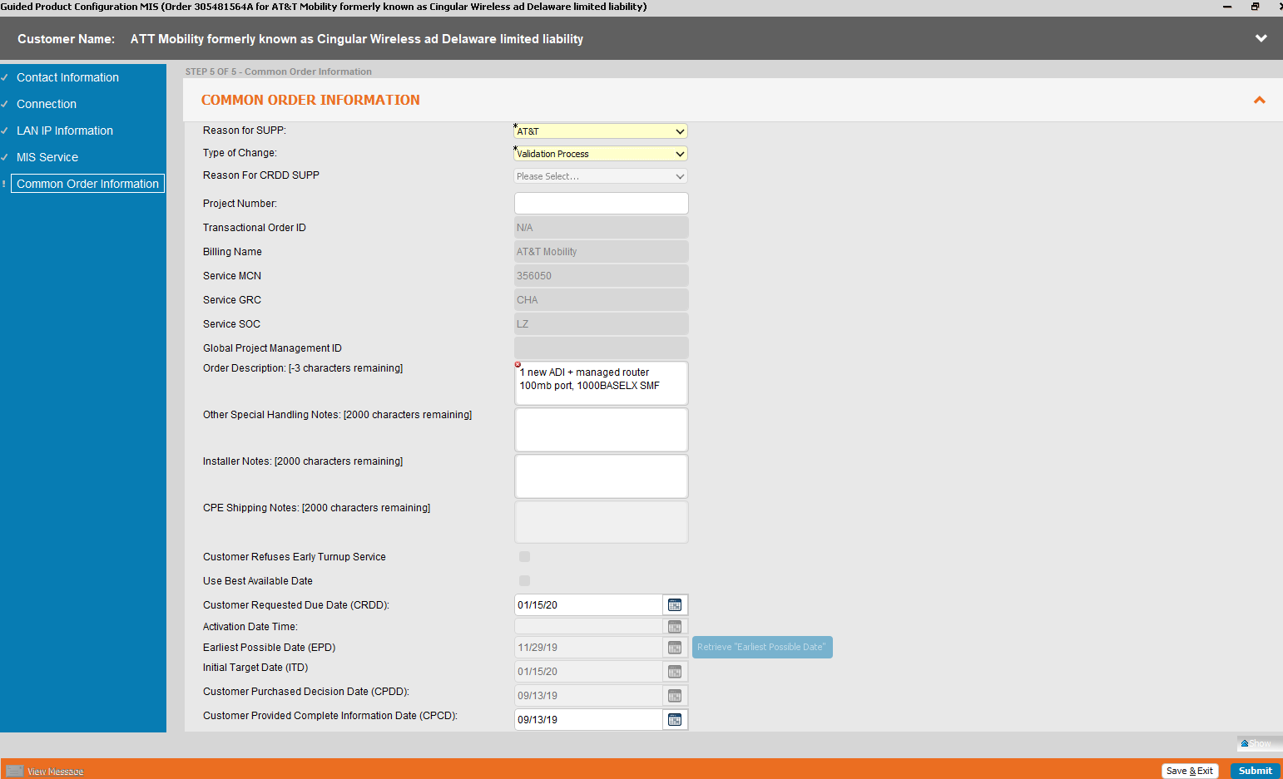

You will get

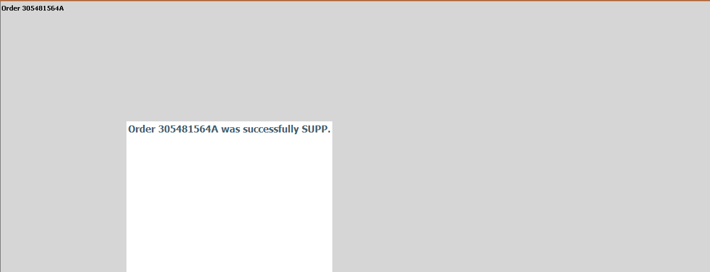

If you search the order again, you’ll see the version number incremented.

1. Go to OMX, You’ll see below task

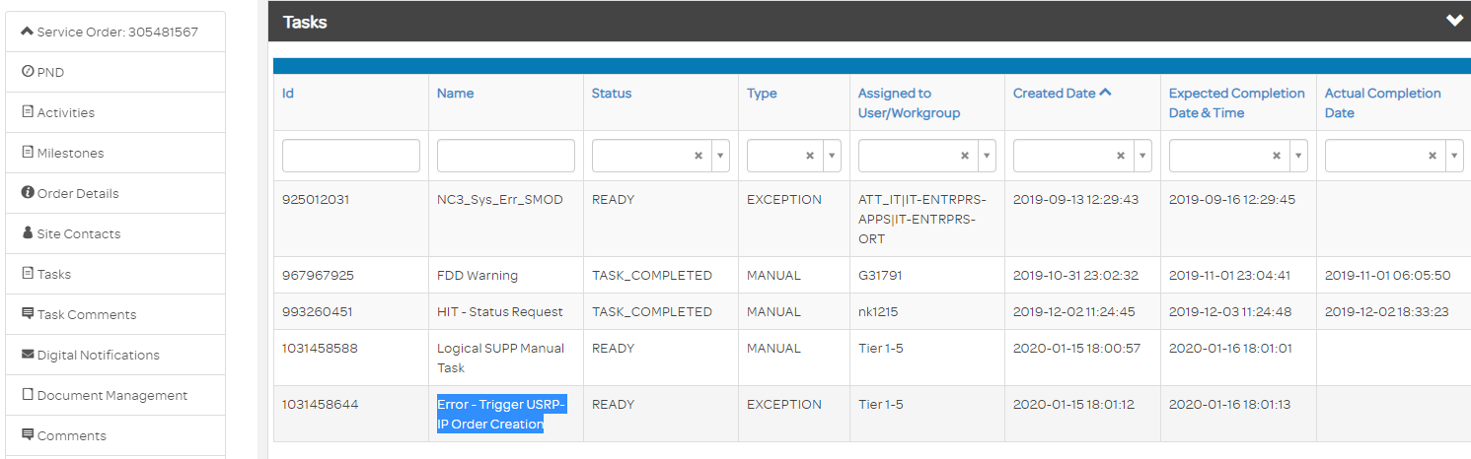

1. Mark the task to Complete

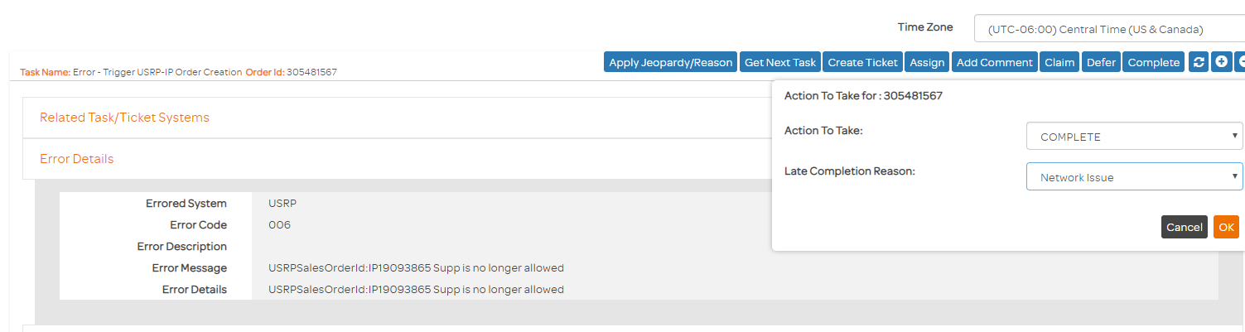

1. Run Below query in OMX DB

select substr(sc.name,17,9),ai.plan_id || '_' || ai.id || '_' || ai.rework_counter,entity_name,actual_start_date,actual_end_date,ai.plan_id,ai.id,spec_ver_number,error_id,ai.state,ai.status,spec_ver_id,last_update_date

from

REFUSER_HALO.OSS_REF_ATTRIBUTE@p1c1d341 ra,

REFUSER_HALO.oss_ref_data@p1c1d341 rd ,

affuser_halo.oss_activity_instance@p1c1d341 ai,

affuser_halo.sc_project_order_instance@p1c1d341 sc

where

ra.ENTITY_ID = rd.ENTITY_ID

and ai.SPEC_VER_ID = ra.ATTRIBUTE_VALUE

and ai.plan_id =sc.plan_id

and sc.name in ('OCX_OrderAction_305481567')

)

and entity_name like '%Provision Equipment%'

order by 1;



1. Choose the selected field and search in OMX AVOS.

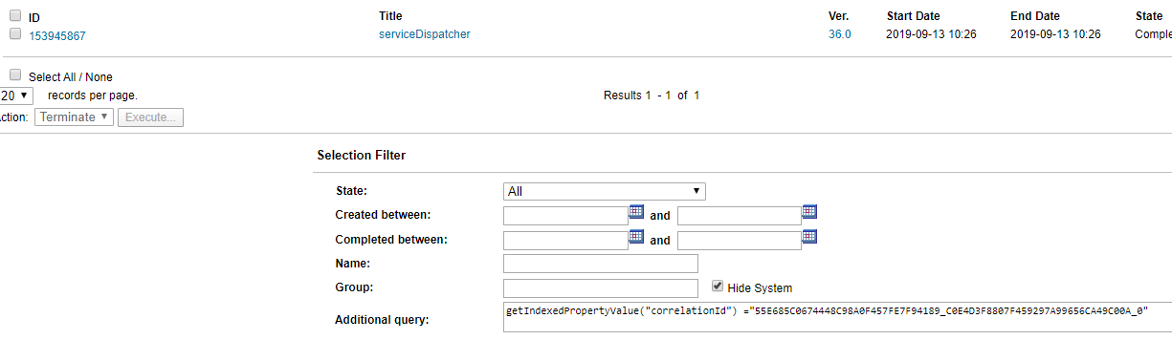

1. From the Service Dispatcher, take the Service Request and execute that from SOAP UI ensuring that version is the current one.

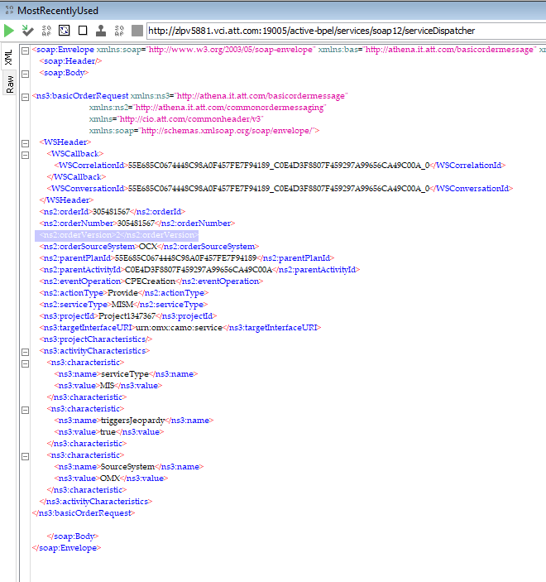

1. Now goto CAMO AVOS and search the order

getIndexedPropertyValue("orderid") ="305481567"

You should see a below process initiated.

CamoMISSuppOrderFlowManager

1. Hit refresh before checking the task . If the order does not encounter any deadlock in CAMO, you will see a Create EOL task for the order in OMX UI.



