

Hi

* OMX Clean up:

For USRP issues,

OMX clean up is done in newton_app.usrp_intf_request table in OMX IM DB.

Validate that the status of the orders is not Success. If Success, it mean that USRP Order Id is already created. For those orders, you can notify USRP about the same

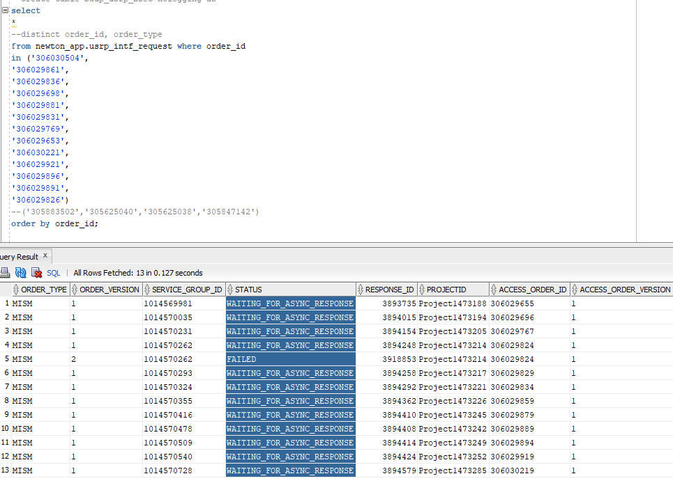

                Delete and Commit.

                delete from newton_app.usrp_intf_request where order_id in

('306030504');

              Commit;

                This completes OMX cleanup.

* OCX Bulk Supp (Queries should be run on OCX OMS DB – SID p1cy2d24)
  + Run the attached query separating the orders by comma

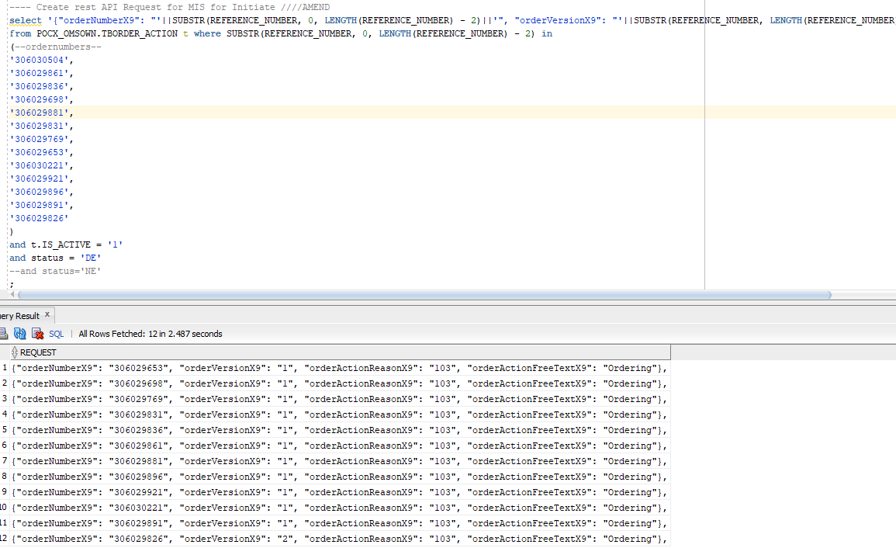

Paste the output to AMEND REST API

End point : <http://ocx-api.it.att.com:12381>

Resource : /rp-webapp-9/ordering/AmendOrderAction

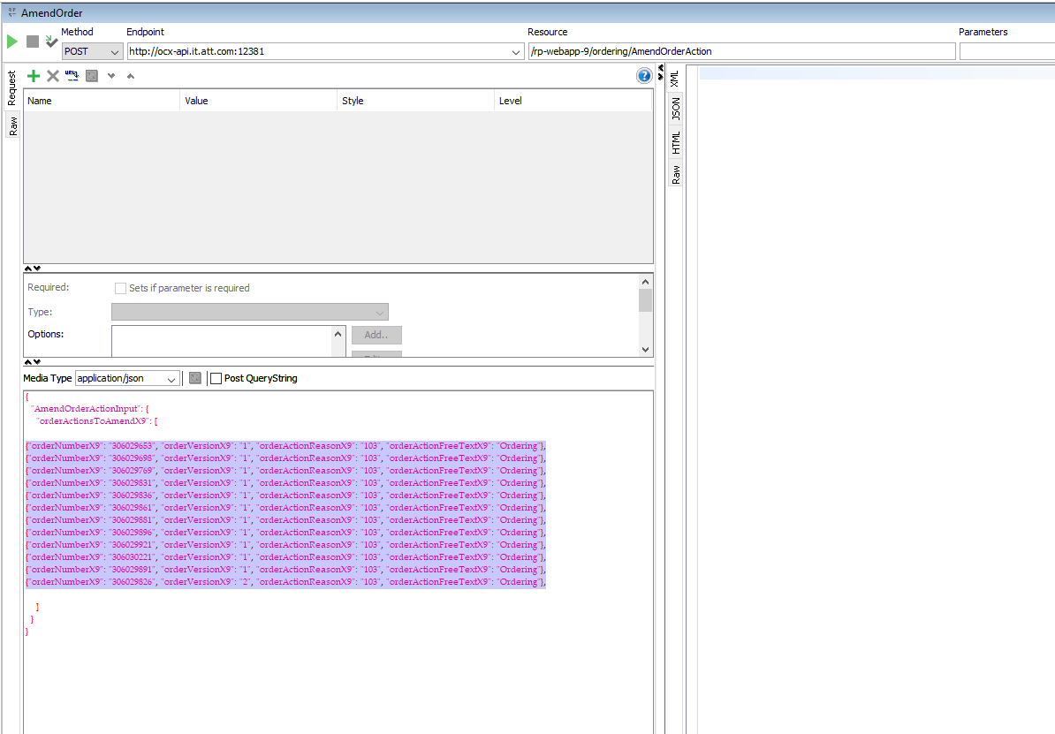

If there are large number of orders, you could see a time-out error. It does not mean that the request did not go through, it just means that the connection could not stay open until the responses could be received.

If you use the next query in OCX OMS DB, you will notice that supp has been initiated.

Run the Submit portion of the attached query and paste the result in the SUBMIT REST call.

End point : <http://ocx-api.it.att.com:12381>

Resource: /rp-webapp-9/ordering/SubmitOrderAction

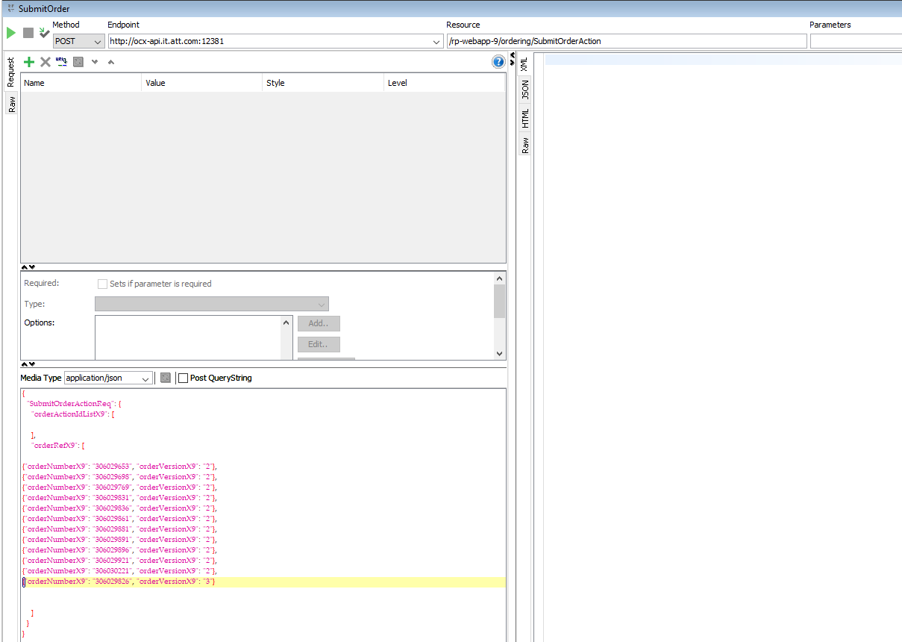

Like Amend, you could get a time out error here.

                                Please ensure that the last comma (,) is removed before submitting any API.

                                Submit API will take longer than Amend. The query can be run to check how many are pending to be submitted.

                Validate a few orders in OMX and in OCX UI that you notice an increment in version number.

For this issue, I have done both OMX and OCX WA.

Closing out both these USH:

000000273162041

000000272874997

Regards

**Aanjo Premlal**

Software Development Specialist

Production Services Group, AT&T Division

+1.972.207.2351 (mobile)  
+1.972.308.3293 (office)

amdocs-a

Follow us on [Facebook](https://urldefense.proofpoint.com/v2/url?u=http-3A__www.facebook.com_amdocs_&d=DwMFAg&c=LFYZ-o9_HUMeMTSQicvjIg&r=0uFu1B4GO_aRIDW9mQkDzMP0UGwY_shthoUAqaZ1qk4&m=8gaEj0dPBKNVum1mJ4ptTkpig3V1Vic8fTI7aX4wMa8&s=oOnX4sWhOKprMiLMMKpFzcbXU-C7-gDtIr-qO-o8bNI&e=), [Twitter](https://urldefense.proofpoint.com/v2/url?u=http-3A__twitter.com_amdocs&d=DwMFAg&c=LFYZ-o9_HUMeMTSQicvjIg&r=0uFu1B4GO_aRIDW9mQkDzMP0UGwY_shthoUAqaZ1qk4&m=8gaEj0dPBKNVum1mJ4ptTkpig3V1Vic8fTI7aX4wMa8&s=ZvsvkalBDuCy78eaC9_rpBOnnqMhej_KAFMAap_zbew&e=), [LinkedIn](https://urldefense.proofpoint.com/v2/url?u=http-3A__www.linkedin.com_company_amdocs&d=DwMFAg&c=LFYZ-o9_HUMeMTSQicvjIg&r=0uFu1B4GO_aRIDW9mQkDzMP0UGwY_shthoUAqaZ1qk4&m=8gaEj0dPBKNVum1mJ4ptTkpig3V1Vic8fTI7aX4wMa8&s=98UVh-i78paTRAZoCm2m3_xVaDWG8LgEeg7YsN5yOCk&e=), [YouTube](https://urldefense.proofpoint.com/v2/url?u=http-3A__www.youtube.com_amdocsinc&d=DwMFAg&c=LFYZ-o9_HUMeMTSQicvjIg&r=0uFu1B4GO_aRIDW9mQkDzMP0UGwY_shthoUAqaZ1qk4&m=8gaEj0dPBKNVum1mJ4ptTkpig3V1Vic8fTI7aX4wMa8&s=4U8j-S_KLw3u8x2y5ZBTaKjXwLICJTaTFPsKm9zBNzU&e=), [Google+](https://urldefense.proofpoint.com/v2/url?u=https-3A__plus.google.com_105657940751678445194&d=DwMFAg&c=LFYZ-o9_HUMeMTSQicvjIg&r=0uFu1B4GO_aRIDW9mQkDzMP0UGwY_shthoUAqaZ1qk4&m=8gaEj0dPBKNVum1mJ4ptTkpig3V1Vic8fTI7aX4wMa8&s=VZhqb0VyVs7WKdF3d_a5bBrypZUCmzJ-97uKWPLdleg&e=) and the [Amdocs blog network](https://urldefense.proofpoint.com/v2/url?u=http-3A__blogs.amdocs.com_&d=DwMFAg&c=LFYZ-o9_HUMeMTSQicvjIg&r=0uFu1B4GO_aRIDW9mQkDzMP0UGwY_shthoUAqaZ1qk4&m=8gaEj0dPBKNVum1mJ4ptTkpig3V1Vic8fTI7aX4wMa8&s=yRq2c77MlF6LqKJ0T7IccWFytCUwQ_cwyPQg3PPNvOM&e=).