第二次作业

一、主要功能

指纹验证识别

二、代码实现

def sift_match(img_A, img_B):

    sift = cv.SIFT_create()

    kp1, des1 = sift.detectAndCompute(img_A, None)

    kp2, des2 = sift.detectAndCompute(img_B, None)

    bf = cv.BFMatcher()

    matches = bf.knnMatch(des1, des2, k=2)

    good_matches = []

    for m, n in matches:

        if m.distance < 0.7 * n.distance:

            good_matches.append(m)

    if len(good_matches) > 500:

        return True

    else:

        return False

def main_1():

    img_template = cv.imread('./0417dataset/DB1_B/101_7.tif')

    img_A = cv.imread('./0417dataset/DB1_B/101_6.tif')

    img_B = cv.imread('./0417dataset/DB1_B/103_7.tif')

    if sift_match(img_template, img_A):

        print("source_A Successful authentication!")

    else:

        print("source_A Failed authentication!")

    if sift_match(img_template, img_B):

        print("source_B Successful authentication!")

    else:

        print("source_B Failed authentication!")

    plt.subplot(131)

    plt.imshow(img_template)

    plt.title('Template')

    plt.axis('off')

    plt.subplot(132)

    plt.imshow(img_A)

    plt.title('Source_A')

    plt.axis('off')

    plt.subplot(133)

    plt.imshow(img_B)

    plt.title('Source_B')

    plt.axis('off')

main_1()

三、运行结果

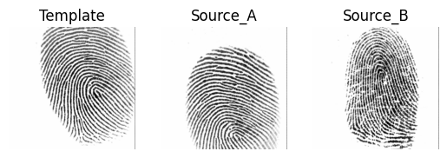

source_A Failed authentication!

source_B Failed authentication!