Unzip the tapping.zip, enter chrome://extensions/ to load unpacked folder tapping
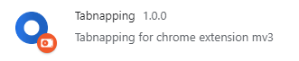
Open a new website
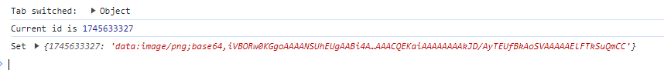
It will detect that we switch to a new tab. It will save the screenshot with tab id every 10 seconds in to local storage.
If after 10 seconds, user still remain on this tab and don’t switch to others, it will update the newest to the local storage. (Only store the newest screenshot to this tab)
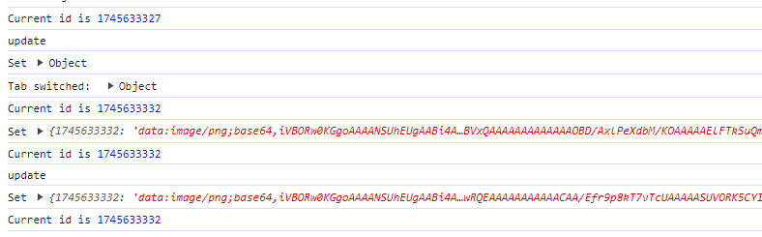Now open a new tab and it has been 10 seconds after the last, it will save the newest screenshot for this tab with it’s own tab id. And also available to update.
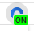The icon will be this if nothing happen (haven’t return to the previous visited tab)
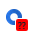If we return to the previous visited tab. The icon will show like this to alert visited.
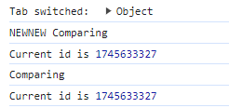
Detect the tab, And trying to comparing with the saved screenshot and the screenshot we take when come back.
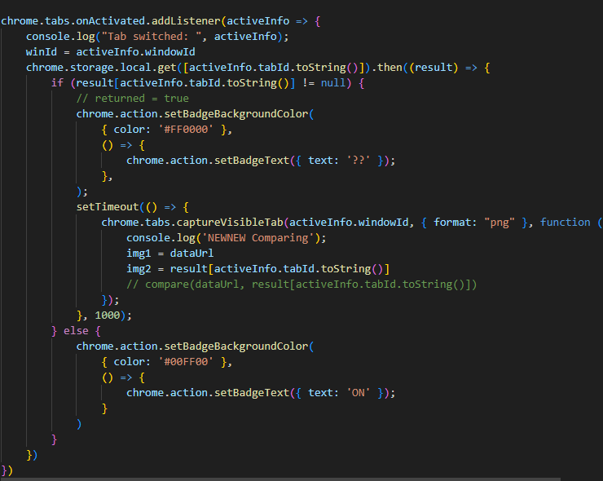

Now click the See Result to send those two pictures to popup.js to calculate and show on the popup 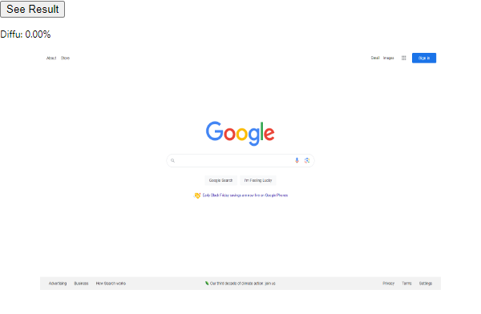
Will show we don’t do anything for this tab
Do anything like click the link and click other tab then come back to see result. Highlight the diff
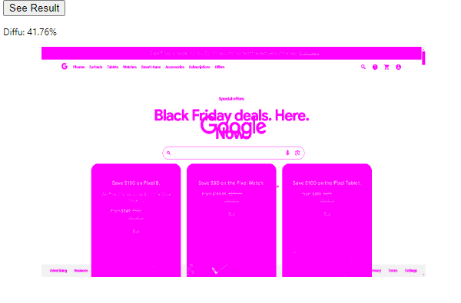After 10 seconds, if we still remain on the tab, it will update the newest screenshot and change the icon back to 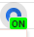
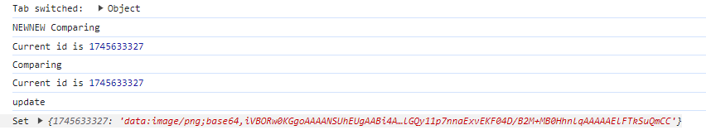
If it’s right now, open a new tab, it will change to
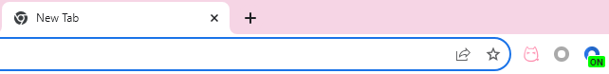
See Result are only available when user turn back to the tab he’s visited

