**《数据库原理》实验报告**

# 实验二（第5次实验 实验名称 ：复合查询及视图操作）

专 业 软件工程

班 级 1班

学 号　 202010804003

学生姓名 肖洋

指导老师 周朝萱老师

数学与计算机学院

2021年 11月 5 日

**一、实验目的 （必须手写）**

**二、实验内容**

在数据库STUDB中利用SQL查询分析器，执行结构化查询语句的SELECT语句，完成连接、嵌套等复合查询语句。

在数据库STUDB中，用图形化操作和SQL命令，完成创建视图、修改视图、删除视图操作

**三、实验环境**

SQL Server2008

**四、程序源码与运行结果**

**（一）**

Select * from student,course

Select * from student,sc where student.sno=sc.sno

select student.*,cno,mark from student,sc

select s.sno,sname,mname,deptname,cname,mark from student s,major m,dept d,course c,sc

where s.mno=m.mno and m.deptno=d.deptno and c.cno=sc.cno and s.sno=sc.sno

and sex='女'

select s.sno,sname,avg(mark) from student s,sc

where s.sno=sc.sno group by s.sno,sname

select s.sno,sname,avg(isnull(mark,0)) from student s join sc on s.sno=sc.sno group by s.sno,sname

select s1.sno,s2.sno,cname,s1.mark from student s,sc s1,sc s2,course c where s.sno=s1.sno and s1.sno!=s2.sno and

s1.cno=s2.cno and s1.mark=s2.mark and s2.cno=c.cno

select * from student where sno in (select sno from sc group by sno having count(*)>3)

select * from student where sno in (select sno from(select sno,count(sno)cnt from sc group by sno)tp where cnt>3)

select sno,sname,sex,birth,mname,deptname from student s,major m,dept d where s.mno=m.mno and m.deptno=d.deptno

order by deptname,mname,sno

select sno,sname,sex,birth,mname,deptname from student s join major m join dept d on d.deptno=m.deptNO on m.MNO=s.MNO

order by deptname,mname,sno

select s.sno,sname,mark from student s left join sc on sc.sno=s.sno

select c.cno,cname,sc.* from sc right join course c on c.cno=sc.cno

select deptname,count(sno) from dept d left join (select sno,deptno from major m,student s where m.mno=s.mno)tp on tp.deptno=d.deptno

group by deptname

select sno ,sname,c.cno,cname,mark from (select s.sno,sname,cno,mark from student s left join sc on s.sno=sc.sno)tp full join course c on c.cno=tp.cno

select mname,max(isnull(mark,0)),min(isnull(mark,0)) from major m,student s,sc,course c

where m.mno=s.mno and s.sno=sc.sno and sc.cno=c.cno and cname = '数据库原理' and mname in ('网络工程','软件工程','计算机科学与技术')

group by mname

select mname,cname,max(isnull(mark,0)),min(isnull(mark,0)) from major m,student s,sc,course c

where m.mno=s.mno and s.sno=sc.sno and sc.cno=c.cno and cname = '数据库原理' and mname in ('网络工程','软件工程','计算机科学与技术')

group by mname,cname

select s.sno,sname,sex,mname,deptname,cname,mark

from dept d,major m,student s,course c,sc

where d.deptno=m.deptno and s.mno=m.mno and s.sno=sc.sno and sc.sno=c.cno

select s.sno,sname,mname,deptname,cname,mark

from student s,dept d,sc,major m,course c

where d.deptno=m.deptNO and m.MNO=s.MNO and s.sno=sc.sno and c.cno=sc.cno

and mark>all(select mark from sc,major m2,student s,course c

where s.mno=m.mno and s.sno=sc.sno and c.cno=sc.cno and m.mno=m2.mno and sex='女' and cname='数据库原理')

and sex='男' and cname='数据库原理'

select s.sno,sname,mname,deptname,cname,mark

from student s,dept d,sc,major m,course c

where d.deptno=m.deptNO and m.MNO=s.MNO and s.sno=sc.sno and c.cno=sc.cno

and mark>(select isnull(max(mark),0) from sc,major m2,student s,course c

where s.mno=m.mno and s.sno=sc.sno and c.cno=sc.cno and m.mno=m2.mno and sex='女' and cname='数据库原理')

and sex='男' and cname='数据库原理'

select s.sno,sname,cname,mark from student s,course c,sc where s.sno=sc.sno and c.cno=sc.cno and

mark >(select isnull(avg(mark),0) from sc sc2 where sc.cno=sc2.cno)

select * from student s where mno in(select mno from major m1 where deptno

in(select m.deptno from dept d2,student s,major m where sname='张三' and d2.deptno=m.deptNO and s.mno=m.mno))

select * from student s where exists(select mno from major m1 where deptno

in(select m.deptno from dept d2,student s,major m where sname='张三' and d2.deptno=m.deptNO and s.mno=m.mno))

select sno,sname from student s where sno in (select s.sno from student s,course c,sc where c.cno=sc.cno and s.sno=sc.sno and cname='数据库原理')

select sno,sname from student s,dept d,major m where deptname='计算机学院' and s.mno=m.mno and d.deptno=m.deptNO

select sno,sname from student s where mno in(select mno from major where deptno in (select deptno from dept where deptname ='计算机学院') )

select s.sno,sname from student s,course c,sc where c.cno=sc.cno and s.sno=sc.sno and cname='数据结构'

intersect

select s.sno,sname from student s,course c,sc where c.cno=sc.cno and s.sno=sc.sno and cname='数据库原理'

SELECT sno,sname FROM student WHERE

sno IN(SELECT sno FROM sc,course c WHERE

sc.cno=c.cno AND cname='数据结构')AND

sno NOT IN(SELECT sno FROM sc,course c WHERE sc.cno=c.cno

AND cname='数据库原理')

24.

SELECT sno,sname,mname FROM student s,major m

WHERE s.mno=m.mno AND sno NOT IN

(SELECT DISTINCT sno FROM sc

WHERE mark<90 or mark IS NULL)AND

sno IN(SELECT DISTINCT sno FROM sc)

SELECT sno,sname,mname FROM student s,major m

WHERE s.mno=m.mno AND NOT EXISTS(SELECT * FROM sc WHERE sno=s.sno AND

(mark<90 OR mark IS NULL)

)AND EXISTS(SELECT*FROM sc WHERE sno=s.sno)

SELECT sno,sname,mname FROM student s,major m

WHERE s.mno=m.mno AND sno NOT IN(

SELECT sno FROM sc WHERE mark < 90 OR mark IS NULL

UNION

SELECT sno FROM student WHERE sno NOT IN

(SELECT sno FROM sc))

SELECT s.sno,sname,cname,mark FROM student s,sc,course c

WHERE s.sno=sc.sno AND sc.cno=c.cno AND

mark>(SELECT avg(isnull(mark,0))FROM sc

WHERE cno=c.cno)

SELECT sno,sname,deptname FROM dept d,major m,student s

WHERE d.deptno=m.deptno AND

m.mno=s.mno AND sno NOT IN (SELECT sno FROM sc)

27.

select sno,sname,mname from major m,student s where m.mno=s.mno and not exists (select * from sc where sno=s.sno and cno='C0005')

SELECT s.sno,sname,count(*)课程门数 FROM student s,sc

WHERE s.sno=sc.sno

GROUP BY s.sno,sname HAVING count(*)>=3

ORDER BY 课程门数 desc,s.sno;

SELECT s.sno,sname,mark FROM student s,sc

WHERE s.sno=sc.sno AND

mno IN (SELECT mno FROM major WHERE deptno=

(SELECT deptno FROM dept

WHERE deptname='计算机学院')

)AND

cno=(SELECT cno FROM course WHERE

cname='数据库原理')

SELECT * FROM student s WHERE NOT EXISTS

(SELECT * FROM course WHERE NOT EXISTS

(SELECT * FROM sc WHERE sno=s.sno

AND cno=course.cno))

SELECT * FROM student WHERE sno IN

(SELECT sno FROM sc GROUP BY sno HAVING

count(DISTINCT cno)=(SELECT count(DISTINCT cno)

FROM course))

SELECT * FROM student

WHERE sno in

(SELECT DISTINCT sno FROM sc sc1 WHERE NOt EXISts

(SELECT cno FROM course except select cno from sc sc2

where sc2.sno=sc1.sno))

SELECT * FROM student WHERE sno IN

(

SELECT DISTINCT sno FROM sc sc1 WHERE NOT EXISTS

(SELECT CNO FROM sc WHERE sno IN

(SELECT sno FROM student WHERE sname ='张三')

EXCEPT

SELECT cno FROM sc sc2 WHERE sc2.sno = sc1.sno)

)

SELECT * FROM student

WHERE NOT EXISTS

(SELECT cno FROM sc scl

WHERE sno IN

(SELECT sno FROM student

WHERE sname='张三')AND

NOT EXISTS

(SELECT cno FROM sc sc2

WHERE sno=student.sno

and cno=scl.cno)

)

select * from student s where sno in (select sno from sc

where cno in (select cno from sc where sno in

(select sno from student where sname='张三')))

（二）

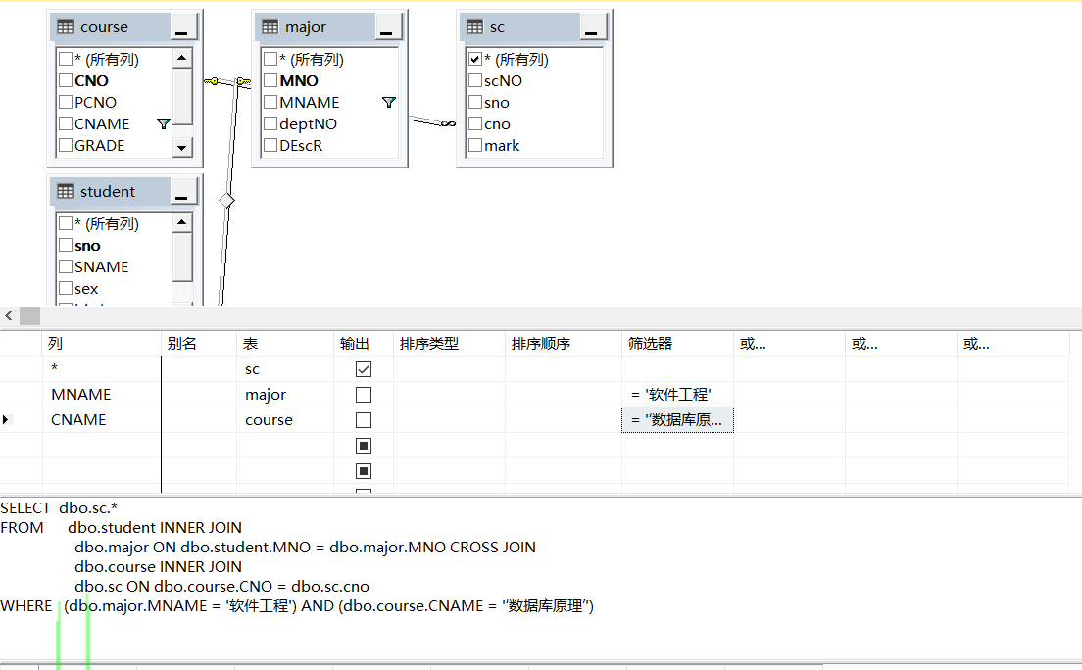

Create view CS_stu(sno,sname,sex,birth,mno,grade,mname)as select s.*,mname from student s,major where s.mno=major.mno and deptno = (select deptno from dept where deptname='计算机学院')

insert into soft_sc (scno,sno,cno,mark) values ('15001','S6001','C0003',89)

插入成功，但在视图中看不见，原表中看得见

insert into CS_stu values('S6002','刘希','男','M1005','软件工程')

视图或函数 'CS_stu' 不可更新，因为修改会影响多个基表

insert into soft_sc values('S6001',90)

列名或所提供值的数目与表定义不匹配。平均值为统计值，不允许更新

update cs_stu set mno='S2003',sex='女' where sname='张三'

成功

update cs_stu set age=30,mname='网络工程' where sname= '张三丰'

修改会影响多个基表

update soft_sc set 平均成绩=平均成绩-5

平均值为统计值，不允许更新

delete from soft_sc where 平均成绩<75

失败：视图中包含聚合函数，无法删除

delete from cs_stu where sname='张三'

失败：cs_stu来自多个表会影响多个表

**五、实验总结 （必须手写）**