Hotel Booking System
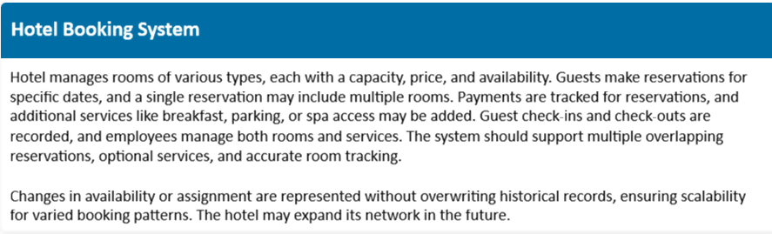
Each table represents a distinct entity or concept, reducing duplication

LOGICAL SCHEME (in separate file and link below)
https://www.drawdb.app/share/NWqZTCUgHguIsl5URfjvzYmE

OBJECTS
Guest table
I’ve started from the guest table. Assuming that every booking is recorded on one guest, no matter how many people will move in.
Document number and type is nullable value, because we need to record the guest when he books the room, but he provides documents only when there is an actual stay.
CONSTRAINT "Guests_unique_0" UNIQUE ("g_document_number", "g_document_type")
Document number and Type are unique, because we may have a customer with an id from one country and the customer with the same number, but it will be a driver license. We accept only id, passport, driver license.
CONSTRAINT chk_doc_type CHECK (g_document_type IN ('id', 'passport', 'driver license')
Guest phone numbers have a specific international format and it is a mandatory field.
NOT NULL CONSTRAINT chk_phone CHECK (g_phone ~ '^\+[1-9]\d{1,13}$')
Field "g_created_at" has default value NOW() to include the time when the row is created.

Rooms table
"room_number" and “hotel_id" are Alternative Key
CONSTRAINT "Rooms_unique_0" UNIQUE ("hotel_id", "room_number")
“r_bed_type" is limited for 3 options:
CONSTRAINT chk_bed_type CHECK r_bed_type IN ('single', 'double', 'both')
We may have only one hotel for now, but with “room_id” and the Hotel table our system is scalable.

Room_pricing_changes table
The table is provided to remain history of pricing with default values
"r_price_valid_from" column provides information about price changing date and time and also is a part of composite PK.
"r_price_valid_from" TIMESTAMPTZ NOT NULL DEFAULT NOW(),
Current price's date_till is 01/01/2099 and is default for the new records:
"r_price_valid_till" TIMESTAMPTZ NOT NULL DEFAULT TO_TIMESTAMP('01-01-2099', 'DD-MM-YYYY')
Those constraints prevent dates overlapping:
CONSTRAINT "Room_pricing_changes_unique_0" UNIQUE ("room_id", "r_price_valid_till")
CONSTRAINT chk_r_price_date CHECK (r_price_valid_till > r_price_valid_from)

Bookings table
Is a central table of a system with many relationships.
-- this fields has impact on view that shows rooms availability
"b_stay_from" TIMESTAMPTZ NOT NULL,
-- this fields has impact on view that shows rooms availability
CONSTRAINT chk_stay_date CHECK (b_stay_till > b_stay_from)
There is a many-to-many relationship between Bookings and Rooms, so I have a separate bridge table Booking_details.
I think creating a View “Room_availability” is needed.
-- availability check: rooms booked in a date range
CREATE INDEX idx_booking_details_room ON "Booking_details" ("room_id");
CREATE INDEX idx_bookings_stay_dates ON "Bookings" ("b_stay_from", "b_stay_till");

Room change mid-stay: set check_out on the current row and insert a new row with the new room_number. Both rows stay, so the full history of the rooms is preserved.

Booking_status table preserves 3NF. Non-key attributes depend on the key, the whole key, and nothing but the key.

Booking_status_history save previous records

Booking_services
There is a many-to-many relationship between Bookings and Services, so we need a bridge table. The table has a composite PK ("booking_id", "service_id").
Assume that some services are counted for person or the guest can use it several times:
"quantity" INTEGER CHECK ("quantity" > 0)
(no need in records with 0 quantity)

Customer_invoices table
Invoice is created at the same time as the corresponding booking is complete. Also we need invoices for the additional bills. Assuming additional bills are paid immediately after invoicing (no need in datetime column in my opinion), while booking invoice can be cancelled at all (column “cancelled_at” added).

Payments table is append-only. Instead of modifying an existing payment, you add a new row. If a payment fails, a separate row is added with the status `failed`, while a retry becomes a new row with the status `completed`. Refunds are also recorded as separate rows with the status `refunded`. So no data is overwritten.
Pay methods are limited:
CONSTRAINT chk_pay_method CHECK (payment_method IN ('card', 'cash', 'other')

Payment_statuses table preserves 3NF.

Services table preserves 3NF.

Additional_services_pricing works the same way as the Room_pricing_changes table.

Actual_stays
The table is needed for check_in-check_out time tracking and information about booking realising and completing.
CHECK (check_out IS NULL OR check_out > check_in)
Only one open stay per room requires unique index:
CREATE UNIQUE INDEX uq_one_open_stay_per_room ON actual_stays (room_id) WHERE check_out IS NULL;

Employees
We have a self-referential relationship on this table (manager_id=>employee_id). This table gives surface information about employees responsible for bookings and services. Employees may need a separate data mart with detailed information about working hours, positions, responsibilities, salaries etc.

SQL code draft is provided in a separate file. All information about FKs is provided there and on the diagram.

DEFINITIONS & ACRONYMS

Cardinalities
- Hotels – Rooms: One hotel has many rooms; each room belongs to one hotel.
- Guests – Bookings: One guest can have many bookings; each booking belongs to one guest.
- Bookings – Booking_details – Rooms: A booking can include multiple rooms, and a room can appear in multiple bookings. Each detail belongs to one booking and one room.
- Bookings – Actual_stays: A booking can have multiple stay records; each stay belongs to one booking. A booking may have no actual stay yet.
- Rooms – Actual_stays: One room can have many stay records over time; each stay refers to one room.
- Bookings – Customer_invoices: A booking can have an invoice or none; each invoice belongs to one booking.
- Customer_invoices – Customer_payments: One invoice can have multiple payments; each payment belongs to one invoice.
- Bookings – Booking_status_history: One booking can have many status history records; each record belongs to one booking and one status.
- Bookings – Employees: One employee can handle many bookings; each booking has one responsible employee.
- Employees – Employees: One manager can supervise multiple employees; an employee can have one manager or none.
- Employees – Hotels: One hotel can have many employees; each employee belongs to one hotel.
- Bookings – Booking_services – Services: A booking can include multiple services, and a service can be used in multiple bookings.
- Rooms – Room_pricing_changes: One room can have multiple pricing records; each record belongs to one room.
- Services – Additional_services_pricing: One service can have multiple pricing records; each record belongs to one service.

Constraints and indexes
PK (Primary Key): Uniquely identifies each row.
FK (Foreign Key): Ensures references point to existing records.
NOT NULL: Makes a field mandatory.
UNIQUE: Prevents duplicate values or combinations, for example, room numbers within one hotel.
CHECK: Restricts values or enforces conditions, such as valid document types or stay dates.
Indexes: Improve query performance, especially for room availability checks and joins. They do not automatically guarantee data integrity unless unique.

