Cross Browser Compatibility Test Report
Cyber Aggression Detector | Manifest V3 desktop extension

Test objective
Assess extension loading, protection controls, classification, masking, custom lists, logging, dynamic scanning, and settings persistence in Google Chrome, Microsoft Edge, Brave, and Opera. Results below are tester-recorded observations, not inferred from browser launch success.

Testing environment
Field | Recorded value
Test date | 2026-09-13
Tester | Cyryl Palisoc
Operating system reported by tester | Microsoft Windows 11 Pro; version 10.0.26200; build 26200; 64-bit
Operating system detected | Microsoft Windows 11 Pro; version 10.0.26200; build 26200; 64-bit
Extension version reported by tester | 1.0.0
Extension version detected | 1.0.0
Inventory capture time | 2026-09-13T06:43:37.2849796Z
Run identifier | 4f2de55d-9ee6-4fa5-a4d0-8f4c307accca
Required configuration | Hybrid 60% Naive Bayes / 40% VADER; threshold 0.50

Overall results
Browser | Passed | Failed | Not Tested | Overall
Google Chrome | 12 | 0 | 0 | Passed
Microsoft Edge | 12 | 0 | 0 | Passed
Brave | 12 | 0 | 0 | Passed
Opera | 12 | 0 | 0 | Passed
Passed requires all 12 required tests to be Passed. Any Failed item produces Failed. Otherwise the overall result is Not Tested, including partially completed testing. Screenshot availability is reported separately; a screenshot alone does not prove a test passed.

Browser versions and installation records
Browser | Product version | File version | Installed
Google Chrome | 153.0.8010.36 | 153.0.8010.36 | True
Microsoft Edge | 153.0.4234.32 | 153.0.4234.32 | True
Brave | 153.1.95.101 | 153.1.95.101 | True
Opera | 135.0.5973.92 | 135.0.5973.92 | True

Google Chrome
Executable: C:\Program Files\Google\Chrome\Application\chrome.exe
Launch record: Launch requested (functionality not tested)

Microsoft Edge
Executable: C:\Program Files (x86)\Microsoft\Edge\Application\msedge.exe
Launch record: Launch requested (functionality not tested)

Brave
Executable: C:\Program Files\BraveSoftware\Brave-Browser\Application\brave.exe
Launch record: Launch requested (functionality not tested)

Opera
Executable: C:\Users\ADMIN\AppData\Local\Programs\Opera\opera.exe
Launch record: Launch requested (functionality not tested)

General observations and data checks
No evidence provided
No input inconsistencies were identified by the report generator. This does not independently verify the submitted observations.

Google Chrome detailed results
Overall: Passed. Passed: 12; Failed: 0; Not Tested: 0.
Required test | Recorded result
1. Extension loaded successfully. | Passed
2. Protection toggle worked. | Passed
3. Hybrid mode operated using 60% Naive Bayes and 40% VADER. | Passed
4. Aggressive text was detected and blurred. | Passed
5. Safe text remained visible. | Passed
6. Eye icon revealed the filtered text. | Passed
7. Eye icon re-blurred the revealed text. | Passed
8. Blocklist term ugly triggered filtering. | Passed
9. Whitelist term super remained visible. | Passed
10. Detection logs and statistics updated correctly. | Passed
11. Dynamically added text was scanned. | Passed
12. Settings changes were applied after the active tab reloaded. | Passed

Observations and encountered problems
No evidence provided

Google Chrome screenshot evidence
Figure 1. Google Chrome compatibility overview. Submitted file: Chrome_Compatibility_Test.png. Image supplied by the tester; authenticity and coverage require review.
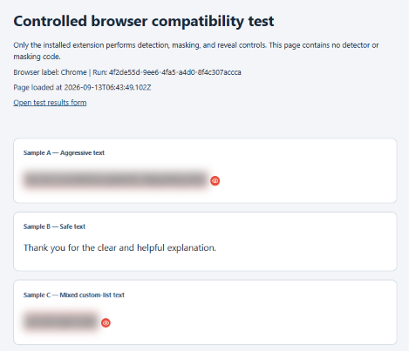

Microsoft Edge detailed results
Overall: Passed. Passed: 12; Failed: 0; Not Tested: 0.
Required test | Recorded result
1. Extension loaded successfully. | Passed
2. Protection toggle worked. | Passed
3. Hybrid mode operated using 60% Naive Bayes and 40% VADER. | Passed
4. Aggressive text was detected and blurred. | Passed
5. Safe text remained visible. | Passed
6. Eye icon revealed the filtered text. | Passed
7. Eye icon re-blurred the revealed text. | Passed
8. Blocklist term ugly triggered filtering. | Passed
9. Whitelist term super remained visible. | Passed
10. Detection logs and statistics updated correctly. | Passed
11. Dynamically added text was scanned. | Passed
12. Settings changes were applied after the active tab reloaded. | Passed

Observations and encountered problems
No evidence provided

Microsoft Edge screenshot evidence
Figure 2. Microsoft Edge compatibility overview. Submitted file: Edge_Compatibility_Test.png. Image supplied by the tester; authenticity and coverage require review.
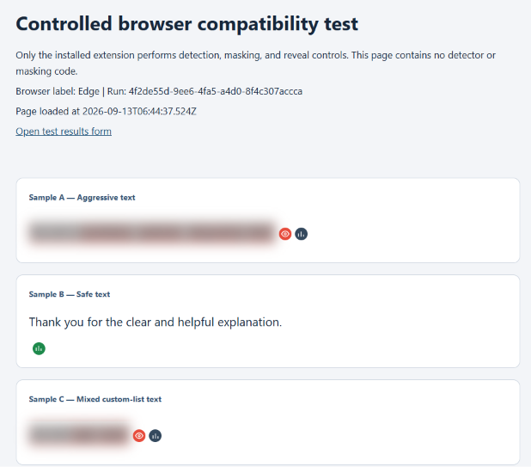

Brave detailed results
Overall: Passed. Passed: 12; Failed: 0; Not Tested: 0.
Required test | Recorded result
1. Extension loaded successfully. | Passed
2. Protection toggle worked. | Passed
3. Hybrid mode operated using 60% Naive Bayes and 40% VADER. | Passed
4. Aggressive text was detected and blurred. | Passed
5. Safe text remained visible. | Passed
6. Eye icon revealed the filtered text. | Passed
7. Eye icon re-blurred the revealed text. | Passed
8. Blocklist term ugly triggered filtering. | Passed
9. Whitelist term super remained visible. | Passed
10. Detection logs and statistics updated correctly. | Passed
11. Dynamically added text was scanned. | Passed
12. Settings changes were applied after the active tab reloaded. | Passed

Observations and encountered problems
No evidence provided

Brave screenshot evidence
Figure 3. Brave compatibility overview. Submitted file: Brave_Compatibility_Test.png. Image supplied by the tester; authenticity and coverage require review.
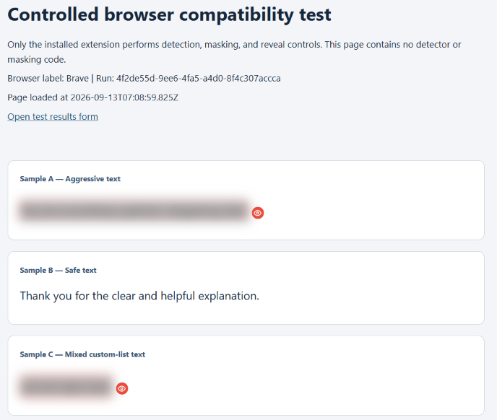

Opera detailed results
Overall: Passed. Passed: 12; Failed: 0; Not Tested: 0.
Required test | Recorded result
1. Extension loaded successfully. | Passed
2. Protection toggle worked. | Passed
3. Hybrid mode operated using 60% Naive Bayes and 40% VADER. | Passed
4. Aggressive text was detected and blurred. | Passed
5. Safe text remained visible. | Passed
6. Eye icon revealed the filtered text. | Passed
7. Eye icon re-blurred the revealed text. | Passed
8. Blocklist term ugly triggered filtering. | Passed
9. Whitelist term super remained visible. | Passed
10. Detection logs and statistics updated correctly. | Passed
11. Dynamically added text was scanned. | Passed
12. Settings changes were applied after the active tab reloaded. | Passed

Observations and encountered problems
No evidence provided

Opera screenshot evidence
Figure 4. Opera compatibility overview. Submitted file: Opera_Compatibility_Test.png. Image supplied by the tester; authenticity and coverage require review.
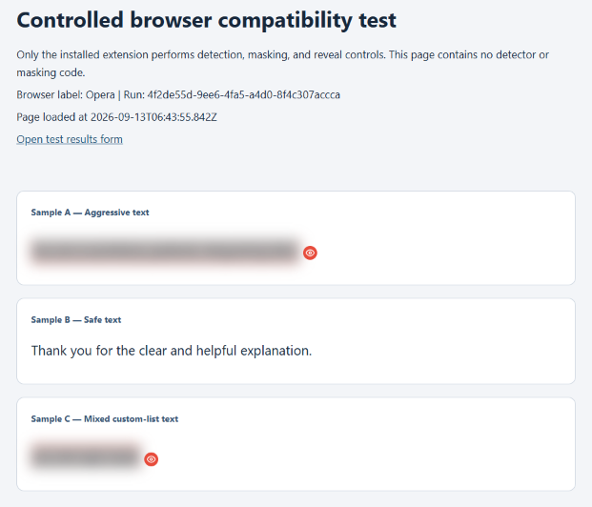

Testing limitations
The scope is limited to the recorded Windows environment and the tested versions of Google Chrome, Microsoft Edge, Brave, and Opera. Results do not establish compatibility with other browsers, operating systems, profiles, or future releases.
This kit automates inventory collection, page serving, browser launch requests, and report formatting. A human must install the actual extension and assess all 12 functional tests. No results are inferred from successful installation or launch.
The controlled page contains a small set of English text samples. It does not measure dataset-level precision, recall, F1-score, general website coverage, multilingual performance, or performance under heavy workloads.
The standard hybrid configuration uses fixed 60/40 weights and a 0.50 threshold. Runtime guards and custom-list overrides are separate behavior; selecting Hybrid alone is insufficient proof of the weighted calculation.
Missing results are Not Tested. Missing, invalid, or unreadable screenshots are No evidence provided. Recorded passes are tester assertions and should be reviewed alongside evidence.
Browser inventories describe executables found on disk. Auto-updates or an already running browser from another installation can differ from that record. Testers must verify the version in the running browser and refresh the inventory if it differs.
Logs and statistics are local to a browser profile and can include other open eligible pages. Close unrelated tabs and reset records before assessing counters. Fixed exact counter totals are not assumed.
The report does not establish statistical significance, universal compatibility, or end-to-end classification quality beyond the recorded checks.

Source traceability
Behavioral procedures were checked against EXTENSION/config.js, manifest.json, content.js, background.js, popup/popup.js, modules/detection_policy.js, and modules/result_display.js. The inventory JSON includes SHA256 hashes of the selected extension files when collected with this kit.
Source file hash records in inventory: 25

