1-1 输出

#include<stdio.h>

int main()

{

printf("hello world\n");

printf("101011901+191027+杨乃宸\n");

return 0;

}

运行结果截图：

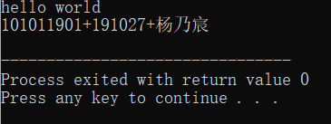

1-2 均值

#include<stdio.h>

int main()

{

int a,b,c;

float avgcj;

printf("请您输入三门课程的成绩\n");

scanf("%d%d%d",&a,&b,&c);

avgcj=(a+b+c)/3.0;

printf("您的三门课程成绩分别为%d、%d、%d\n",a,b,c);

printf("您的平均成绩是%.2f\n",avgcj);

return 0;

}

运行结果截图：

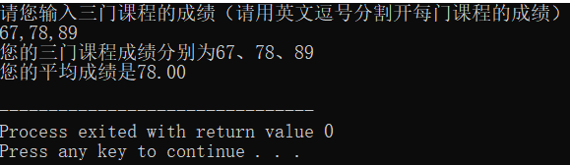

1-3 分段

#include<stdio.h>  
int main()  
{

double eks,y;

printf("请您输入任意一个数字\n");

scanf("%lf",&eks);

if(eks<1)

y=eks

else

{

if(eks>=1&&eks<10)

y=2eks-1;

else

y=3eks-11;

}

printf("您输入的数字为%lf\n",%eks);  
printf("y的值为%lf\n",y);  
return 0;  
}

运行结果截图：

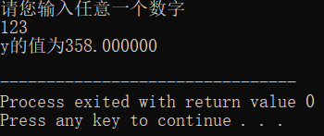

1-4 分级

#include<stdio.h>

int main()

{

int score;

char level;

printf("请您输入学生成绩\n");

scanf("%d",&score);

printf("该生的成绩为%d\n",score);

switch((int)(score/10))

{

case 10:;

case 9:printf("该生分数为A等级\n");break;

case 8:printf("该生分数为B等级\n");break;

case 7:printf("该生分数为C等级\n");break;

case 6:printf("该生分数为D等级\n");break;

case 5:

case 4:

case 3:

case 2:

case 1:

case 0:printf("该生分数为E等级\n");break;

default:printf("deta error!\n");break;

}

return 0;

}

运行结果截图：

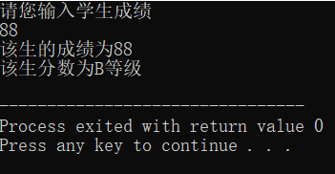

1-5 计算

#include<stdio.h>

int main()

{

int a,b,sum,chu,nokori;

double fuchu;

printf("请您输入任意两个整数\n");

scanf("%d%d",&a,&b);

a=(int)a;

b=(int)b;

printf("您输入的两个整数为%d,%d\n",a,b);

sum=a+b;

chu=a/b;

fuchu=(float)a/b;

nokori=a%b

printf("a+b=%d\n",sum);

printf("a÷b的整数结果是%d\n",chu);

printf("a÷b的带小数结果是%lf\n",fuchu);

printf("a÷b的余数是%d\n",nokori);

return 0;

}

运行结果截图：

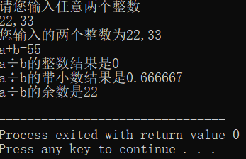

1-6 逆序

#include<stdio.h>

int main()

{

int shuzi,weishu,nxdy,ge,shi,hun,thou,wan;

printf("请您输入一个不多于五位的正整数\n");

scanf("%d",&shuzi);

shuzi=(int)shuzi;

if(shuzi>99999||shuzi<=0)

{

printf("您输入的数字不是一个不多于五位的正整数\n");

}

else

{

printf("您输入的整数为%d\n",shuzi);

wan=(int)(shuzi/10000);

if(wan==0)

{

weishu=4;

}

else

{

weishu=5;

}

thou=(shuzi-wan\*10000)/1000;

if(thou==0)

{

weishu=3;

}

hun=(shuzi-wan\*10000-thou\*1000)/100;

if(hun==0)

{

weishu=2;

}

shi=(shuzi-wan\*10000-thou\*1000-hun\*100)/10;

if(shi==0)

{

weishu=1;

}

ge=shuzi-wan\*10000-thou\*1000-hun\*100-shi\*10;

printf("您输入的整数为%d位数\n",weishu);

if(weishu==5)

{

printf("其万位数为%d\n",wan);

}

if(weishu>=4)

{

printf("其千位数为%d\n",thou);

}

if(weishu>=3)

{

printf("其百位数为%d\n",hun);

}

if(weishu>=2)

{

printf("其十位数为%d\n",shi);

}

if(weishu>=1)

{

printf("其个位数为%d\n",ge);

}

if(weishu==5)

{

ge\*=10000;

shi\*=1000;

hun\*=100;

thou\*=10;

nxdy=ge+shi+hun+thou+wan;

}

if(weishu==4)

{

ge\*=1000;

shi\*=100;

hun\*=10;

nxdy=ge+shi+hun+thou;

}

if(weishu==3)

{

ge\*=100;

shi\*=10;

nxdy=ge+shi+hun;

}

if(weishu==2)

{

ge\*=10;

nxdy=ge+shi;

}

if(weishu==1)

{

nxdy=ge;

}

printf("逆序打印输出的新数字为%d\n",nxdy);

}

return 0;

}

运行结果截图：

