1：安装Jenkins,安装成功之后浏览器会自动打开登陆页面。

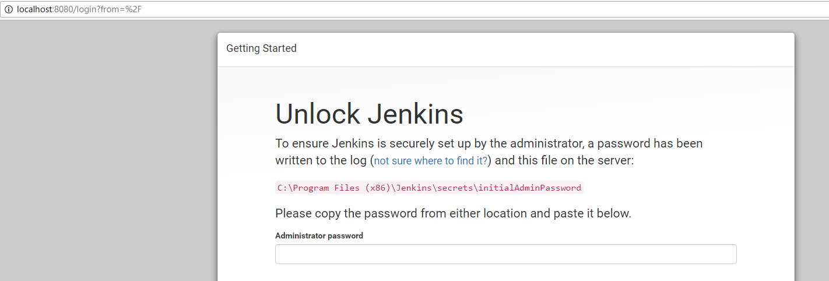

初始密码：在C:\Program Files (x86)\Jenkins\secrets\initialAdminPassword

就是一串随机字符串

dfc3ffb1f92b48b491c5ca9174343e52

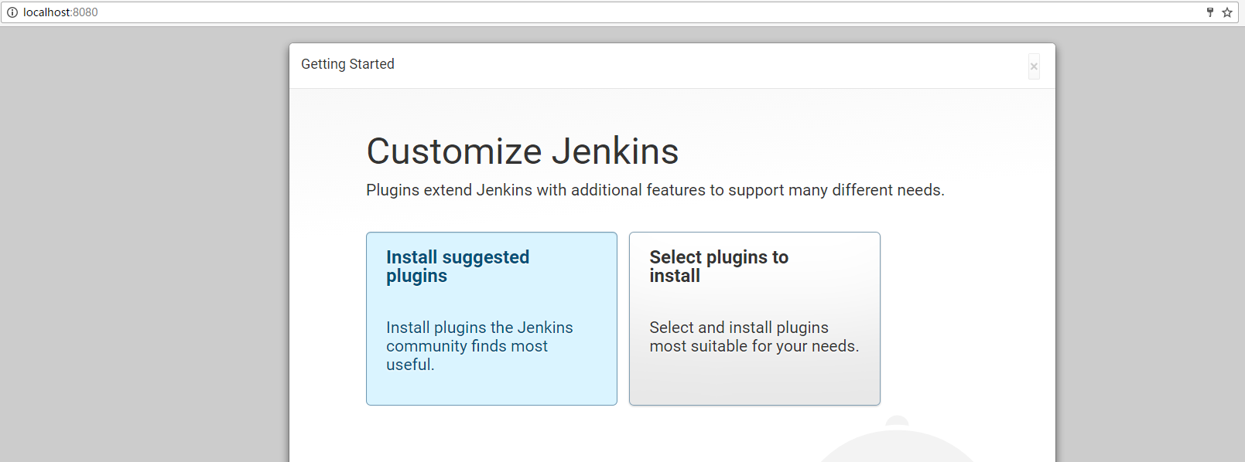

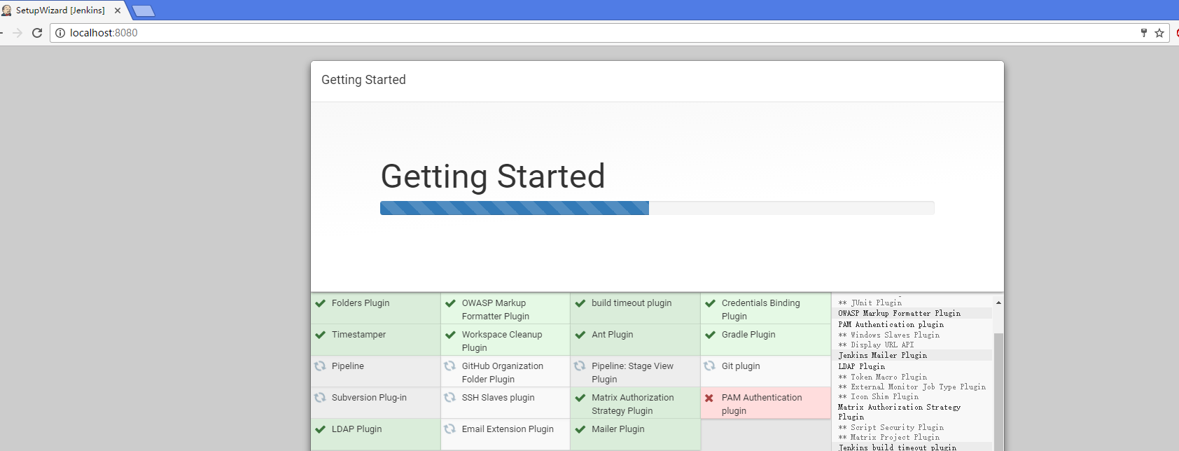

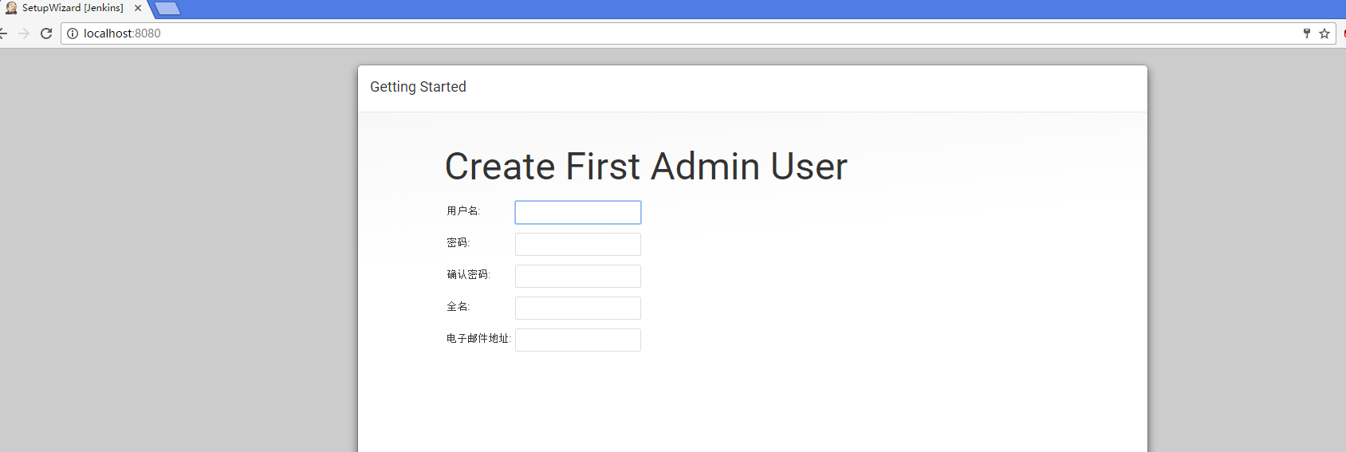

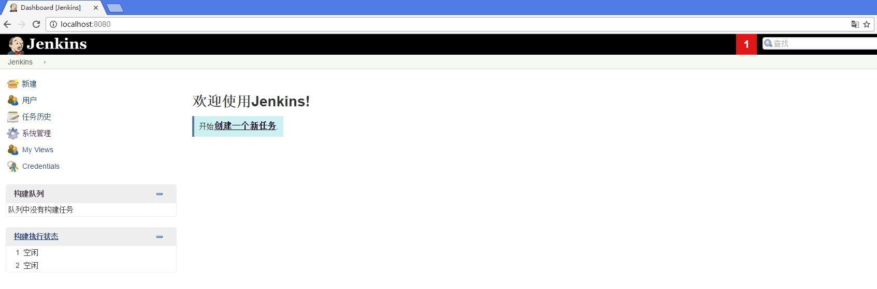

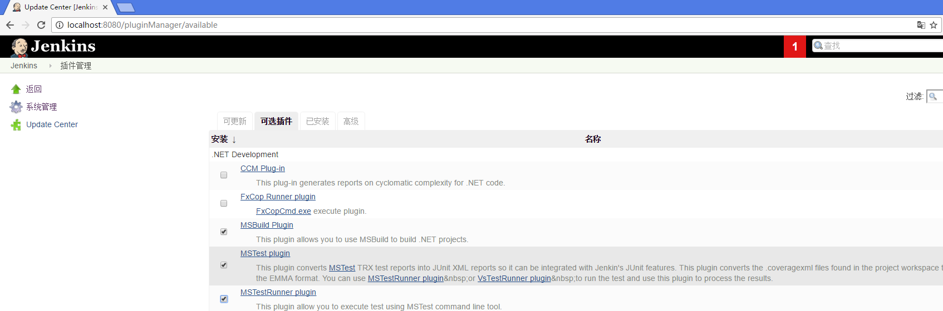

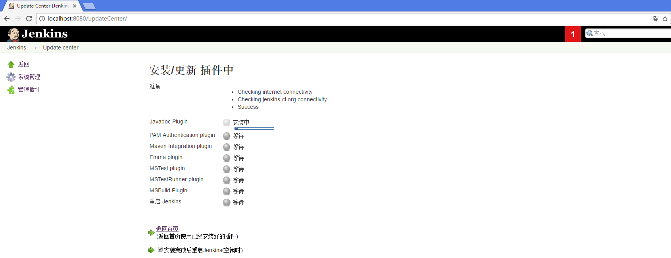

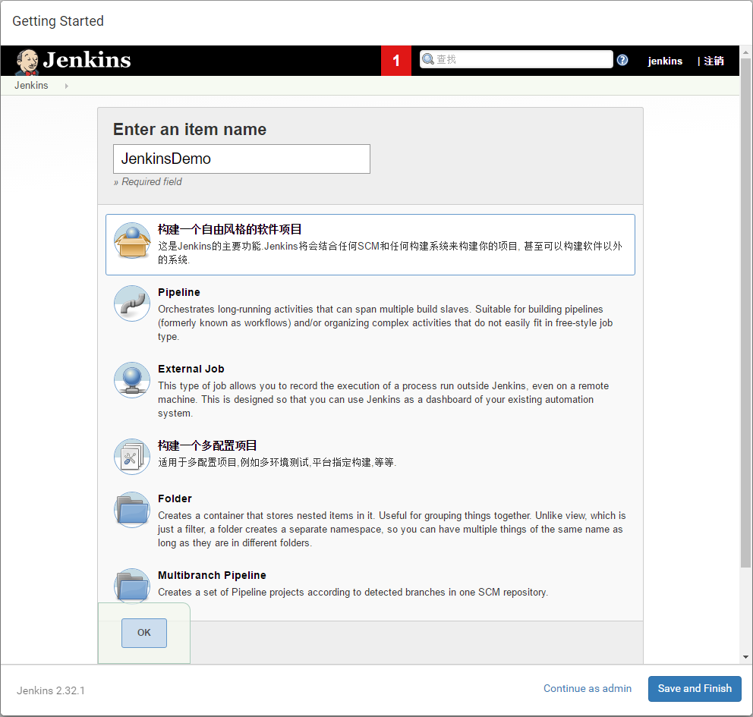

remote: GitLab: You are not allowed to push code to protected branches on this project.

To http://192.168.2.122/yang/JenkinsCI.git

! [remote rejected] master -> master (pre-receive hook declined)

创建项目之后，先创建一个Readme.md文件