Dobot on Raspberry Pi

<https://physical-computing-lab.net/dobot/dobotapi-for-jetsonnano.html>

method 解說

<https://physical-computing-lab.net/faq/blockly-dobotapi.html>

raspberry pi install realsense

<https://github.com/datasith/Ai_Demos_RPi/wiki/Raspberry-Pi-4-and-Intel-RealSense-D435>

注意：

configure: WARNING: no configuration information is in third_party/googletest

需要下载googletest，下载地址：https://github.com/google/googletest/releases，解压后放在./protobuf-3.6.1/third_party/googletest，然后执行./autogen.sh之后的

CMake Error at /usr/share/cmake-3.16/Modules/FindPackageHandleStandardArgs.cmake:146 (message):

Could NOT find OpenSSL, try to set the path to OpenSSL root folder in the

system variable OPENSSL_ROOT_DIR (missing: OPENSSL_CRYPTO_LIBRARY

OPENSSL_INCLUDE_DIR)

Call Stack (most recent call first):

/usr/share/cmake-3.16/Modules/FindPackageHandleStandardArgs.cmake:393 (_FPHSA_FAILURE_MESSAGE)

/usr/share/cmake-3.16/Modules/FindOpenSSL.cmake:447 (find_package_handle_standard_args)

CMake/external_libcurl.cmake:56 (find_package)

CMake/global_config.cmake:93 (include)

CMakeLists.txt:48 (global_set_flags)

-- Configuring incomplete, errors occurred!

See also "/home/ubuntu/librealsense/build/CMakeFiles/CMakeOutput.log".

sudo apt-get install libssl-dev

<https://github.com/IntelRealSense/librealsense/issues/10033>

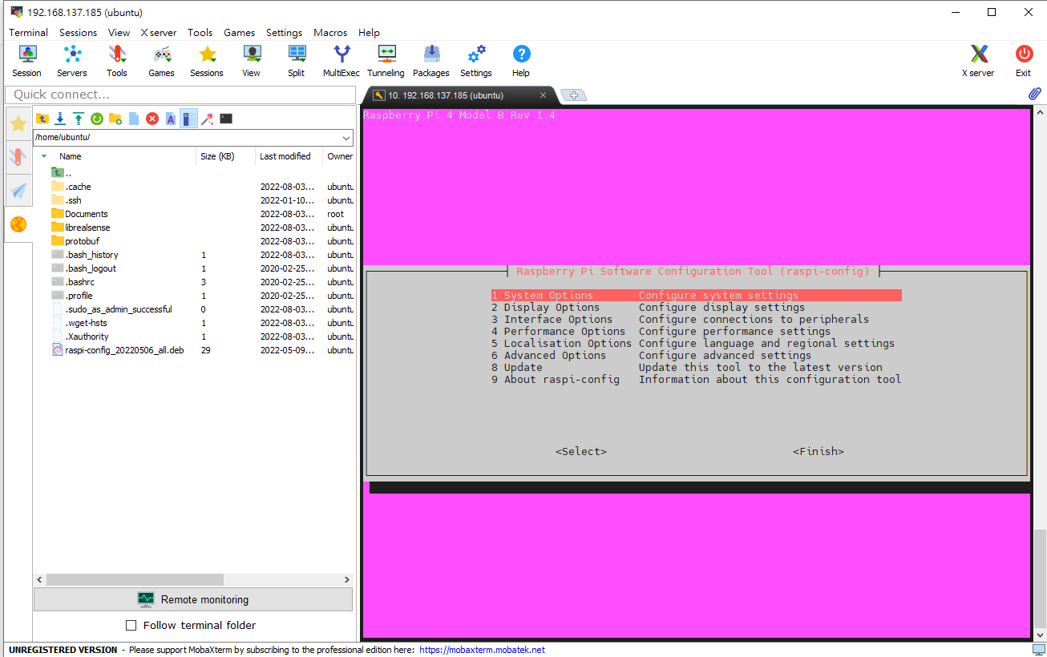

<https://github.com/IntelRealSense/librealsense/tree/jupyter>