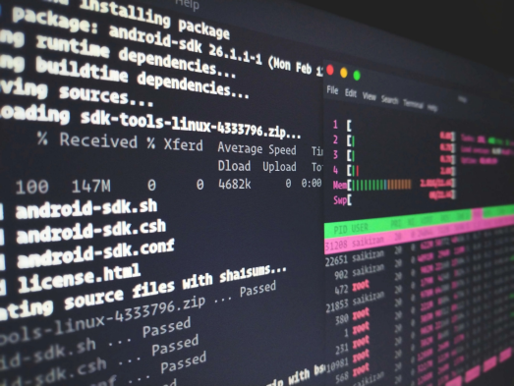Lecturer: Ngo Tra

COMMAND LINE (CLI)

⬛ Command line or CLI (command line interface)

⬛ The CLI is the interface in which we enter commands for the computer to process.

⬛ Windows: ⊞Win → type **cmd** or **Command Prompt**

OPEN TERMINAL IN WINDOWS

⬛ ⊞Win → type **cmd** or **Command Prompt**

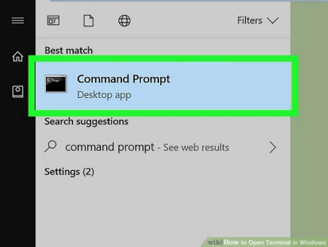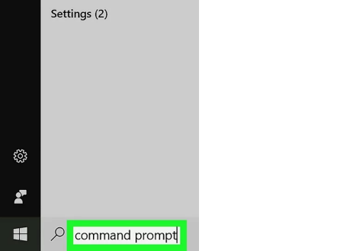

OPEN TERMINAL IN WINDOWS

⬛ ⊞**Win+R** → type **cmd** → Enter

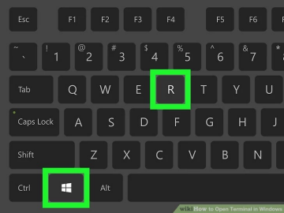

OPEN TERMINAL IN MACOS

⬛ **Command + Space** → type **Terminal**

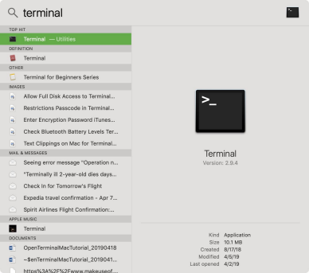

**MOST COMMON AND USEFUL COMMANDS**

o **echo** prints in the terminal whatever parameter we pass it.



o **pwd (Mac)/ cd (Win)** stands for print working directory and it prints the "place" or directory we are currently at in the computer.



**MOST COMMON AND USEFUL COMMANDS**

o **ls (Mac)/ dir (Win)** presents you the contents of the directory you're currently in. It will present you with both the files and other directories your current directory contains.

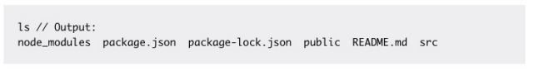o **ls –a (Mac) or dir/a** It will also show you hidden files or directories. Like .git or .gitignore files

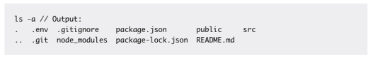

**MOST COMMON AND USEFUL COMMANDS**

⬛ Clear Terminal:

o Mac**: clear** or **command + L**

o Window**: clear**

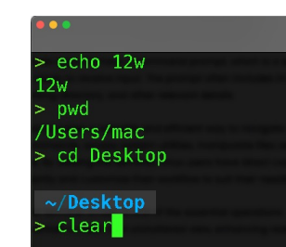

**MOST COMMON AND USEFUL COMMANDS**

o **cd** is short for Change directory and it will take you from your current directory to another.

o While on my home directory, I can enter **cd Desktop** and it will take me to the Desktop Directory.

o If I want to go up one directory, meaning go to the directory that contains the current directory, I can enter cd ..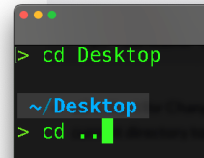

**MOST COMMON AND USEFUL COMMANDS**

o **mkdir** stands for make directory (folder) and it will create a new directory for you. You have to pass the command the directory name parameter.

o If I wanted to create a new directory called "Test" I would enter **mkdir test**.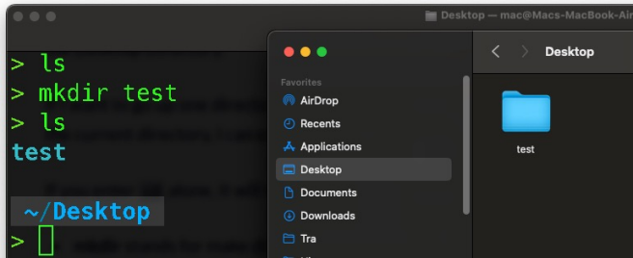

**MOST COMMON AND USEFUL COMMANDS**

o **rmdir** stands for Remove directory and it does just that. It needs the directory name parameter just as mkdir: **rmdir test**

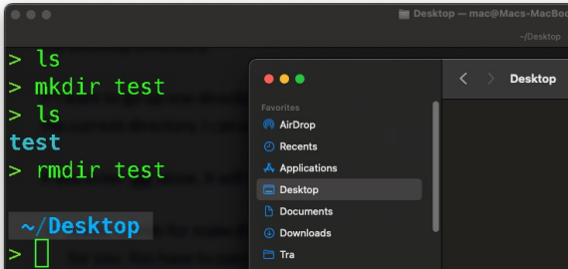

**MOST COMMON AND USEFUL COMMANDS**

⬛ **touch** allows you to create an empty file in your current directory. As parameters it takes the file name, like **touch test.txt**.

⬛ **rm** allows you to delete files, in the same way rmdir allows you to remove directories. **rm test.txt**

**MOST COMMON AND USEFUL COMMANDS**

⬛ **cp** allows you to copy files or directories. This command takes two parameters: the first one is the file or directory you want to copy, and the second one is the destination of your copy (where do you want to copy your file/directory to).

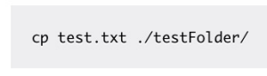

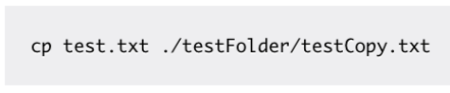

**MOST COMMON AND USEFUL COMMANDS**

⬛ **mv** is short for move, and lets us move a file or directory from one place to another. That is, create it in a new directory and delete it in the previous one (same as you could do by cutting and pasting).





**MOST COMMON AND USEFUL COMMANDS**

o **head** allows you to view the beginning of a file or piped data directly from the terminal.



• **tail** works the same but it will show you the end of the file.

**MOST COMMON AND USEFUL COMMANDS**

o **code** will open your default code editor. If you enter the command alone, it just opens the editor with the latest file/directory you opened.

o You can also open a given file by passing it as parameter: **code test.txt**

o You can also open a given folder (project) by: **cd testFolder → code .**

**LET ME OUTTTT**

o Type **:q!** and hit enter 

o **ctrl+c** allows you to exit the current process the terminal is running.

o For example, if you're creating a react app with **npx create-react-app** and want to cancel the build at some point, just hit **ctrl+c** and it will stop.

**SUDO (SUPERUSER DO)**

o It allows the permitted user (the administrator user) to run commands in the Mac Terminal as a superuser or another user with extra security privileges.

o In windows, you just need to open the command line

**SUDO (SUPERUSER DO)**

ABOUT VERSION CONTROL

⬛ Version control is a system that records changes to a file or set of files over time so that you can recall specific versions later.

⬛ It allows you to:

⬛ revert selected files back to a previous state

⬛ revert the entire project back to a previous state

⬛ compare changes over time

⬛ see who last modified something that might be causing a problem ⬛ who introduced an issue and when

⬛ Using a Version Control system (VCS) also generally means that if you screw things up or lose files, you can easily recover.

LOCAL VCS 

⬛ Many people’s version-control method of choice is to copy files into another directory (perhaps a time-stamped directory, if they’re clever).

⬛ This approach is very common because it is so simple, but it is also incredibly error prone.

⬛ It is easy to forget which directory you’re in and accidentally write to the wrong file or copy over files you don’t mean to.

⬛ To deal with this issue, programmers long ago developed local VCSs that had a simple database that kept all the changes to files under revision control.

⬛ One of the most popular VCS tools was a system called RCS, which is still distributed with many computers today. RCS works by keeping patch sets (that is, the differences between files) in a special format on disk; it can then re-create what any file looked like at any point in time by adding up all the patches.

**CENTRALIZED**VCS

⬛ The next major issue that people encounter is that they need to collaborate with developers on other systems.

⬛ These systems (such as CVS, Subversion, and Perforce) have a single server that contains all the versioned files, and a number of clients that check out files from that central place.

⬛ Benefits: everyone knows to a certain degree what everyone else on the project is doing

⬛ Drawback: single point failure

DISTRIBUTED VCS 

⬛ In a DVCS (such as Git, Mercurial or Darcs), clients don’t just check out the latest snapshot of the files; rather, they fully mirror the repository, including its full history.

⬛ Thus, if any server dies, and these systems were collaborating via that server, any of the client repositories can be copied back up to the server to restore it. Every clone is really a full backup of all the data.

**WHAT IS GIT?**

⬛ **Other VCS Snapshots**



**GIT SNAPSHOTS**

⬛ With Git, every time you commit, or save the state of your project, Git basically takes a picture of what all your files look like at that moment and stores a reference to that snapshot.

⬛ To be efficient, if files have not changed, Git doesn’t store the file again, just a link to the previous identical file it has already stored. Git thinks about its data more like a **stream of snapshots**.



**GIT BRANCHES**



**GIT FLOW**

⬛ Fundamentally, Git flow involves isolating your work into different types of Git Branches. 

⬛ In the Git flow workflow, there are five different branch types:

⬛ Main

⬛ Develop

⬛ Feature

⬛ Release

⬛ Hotfix

**GIT FLOW – MAIN BRANCH**

⬛ *Please note: the main branch is commonly referred to as “master”; we have made an intentional decision to avoid that outdated term and have chosen to use “main” instead.*

⬛ The purpose of the main branch in the Git flow workflow is to contain production-ready code that can be released.

⬛ In Git flow, the main branch is created at the start of a project and is maintained throughout the development process. The branch can be tagged at various commits in order to signify different versions or releases of the code, and other branches will be merged into the main branch after they have been sufficiently vetted and tested.

**GIT FLOW – DEVELOP BRANCH**

⬛ The develop branch is created at the start of a project and is maintained throughout the development process, and contains pre production code with newly developed features that are in the process of being tested.

⬛ Newly-created features should be based off the develop branch, and then merged back in when ready for testing.

**GIT FLOW – SUPPORTING BRANCH**

⬛ When developing with Git flow, there are three types of supporting branches with different intended purposes: feature, release, and hotfix.

**GIT FLOW – FEATURE BRANCH**

⬛ The feature branch is the most common type of branch in the Git flow workflow. It is used when adding new features to your code.

⬛ When working on a new feature, you will start a feature branch off the develop branch, and then merge your changes back into the develop branch when the feature is completed and properly

reviewed.



**GIT FLOW – RELEASE BRANCH**

⬛ The release branch should be used when preparing new production releases. Typically, the work being performed on release branches concerns finishing touches and minor bugs specific to releasing new code, with code that should be addressed separately from the main develop branch.

**GIT FLOW – HOTFIX BRANCH**

⬛ In Git flow, the hotfix branch is used to quickly address necessary changes in your main branch.

⬛ The base of the hotfix branch should be your main branch and should be merged back into both the main and develop branches. Merging the changes from your hotfix branch back into the develop branch is critical to ensure the fix persists the next time the main branch is released.

**GIT**

⬛ Installation:

o **Mac:** https://git-scm.com/downloads/mac o **Window:** https://gitforwindows.org/ ⬛ Type **git version** to verify Git was installed

**GIT**

⬛ Create a Github account: https://github.com/



**GIT CONFIG**

o You can view all of your settings and where they are coming from using: **git config --list --show-origin**

****• Setup your identity



**GIT NEW PROJECT**



**GIT NEW PROJECT**



**GIT CLI**

o **cd** into your project folder

o **git init** will create a new local repository for you.

o **git add** adds one or more files to staging. You can either detail a specific file to add to staging or add all changed files by typing **git add .**

**GIT CLI**

o **git commit** commits your changes to the repository. Commits must always be must be accompanied by the -m flag and commit message.



**GIT CLI**

o And as last step, we rename our master branch to main, add the remote origin we just obtained, and push our code to GitHub



**GIT SSH KEY**

o If you don't have a private token yet, you can generate it in GitHub in **User icon > Settings > SSH and GPG keys**

o https://docs.github.com/en/authentication/connecting-to-github with-ssh/generating-a-new-ssh-key-and-adding-it-to-the-ssh-agent

**GIT STATUS**

o **git status** tells you what branch are you currently on and whether you have changes to commit or not.



**GIT CLONE**

o **git clone** allows you to clone (copy) a repository into the directory you're currently in. Keep in mind you can clone both remote repositories (in GitHub, GitLab, and so on) and local repositories (those that are stored in your computer).



**GIT CLONE**



**GIT PULL**

o **git pull** pulls (downloads) the code from your remote repository and combines it with your local repo. This is particularly useful when working in teams, when many developers are working on the same code base. In this case each developer periodically pulls from the remote repo in order to work in a code base that includes the changes done by all the other devs.



**GIT BRANCH**

o **git branch** lists all the available branches on your repo and tells you what branch you're currently on. If you want to create a new branch, you just have to add the new branch name as parameter like git branch <branch name>.



**GIT BRANCH**

o You’ve decided that you’re going to work on issue #53 in whatever issue tracking system your company uses. To create a new branch and switch to it at the same time, you can run the git checkout command with the -b switch:

**git checkout -b iss53** 



https://git-scm.com/book/en/v2/Git-Branching

Basic-Branching-and-Merging

**GIT BRANCH**



**GIT MERGE**



**GIT MERGE**



**GIT MERGE**



**LEARNING GIT GAMES**

https://learngitbranching.js.org/

