不同嚴重程度腦性麻痺高風險兒童語音發展及典型喃語比較

**Phonetic development and canonical babbling ratio in children with high risk of cerebral palsy: Comparison of children who differ in the severity**

Ching Yang (楊浄)1*、Ellen Wu (吳亭緯)1、Li-Wen Chen (陳俐文)2、Yung-Chieh Lin (林永傑)2、Wei-Ping Wang (汪維平)3、Chia-Cheng Lee (李佳錚)4、Li-Mei Chen (陳麗美)5

1國立成功大學外文系（所）大學生

2國立成功大學醫學院小兒科主治醫師

3溫有諒醫院職能治療師

4 Department of Speech & Hearing Sciences, Portland State University

5國立成功大學外文系（所）教授

摘要

腦性麻痺(CP)常見症狀為言語發展遲緩和說話困難，過去研究指出兒童喃語期延遲可作為言語發展異常的指標。由此可見，兒童語言發展過程中，喃語期是發展語音和語言的關鍵階段。在典型喃語期(canonical babbling stage、約6-10個月大，Stoel-Gammon, 2006），幼兒會出現子音加母音的音節，例如[ba]、[mama]。本研究使用語音符號轉寫幼兒的發聲，再分別計算典型喃語百分比（canonical babbling ratio, CBR =子音加母音的音節數/總音節數，Oller & Eilers, 1988）以及計算子音和母音的出現頻率。此項研究的主要目的為比較不同嚴重程度腦性麻痺兒童的CBR和其語音發展。共有六名腦性麻痺高風險兒童參與此研究，分別是三位輕度腦性麻痺兒童和三位重度腦性麻痺兒童。研究的主要發現: 1))輕度腦性麻痺嬰兒的CBR較高，也比較穩定增長。例如，一位輕微CP在9, 12, 15個月大時，CBR分別為0.2 - 0.4- 0.6，呈現穩定成長趨勢。一位較嚴重CP從9到12個月大，CBR一直維持在0.1或更低; 2)輕度腦性麻痺組中，子音出現率高於重度組，而且使用的子音與母音的類別較廣泛。依研究結果顯示CBR和語音發展在輕度CP和重度CP兒童之間存在差異。CBR和語音發展可能作為預測疾病與觀察比較不同嚴重程度疾病的重要項目。

關鍵字: 典型喃語、腦性麻痺、典型喃語百分比、語音發展

**ABSTRACT**

The common symptoms of cerebral palsy (CP) are delay in speech development. Previous study has indicated that late onset of canonical babbling can be a predictor of developmental speech disorder. Canonical babbling is a key to speech and language development. During canonical babbling stage (about 6-10 months of age, Stoel-Gammon, 2006), consonant-vowel syllables appear in early utterances, e.g., [ba] and [mama]. In this current research, the recordings were transcribed by using phonetic symbols, and then canonical babbling ratio (CBR= # of consonant-vowel syllables / total # of syllables, Oller & Eilers, 1988) and the frequency of distribution of consonants and vowels were computed. The present study aimed to compare CBR and phonetic development in children with CP of different severity level. A total of 6 children engaged in this study, three with mild CP and three with severe CP. Major findings were: 1) Mild CP group had higher CBRs, and showed steady increase overtime. For example, one mild CP showed increase of CBR of 0.2 - 0.4- 0.6 at 9, 12, 15 months of age respectively, while one severe CP kept CBR at about 0.1 or below from 9 to 12 months of age; 2) There were more consonants in the production of mild CP. Moreover, mild CP had a wider range of consonant and vowel inventories. The results indicated that CBR and phonetic development might be used to distinguish mild CP and severe CP, and CBR and phonetic development can be important predictors for the severity of diseases.

**Keywords:** canonical babbling, cerebral palsy, canonical babbling ratio, phonetic development

1. **INTRODUCTION**

Prelinguistic period means the time before language emerging. Infants usually communicate by gestures and vocalizations. At approximately 4 months of age, infants start babbling. Their babblings sometimes sound like adults’ utterances. Producing ‘speech-like’ vocalization is a milestone to develop their language (Lang, Sigrun et al., 2019).

Early phonetic development contains five stages, ‘phonation’ (0-2months), ‘cooing’ (2-4 months), ‘vocal play’ (4-6 months), ‘canonical babble’ (6-10 months) and ‘jargon babble’ (10 months and older). Starting from the third stage, infants begin producing the structure of consonant-vowel sounds. Later, infants enter ‘canonical babbling’ stage. They start to have alternate consonants and vowels. Syllables occur as single or as strings of repeated syllables like [mama] (Stoel-Gammon, 2006).

Previous research (Lang, Bartl-Pokorny, Pokorny, et al.,2019) indicated that late onset of canonical babbling can be a marker of disorder. The research shows that late onset of canonical babbling become a critically important aspect of a screening battery for developmental disabilities at the end of the first year of life. The researchers screened 3400 infants around the age of 10-month who might have high risk of disorder. About half of infants with late onset of canonical babbling had been previously diagnosed as a certain disease which may lead to medical problems (Oller, Eilers, Neal, Schwartz,1999).

Along with the phonetic development, the infants might begin utter some sounds. Initially, the infants quickly learn [a,e,i,o,u] because those sounds do not need complicated controlling skills. They acquire bilabial (e.g. [b, p, m]), alveolar (e.g. [d, t]), nasal [n], and velar (e.g. [g, k]) sounds within prelinguistic period.

The purposes of this study is to observe the discrepancy and similarity in phonetic development and CBR (canonical babbling ratio) among six children with high-risk of CP and with different severity.

1. **METHODS**

Three children with severe CP and three children with mild CP were observed. Their ages are within 3 months to 19 months. The participants in two groups were named mild CP 1, mild CP 2, mild CP 3, severe CP 1, severe CP 2 and severe CP 3. Participants were recruited from the Division of Neonatology in the Department of Pediatrics of National Cheng Kung University Hospital. The data were recorded with TASCAM recorder and SHURE wireless mini microphone.

The coding was conducted with Praat (Boersma & Weenink, 2016) with the worldbet system (Hieronymus, 1994). The worldbet system corresponded to IPA such as c} (worldbet system) as ɕ(IPA). Some sounds would be discarded because they overlapped with the adults’ sound or noise, and contained low volumes. Transferred worldbet was written on Excel and consonant-vowel syllables (CV) were marked in yellow.

Canonical Babbling Ratio was calculated with the following formula (Oller, Eilers, Steffens, Lynch & Urbano, 1994).

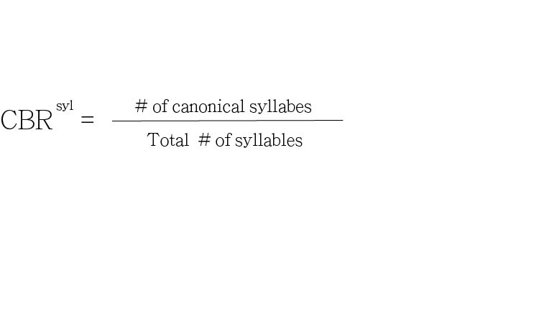

***Figure 1. The canonical babbling ratio formula***

1. **RESULTS**

The utterances were divided into two categories, CV syllable (*Figure 2*) and Non-CV syllable (*Figure 3*) to calculate CBR (canonical babbling ratio).

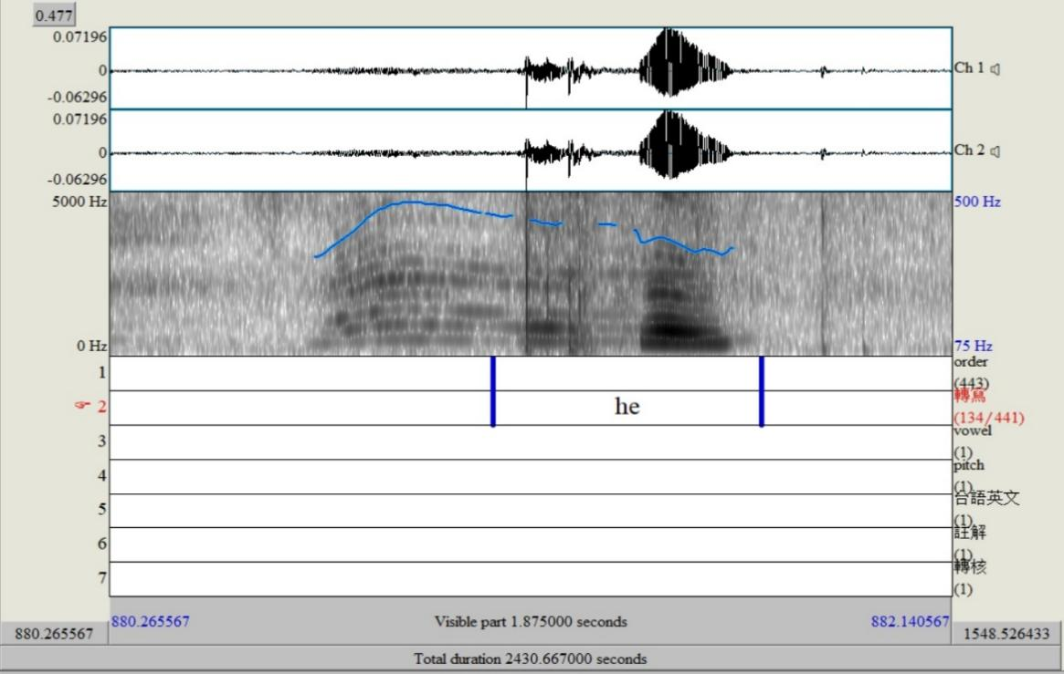

***Figure 2. An example of CV syllable. (produced by mild CP 2 at about 9 months of age)***

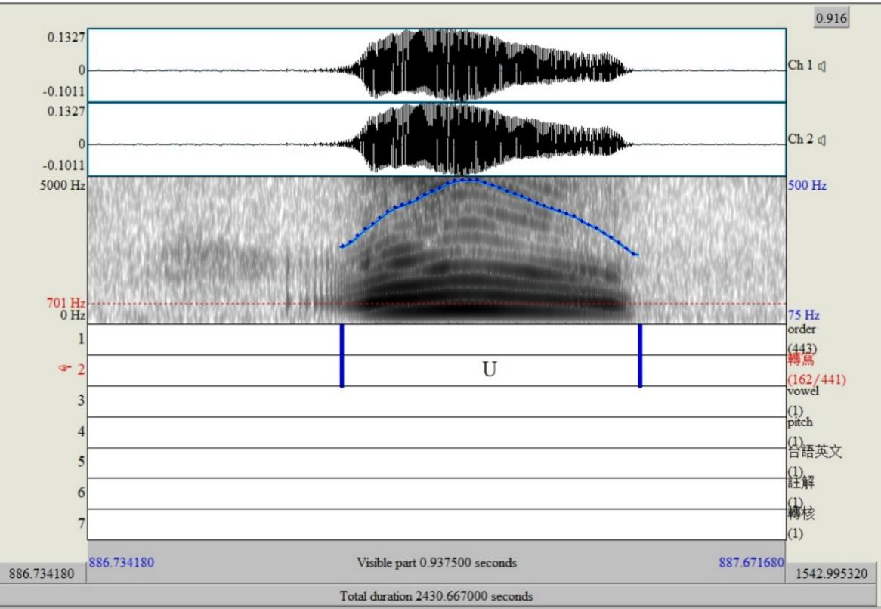

***Figure 3. An example of non-CV syllable (Vowel only syllable). (produced by mild CP 2 at about 9 months of age)***

In *figure 2 and figure 3*, according to the worldbet system, phonetic symbol ‘he’ is referred to [he] (IPA) sound and ‘U’ is [ʊ] (IPA). The previous one is categorized as C+V syllable and the latter one is non-C+V syllable owing to a single vowel. The following chart provides more details and examples.

***Table 1. An example of data of transferred phonetic syllables. (produced by CP 1 at about 5 months of age)***

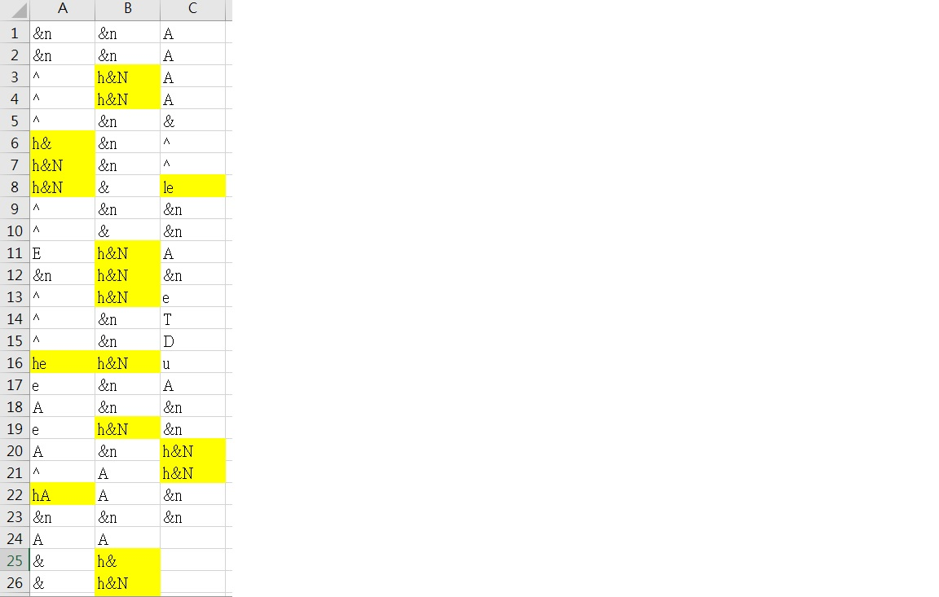

In *Table 1*, the three columns represent transferred data of phonetic symbols. The areas marked in yellow are ‘C+V syllable’. ‘Non C+V syllable’ includes a single consonant, vowel, or any combination composed of consonants and vowels without following C+V structures such as diphthongs.

***Table 2. A list of consonant inventory and vowel inventory in mild CP (produced by Mild CP 1 at about 15 months of age)***

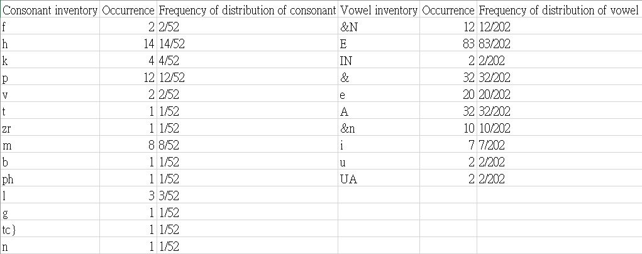

***Table 3. A list of consonant inventory and vowel inventory in severe CP (produced by Severe CP 1 at about 19 months of age)***

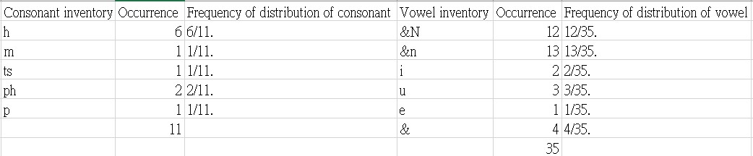

*Table 2.and 3* are the chart of consonants inventory and vowel inventory at different ages.

***Table 4. The CBR of three infants with mild and severe CP***

|  |  |  |  |  |  |
| --- | --- | --- | --- | --- | --- |
| **Participants** | **Months of Age** | |  | **CBR** | |
| **Mild CP 1** | 7 |  | | | 2% |
|  | 8 |  | | | 0% |
|  | 11 |  | | | 4% |
|  | 15 |  | | | 27% |
| **Mild CP 2** | 4 |  | | | 8% |
|  | 5 |  | | | 8% |
|  | 7 |  | | | 16% |
|  | 16 |  | | | 43% |
| **Mild CP 3** | 3 |  | | | 22% |
|  | 5 |  | | | 23% |
|  | 9 |  | | | 21% |
|  | 12 |  | | | 41% |
|  | 15 |  | | | 60% |

|  |  |  |  |
| --- | --- | --- | --- |
| **Participants** | **Months of Age** | **CBR** | |
| **Serious CP 1** | 7 | | 0% |
|  | 9 | | 0% |
|  | 12 | | 9% |
|  | 16 | | 0% |
| **Serious CP 2** | 6 | | 3% |
|  | 10 | | 2% |
|  | 13 | | 21% |
| **Serious CP 3** | 9 | | 12% |
|  | 10 | | 11% |
|  | 12 | | 50% |
|  | 13 | | 0% |

After analyzing and calculating by using CBR formula (*Figure 1*), the results are displayed in *Table 4*. The tableillustrates high and low CBRs and their development along with their ages. In Mild CP group, the ratio increases steadily such as mild CP2(8%-8%-16%-43%). Severe CP3 fall from 50% to 0% during the age of 12 months to 13 months.

***Figure 4. The tendency of distribution of CBR of infants with mild CP and severe CP.***

Based on the statistics in previous charts, the CBRs of mild CP group are higher and escalate steadily.

***Table 5. The distribution of CBR of infants with mild CP and severe CP.***

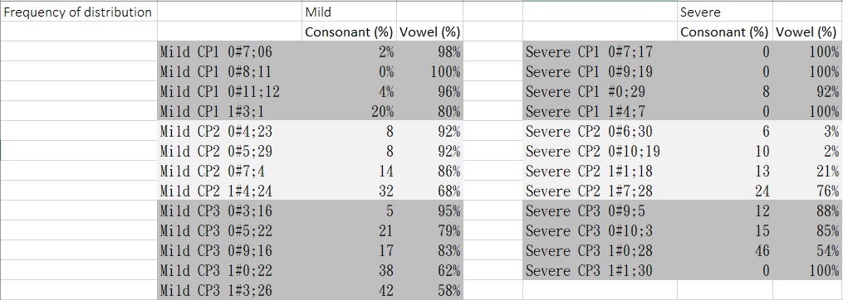

***Table 6. Consonants and vowels produced by mild CP group***

***Table 7. Consonants and vowels produced by Severe CP group***

*Table 5.* represents the distribution of CBR of infants with mild CP and severe CP. Most infants can acquire the vowel sounds quickly. On average, children with mild CP can produce various and complicated sounds like alveolar /l/.

1. **DISCUSSION**

The data show that mild CP infants can utter a wide range of sounds and have more complete development than the severe CP group. Both mild and severe CP infants can use basic vowel sounds [a,e,i.o.u] appropriately. As to consonants, the severe group has limited consonant inventory. Consonants [d], [t] and [k] never or seldom appear in severe CP. For example, in severe CP 3, the frequency of distribution raises between age of 9 months and 12 months, but at the age of 13 months, the frequency of distribution of consonants drops to 0%. On the contrary, in mild CP, the frequency of distribution of vowels and consonants develops gradually.

The results indicate that mild CP group generally has higher ratio and total of CBRs slightly fluctuate in path with their ages which suggests that their speech development might be impacted by the disorder but not very critical. For the severe group, the statistics states that their CBRs are low. Therefore, in company with unusual or low CBRs in the severe group, they might have some developmental disorders. The results correspond to previous findings. Late onset of canonical babbling may be a suitable predictor of speech and language disorders (Oller, Eiler, & Neal, 1996).

1. **ACKNOWLEDGEMENT**

This investigation was supported through funds from Ministry of Science and Technology in Taiwan (NSC102-2410-H-006-060). Special thanks are extended to the families of the children in this longitudinal study for their support of this project.

1. **REFERENCES**

Boersma, P. & Weenink, D. (2016). Praat: doing phonetics by computer [computer program] version. 6.0.21, 2016. Retrieved from <http://www.praat.org/>

Chen, C.-T., Lo, Y.- M., Wang, W.- P., & Chen, L.- M. (2019). Reduplicated babbling and variegated babbling in infants with high-risk of CP and typically developing infants. Proceedings of the 32nd Symposium of the Acoustical Society of Taiwan, (pp. 125-132).

Cobo-Lewis, A.B., Oller, D.K., Lynch, M.P., & Levine, S.L. (1996). Relations of motor and vocal milestones in typically developing infants and infants with Down syndrome. *American Journal of Mental Retardation, 100*, 456–467.

Eilers, R.E., Oller, D.K., Levine, S., Basinger, D., Lynch, M.P., & Urbano, R. (1993). The role of prematurity and socioeconomic status in the onset of canonical babbling in infants. *Infant Behavior and Development, 16,* 297–315.

Eilers, R.E., Neal, A.R., & Oller, D.K. (1996). Late onset babbling as an early marker of abnormal development (Poster presentation). Providence: International Conference on Infant Studies.

Hieronymus, James L. (1994). ASCII Phonetic Symbols for the World's Languages: Worldbet. AT&T Bell Laboratories Technical Memorandum.

Hong, Y.-A., Chen, C.-T., Cheng, C.- Y., Lan, T., & Chen, L.- M. (2019). The 20th International Conference and Workshops of Early Intervention for Children with Developmental Delays, pp. 148-149. ISBN 978-986-91150-5-6.

Koopmans-van Beinum, F.J., & van der Stelt, J.M. (1986). Early stages in the development of speech movements. In B. Lindblom & R. Zetterstrom (Eds.), *Precursors of early speech* (pp. 37–50). New York: Stockton Press.

Lang, S., Bartl-Pokorny, K. D., Pokorny, F. B., Garrido, D., Mani, N., Fox-Boyer, A. V., Zhang, D., & Marschik, P. B. (2019). Canonical Babbling: A Marker for Earlier Identification of Late Detected Developmental Disorders?. *Current developmental disorders reports*, *6*(3), 111–118. <https://doi.org/10.1007/s40474-019-00166-w>

Locke, J. L (1983). *Phonological acquisition and change*. Academic Press, New York

Molemans, I., Van Den Berg, R., Van Severen, L., & Gillis, S. (2012). How to measure the onset of babbling reliably? *Journal of Child Language,* *39*(3), 523-552. doi:10.1017/S0305000911000171

Oller.D. K (1980). The emergence of the sounds of speech in infancy. In G. H.

Yeni-Komshian. J. F Kavanagh and C.A. Ferguson (Eds.). *Child phonology* (Vol. 1: Production, pp.93-112). New York: Academic Press.

Oller, D. K. (1984). Speech-like vocalizations of normal and impaired infants. Paper presented at the Midwest Child Phonology Conference, Purdue University, West Lafayette, IN.

Oller, D., & Eilers, R. (1988). The role of audition in infant babbling. *Child Development,* *59*(2), 441-449. doi:10.2307/1130323

Oller, D., Eilers, R., Steffens, M., Lynch, M., & Urbano, R. (1994). Speech-like vocalizations in infancy: An evaluation of potential risk factors. *Journal of Child Language,* *21*(1), 33-58. doi:10.1017/S0305000900008667

Oller, D. K., Eilers, R. E., & Neal, A. R. (1998). Late onset canonical babbling: a possible early marker of abnormal development. *American Journal on Mental Retardation*, *103*(3), 249–263.

Oller, D. K., Eilers, R. E., Neal, A. R., & Schwartz, H. K. (1999). Precursors to speech in infancy: The prediction of speech and language disorders. *Journal of Communication Disorders, 32*(4), 223-245.

Stark, R. E. (1980). Stages of speech development in the first year of life. In G. H.

Yeni-Komshian, J. F. Kavanagh and C. A. Ferguson (Eds.), *Child phonology* (Vol. 1: Production, pp. 73-92) New York: Academic Press.

Stoel-Gammon, Carol. (2006). Infancy: Phonological Development. Encyclopedia of Language & Linguistics. 10.1016/B0-08-044854-2/00838-5.

Spencer P.E. (2011) Prelinguistic Communication. In: Goldstein S., Naglieri J.A. (eds) Encyclopedia of Child Behavior and Development. Springer, Boston, MA