Readme:

1. import the java project and start tomcat.
2. then open VScode and import the project, open terminal input following command using “cd quiz-app” then “ng serve “. Open your browser on the link.

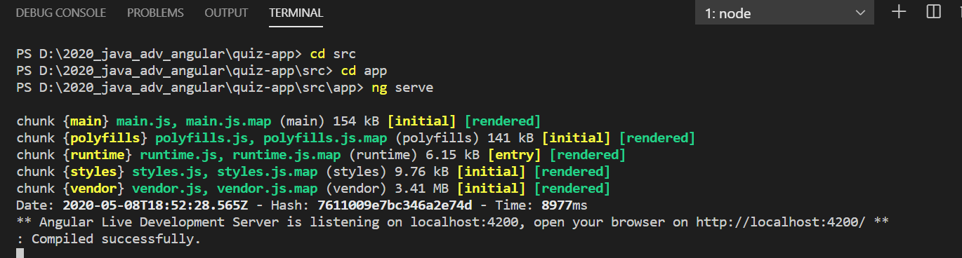

1. There are three links
2. the first one——Edit question and MCQChoices is to operate questions and choices. Attribute the choices to the different questions

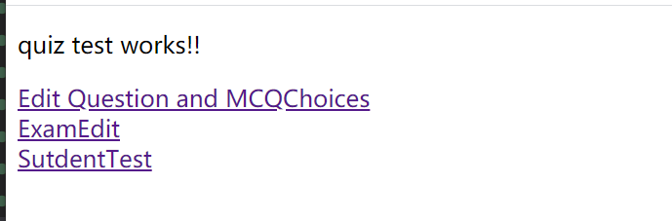

1. according these tips to create questions and choices, and then you would search and update these question.

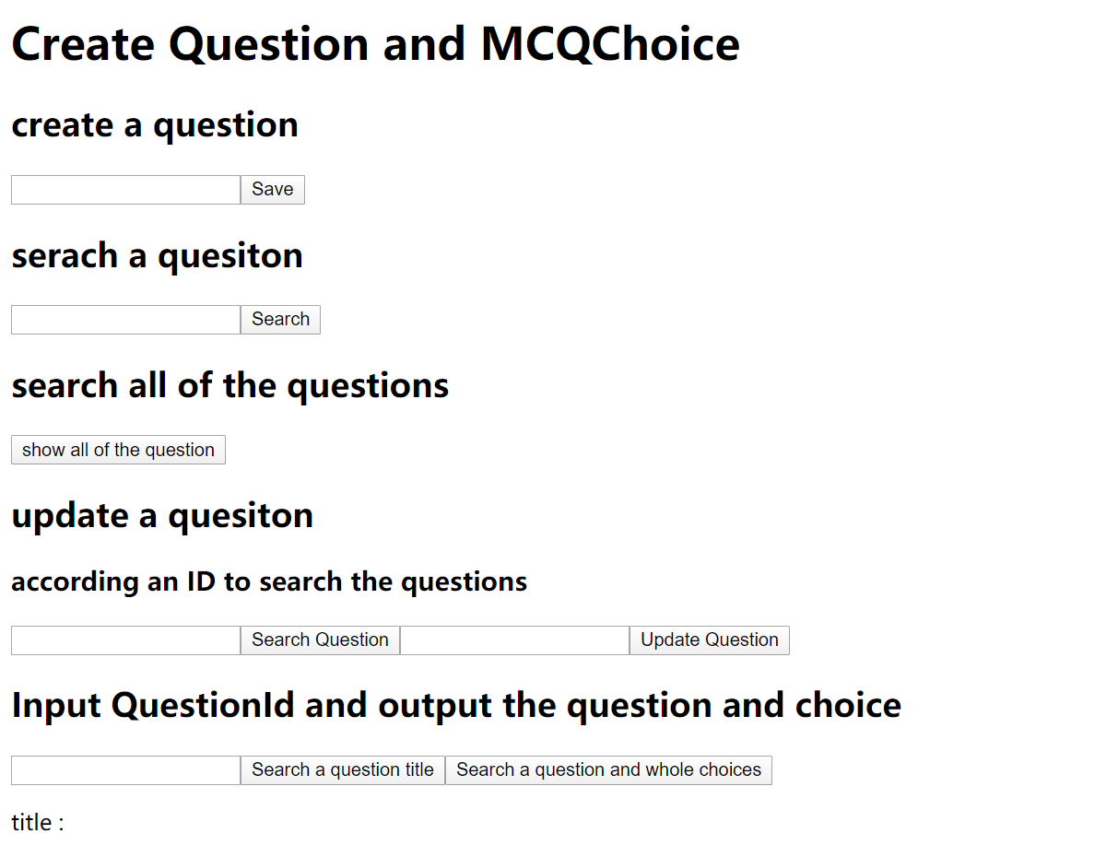

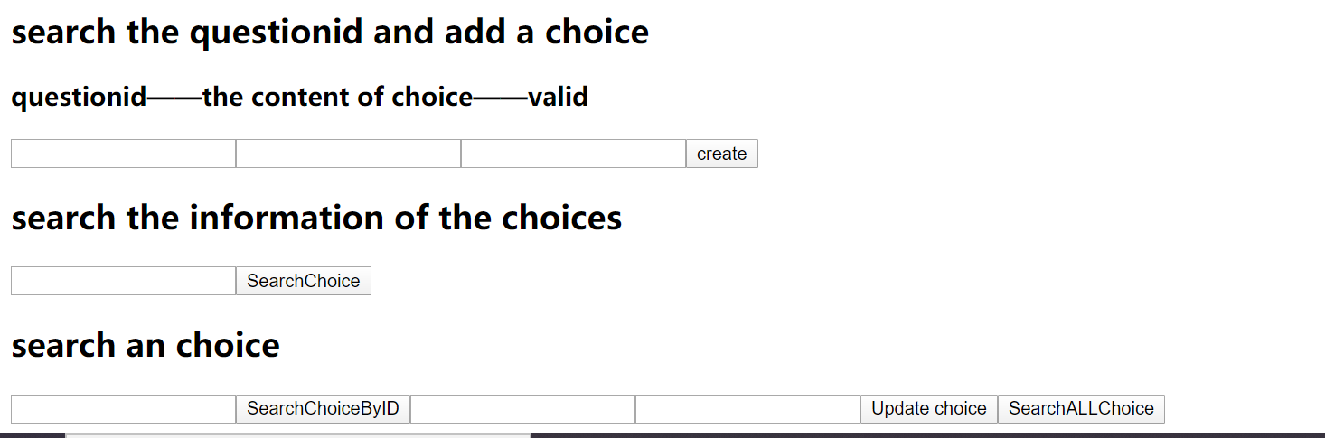

1. the second link ——ExamEdit

they create an exam and attribute the questions to different the examlist.

the second line, you would input an exam title and could get the whole test including questions ,choices and answers.

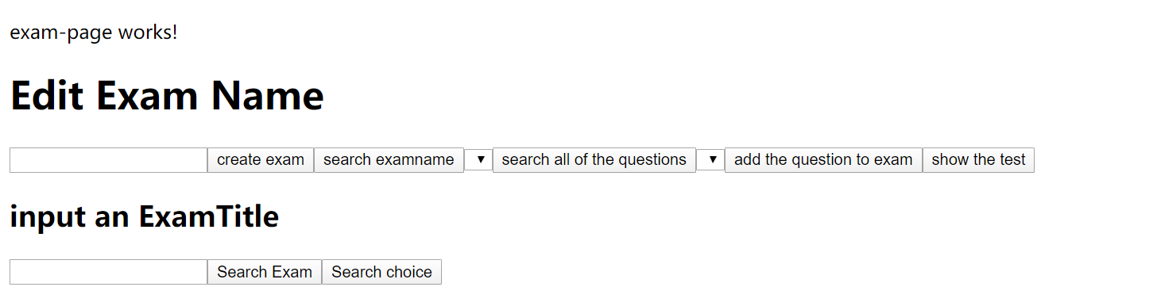

1. the third link is the user page, the student could create a name then input the test name and begin a test. If the student answers all of the questions ,submit the test .in the last line ,the student would input his/her name and test name to search all of his/her answers.

