- 關於皮膚腫瘤之敘述, 下列何者錯誤？
  - 非黑色素瘤中，基底細胞癌(Basal cell carcinoma)所佔的比率最高
  - Basal cell carcinoma發生淋巴轉移機率較鱗狀上皮細胞癌高
  - Melanoma治療以手術切除為主
  - 神經侵犯(perineural invasion) 在皮膚的基底細胞癌(BCC)及鱗狀上皮細胞癌(SCC)的發生率約佔2-3%
    - B (皮膚)
      - 易
        - Principle and Practice of Radiation Oncology, 6th ed, 2013, Chapter 33
          - (A) P626, The most common carcinomas of the skin are BCC (65%), SCC (30%), or …
(B) P628. The overall risk of lymphatic metastases is estimated to be 10-15% for cutaneous SCC of the skin. The risk of lymph node metastases from previously untreated BCCs is < 1%.
(C) P631. The preferred treatment for melanoma is resection of the primary lesion and any grossly positive regional nodes.
(D) P626. Perineural invasion is observed in 2% to 3% of patients with BCCs and SCCs.
- 皮膚腫瘤病人若有神經侵犯常見有感覺異常等症狀，而神經侵犯常見於中央面部的病灶，請問尤其容易侵犯哪幾條腦神經 (Cranial nerve; CN)？
  - CN V1 and CN V2
  - CN V1 and CN VII
  - CN V2 and CN VII
  - NC V1, CNV2 and CN VII
    - C(皮膚)
      - 中等
        - Principle and Practice of Radiation Oncology, 6th ed, 2013, Chapter 33
          - P628, Patients with PNI may complain of paresthesia, especially the sensation of worms crawling under skin (formication). PNI is usually observed with midface lesions and most often involves cranial nerves V2 and/or VII.
- 關於Merkel cell carcinoma (MCC)之敘述, 下列何者錯誤？
  - 是皮膚的神經內分泌瘤 (neuroendocrine carcinoma)。
  - 好發於白人老年男性。
  - 治療上以手術切除及術後放射治療為主，化療角色仍不確定。
  - Human polyomavirus 被認為與MCC有相關，且有該病毒感染者的預後較差。
    - D (皮膚)
      - 易
        - Principle and Practice of Radiation Oncology, 6th ed, 2013, Chapter 33
          - (A) P627, MCC is a small cell neuroendocrine carcinoma arising in the skin.
(B) P628. MCC occurs primarily in white men between 60 and 80 years of age.
(C) P631. The preferred treatment for MCC is resection of the primary tumor and any grossly positive regional nodes. lesion and any grossly positive regional nodes. Our bias is to treat both the primary site and regional lymphatics with postoperative RT….The role of adjuvant chemotherapy is ill defined.
(D) P628. Human polyomavirus is thought to be etiologic in a significant proportion of patients; human polyomavirus DNA in the MCC cells may be associated with an improved prognosis.
- 有關黑色素癌(Melanoma)侵犯深度與前哨淋巴腺轉移陽性率的關係，下列何者為誤？
  - 侵犯深度 ≦ 1 mm，前哨淋巴轉移之機率 ≤ 5 %。
  - 侵犯深度 1.01 至 2.00 mm，前哨淋巴轉移之機率 7-19 %。
  - 侵犯深度 2.01 至 4.00 mm，前哨淋巴轉移之機率 19-32 %。
  - 侵犯深度 > 4.00 mm，前哨淋巴轉移之機率 > 50 %
    - D (黑色素癌之淋巴轉移)
      - 難
        - Principle and Practice of Radiation Oncology, 6th ed, 2013, Chapter 33
          - P628, Table 33.1：13-45% for lesions > 4 mm。
- 關於cutaneous melanoma的的敘述 , 何者正確？
  - Acral (四肢的) lentiginous melanoma 好發於軀幹
  - Lentigo (雀斑) maligna melanoma 是melanoma中預後最差的。
  - Melanoma有lung metastasis是M1b (AJCC 8th ed)。
  - 根據AJCC stage第8版，melanoma有3顆LNs metastases是N1。
    - C (皮膚)
      - 中等
        - Eric K. Hansen, Mack Roach III, et al. Handbook of Evidence-Based Radiation Oncology 3rd Edition.
          - (A) P5. Acral lentiginous melanoma usually presents on soles and palms。
(B) P5. Lentigo maligna (best prognosis; Hutchinson’s freckle involves epidermis only of case)。
(C) P25。
(D) P25. 3 LNs metastases是N2。
- 根據基底細胞癌(Basal cell carcinoma)及鱗狀細胞癌(Squamous cell carcinoma) 2010 AJCC Staging System，下列何者為其高危險因子(high risk features)？
  - 侵犯深度小於2公分
  - 周邊神經侵犯(perineural invasion)
  - 潰瘍性表皮病灶
  - 眼皮(eyelid)為原發病灶
    - B(皮膚)
      - 中等
        - Principle and Practice of Radiation Oncology, 6th ed, 2013, Chapter 33
          - P629. Table 33.2, High risk features: depth invasion >2mm thickness; Clark level > IV; perineural invasion; primary site ear or non-hair-bearing lip; poorly differentiated or undifferentiated
- 關於皮膚癌（skin cancer）之描述，下列何者錯誤？
  - Merkel cell carcinoma主要發生在60至80歲之白種人男性，多數病灶於診斷時小於等於2公分
  - 皮膚之鱗狀上皮癌（squamous cell carcinoma）約有10%至15%淋巴轉移之機率，復發之病灶，其淋巴轉移之機率增高
  - 未經治療之皮膚基底細胞癌（basal cell carcinoma），其淋巴轉移之機率高，且機率和腫瘤大小、侵犯深度、組織學型態有相關性
  - 皮膚黑色素瘤（melanoma）比起基底細胞癌（basal cell carcinoma）及鱗狀上皮癌（squamous cell carcinoma），有較高之局部淋巴轉移及經血行擴散之機會，且此機率和原腫瘤之侵犯深度有關
    - C
      - 易
        - Principle and Practice of Radiation Oncology, 6th ed, 2013, Chapter 33
          - P628.
(A) MCC occurs primarily in white men between 60 and 80 years of age. ….. Most lesions are ≤ 2 cm in size at diagnosis。
(B) The overall lymphatic metastases is estimated to be 10% ~ 15 % for cutaneous SCC of skin. The risk increases with the size of the lesion, depth of the penetration, histologic grade, and recurrence。
(C) The risk of lymph node metastases from previously untreated BCCs is <1% and is not related to size, depth of penetration, or histologic subtype。
(D) Melanoma is more aggressive and prone to metastasize to regional lymph nodes and exhibit hematogenous dissemination compared with BCC and SCC。
- 下列敘述何者錯誤？
  - 基底細胞斑症候群(Basal cell nevus syndrome)可包含錯構瘤(Hamartomas)
  - 皮膚的鱗狀細胞癌(Squamous cell carcinoma)，淋巴擴散的機率約10-15%
  - 皮脂腺癌(Sebaceous gland carcinoma)通常生長緩慢
  - 黑色素瘤(Melanoma)屬於神經內分泌癌(neuroendocrine carcinoma)
    - D(皮膚)
      - 中等
        - Principle and Practice of Radiation Oncology, 6th ed, 2013, Chapter 33
          - P627、628.
(D) Melanoma arises from melanocytes. MCC is a small cell neuroendocrine carcinoma arising in the skin.
- 關於皮膚腫瘤之敘述, 下列何者錯誤？
  - Actinic keratosis是Basal cell carcinoma的癌前病變。
  - Basal cell carcinoma發生淋巴轉移機率較Squamous cell carcinoma低。
  - 日曬會增加罹患的風險。
  - Merkel cell carcinoma相較於其他非黑色素瘤的皮膚腫瘤來說更為惡性。
    - A (皮膚)
      - 易
        - (1) Principle and Practice of Radiation Oncology, 6th ed, 2013, Chapter 33; (2) Eric K. Hansen, Mack Roach III, et al. Handbook of Evidence-Based Radiation Oncology 3rd Edition.
          - (A) Handbook P4, Actinic keratosis (AK) is a premalignant lesion that can develop into SCC
(B) Perez P628. The overall risk of lymphatic metastases is estimated to be 10-15% for cutaneous SCC of the skin. The risk of lymph node metastases from previously untreated BCCs is < 1%.
(C) Perez P626. The risk for carcinoma of the skin increases with sun exposure.
(D) Perez P628. MCCs displays an aggressive growth pattern….localized 55%, positive regional nodes 31% and distant metastasis 6%。
- 關於Basal cell nevus syndrome之敘述, 下列何者錯誤？
  - 是自體顯性遺傳(autosomal-dominant)疾病。
  - 好發於20-30歲。
  - 常見有家族史。
  - 常見多發的SCC病灶。
    - D (皮膚)
      - 難
        - Principle and Practice of Radiation Oncology, 6th ed, 2013, Chapter 33
          - P628
(A)The basal cell nevus syndrome is an autosomal-dominant disorder with a high level of penetrance but a variable clinical picture.
(B) and (C). The age of onset is frequently in the second or third decade of life, and a family history is often positive for the disorder. Perez P628. The overall risk of lymphatic metastases is estimated to be 10-15% for cutaneous SCC of the skin. The risk of lymph node metastases from previously untreated BCCs is < 1%.
(D) The clinical syndrome may be composed of any or all of the following: Multiple BCCs; jaw cysts; palmar or plantar pits; skeletal abnormalities; ectopic calcification; eye muscle palsies; hamartomas; epidermal cysts.
- 關於basal cell skin cancer容易復發的危險因子，以下何者不是？
  - 病灶邊緣不清楚。
  - 病灶部位以前接受過放射線治療。
  - 神經侵犯 (perineural invasion)。
  - 病灶發生在cheeks, forehead, scalp, neck and pretibia。
    - D (皮膚)
      - 中等
        - NCCN Guideline Version 1.2020. Basal Cell Skin Cancer

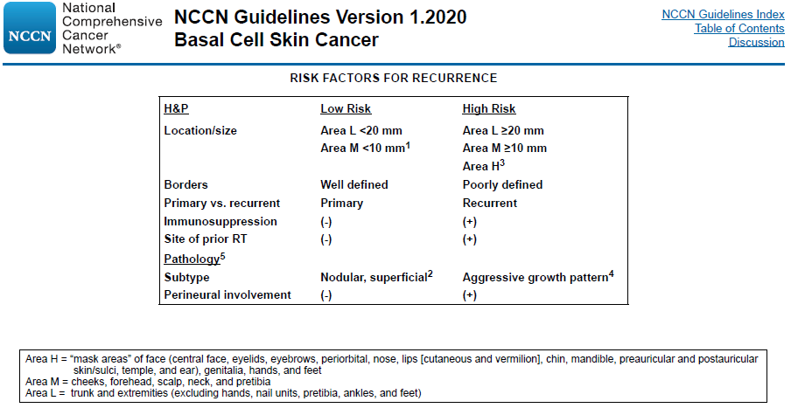
- 若單獨使用放射治療(radiotherapy alone)來治療basal cell carcinoma小於2公分的病灶，依據NCCN guideline 2020的放射治療劑量建議，以下何者不適合？
  - 66-70 Gy over 6-7 weeks。
  - 60-64 Gy over 6-7 weeks。
  - 50-55 Gy over 3-4 weeks。
  - 40 Gy over 2 weeks。
    - A (皮膚)
      - 難
        - NCCN Guideline Version 1.2020. Basal Cell Skin Cancer
