專科醫師甄審影像題參考用答案卷
題目 | 答案
- 簡述病人癌症相關檢查主要重點發現。
(image/lab/surgical/pathology/risk factors)
- 完整定義病人之癌症分期，使用AJCC^{8th} 及其他主要分期系統。
- 依照實證醫學指引，提出病人之完整治療規劃，包括其他Multimodality輔助治療，並簡述indications, benefits & risks相關證據。 | NCCN2020:  Gr 4  KPS >60，無論是否methylated  術後cat1都是 RT + caTMZ +/- TTF  CCRT with temozolomide 75 mg/m2 QD during RT  Adjuvant CT with temozolomide 150 – 200 mg/m2 x 5 days Q4W x 6 months  Gr 3  KPS >60， RT + adj/neo PCV x 6c/4c  Gr 2  For high risk(未滿足<40y且GTR) => RT + PCVx6c (by phase II RTOG 9802)
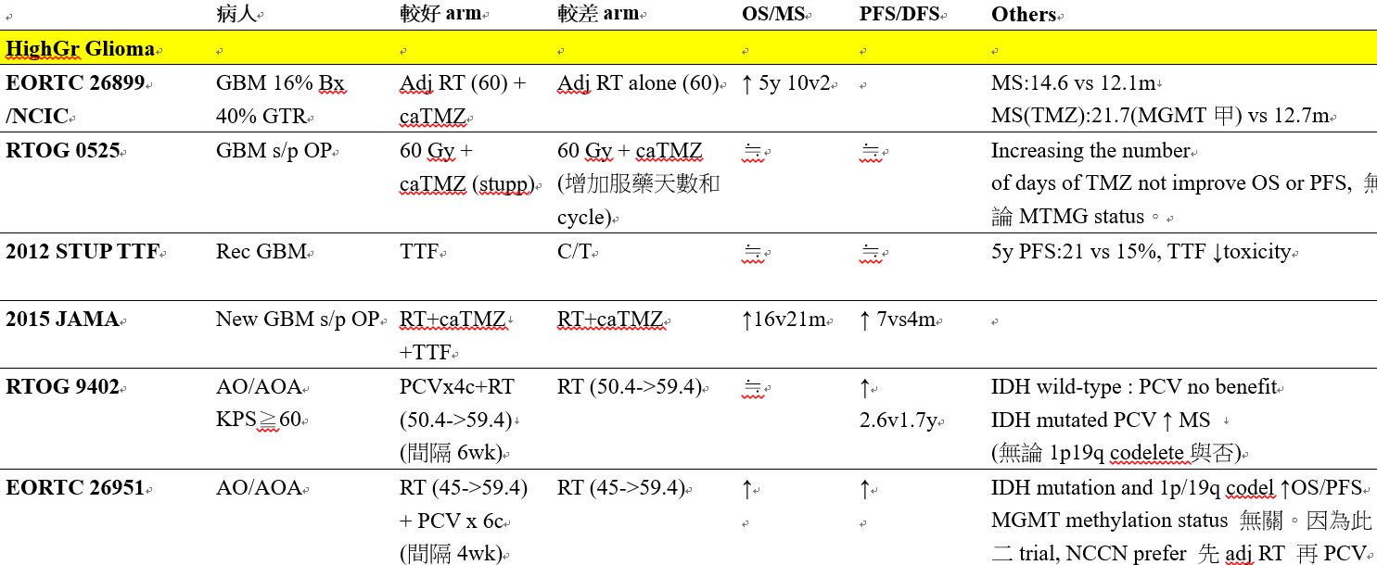
- 如果安排病人接受放射治療
a. 明確定義CT simulation:  - Patient positioning and immobilization  - CT image acquisition (thickness)  - Scanning localization 範圍  - 3DCT/4D CT/gating | -電腦斷層模擬攝影(CT simulation)，若臨床需要可考慮靜脈顯影劑注射以增加腫瘤與血管淋巴等組織之辨識。  -仰臥，並以適當之固定器(thermoplastic mask)固定。  -以雷射光於病人頭部模具畫上等中心(isocenter)記號。  -每2.5-5 毫米擷取一張電腦斷層影像
- 明確定義治療靶區之GTV、CTV及PTV範圍 | NCCN 2020 and Nancy Lee-Target Volume Delineation for Conformal and Intensity-Modulated Radiation Therapy  HGG  GTV1:postop T2 flair + cavity + T1 contrast residual  GTV:2:cavity + T1 contrast residual  CTV 1/2 = GTV 1/2 + 1-2 cm (CTV可跨中線，但不超過骨頭)  PTV 1/2 = CTV 1/2 + 3-5mm  LGG  GTV: post T2 flair + post T1 contrast  CTV = GTV + 1-2 cm  PTV = CTV + 1-2 cm
- 明確定義Radiation modality (2D/3D/4D, IMRT/Arc/SRS) | Arc
- 靶區之放射劑量及次數:  - (GTV, CTV, PTV)  - Prescription dose  - Fractionation schedules  - Beam energy  - Image procedures (KV imaging /CBCT) | 6 MV  HGG  Phase I: PTV 1: 46/2 or 45-50.4/1.8  Phase II: PTV 2: to 60/2 or 59.4/1.8  Poor PS (KPS<60), elderly (>70): 34/10 or 40.05/15  Elderly, fragil: 25/5  LGG  Standard: 45-54 / 1.8  IDH wild: 59.4 -60 / 1.8-2
- 明確定義相關正常組織之放射線劑量限制  - Dose to critical structures  - Tolerance level (TD5/5) | Dmax Dmean Others  Temporal 68, 1cc<58  Normal brain 60  Chiasm/optic n. 54(HN)-55(GBM)  Pituitary 50 40  Hippocampus 16-17 D100<9  Cord Max < 45-50 (<0.1% myelopathy)  Retina 45(HN)-50(GBM)  Lens 7-10  Lacriminal gland 34  Cochlea 35 (55 in NPC) 35-45 (<30% hearing loss) V30<50%  Inner ear 50  Parotid, contra <20  Parotid, ipsil <26  Larynx 66 35-45 (involved) 20 (uninvolved) V55 < 10%  Lips <20  Mandible / TMJ 0.1cc < 70  Esophagus 30-34  Brachial plexus 66-70
- 明確定義放射治療電腦計劃之評估方法及標準 | 59.4 – 60 Gy isodose surface encompass 100% GTV 2  59.4 – 60 Gy isodose surface encompass ≧ 95 % CTV 2  54 Gy isodose surface encompass ≧ 99 % PTV 2  100% PTV2 receive ≧ 95% prescribed dose  No more than 20% of PTV2 receive ≧ 110% prescribed dose  No more than 1% of PTV2 receive ≦ 93% prescribed dose  No more than 1 c.c. outside PTV2 receive ≧ 110% prescibed dose  ----  46 – 50.4 Gy isodose surface encompass 100% GTV 1  46 – 50.4 Gy isodose surface encompass ≧ 97 % CTV 1  46 – 50.4 Gy isodose surface encompass ≧ 95 % PTV 1  100% PTV1 receive ≧ 95% prescribed dose  No more than 20% of PTV1 receive ≧ 110% prescribed dose  No more than 1% of PTV1 receive ≦ 93% prescribed dose  No more than 1 c.c. outside PTV1 receive ≧ 110% prescibed dose
- 簡述放射治療可能引發之副作用 | Acute (within 4–6 week): alopecia, radiation dermatitis, fatigue, transient worsening of symptoms due to edema, nausea, and vomitings after radiation.  Subacute (6 weeks to 6 months after RT): somnolence(嗜睡) syndrome,  fatigue, neurologic deterioration, perhaps caused by changes in capillary permeability and transient demyelination.  Late (6 months to many years after RT): radiation necrosis, hearing loss, retinopathy, cataract, visual changes, endocrine abnormalities, cerebrovascular accidents, decreased new learning ability, short-term memory, and problem solving skills.
- 於病人之CT定位圖中，分別畫出GTV及 CTV

