專科醫師甄審影像題參考用答案卷ANAL
題目 | 答案
- 簡述病人癌症相關檢查主要重點發現。
(image/lab/surgical/pathology/risk factors)
- 完整定義病人之癌症分期，使用AJCC^{8th} 及其他主要分期系統。
- 依照實證醫學指引，提出病人之完整治療規劃，包括其他Multimodality輔助治療，並簡述indications, benefits & risks相關證據。 | NCCN: primary CCRT  Continuous infusion 5-FU 1000 mg/m2/day IV days 1–4 and 29–32 Mitomycin 10 mg/m2 IV bolus days 1 and 29 Concurrent radiotherapy  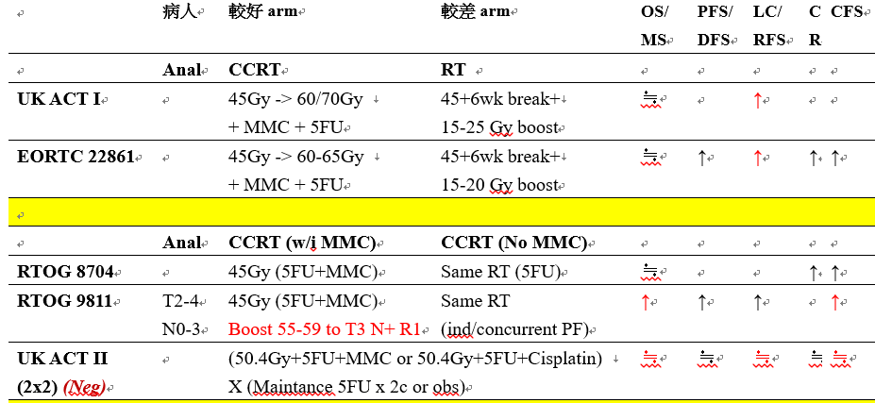
- 如果安排病人接受放射治療
a. 明確定義CT simulation:  - Patient positioning and immobilization  - CT image acquisition (thickness)  - Scanning localization 範圍  - 3DCT/4D CT/gating | -採用舒適之仰臥姿勢，病患腳部擺放在腳踝固定器(ankle fix device)上，提高病患之穩定度。 視病患穩定狀況考慮施用真空墊(vacuum bag)作為固定模具。  將治療中心標記在下腹部皮膚上，若使用真空墊固定的表面也要畫上標記。若想減少小腸之照射，可以俯臥姿勢，並使用腹式板(belly board)。  -電腦斷層之掃描範圍約從第3腰椎到恥骨下5公分，切片厚度為3 ~5毫米。  -3DCT技術
- 明確定義治療靶區之GTV、CTV及PTV範圍 | RTOG 0529  GTV-T: visible tumor  GTV-N: visible positive N  CTV-T: GTV-T + 2.5 cm  CTV-N: GTV-N+ 0.5-1cm  CTV pelvis = CTV-T + CTV-N + nodal regions including perirectal, pre-sacral, int/ext iliac, and inguinal nodes  Superiorly: bifurcation of common iliacs (~L5/S1)  Lateral border of mesentery: pelvic sidewall muscles or bone (if muscle absent); anteriorly 1cm into posterior bladder (for bladder variation)  External iliac vessels + 7-8mm mgn including small nodes (even if appear reactive)  Inguinal nodes: cover entire compartment, esp medially; include 2cm inferior to saphenous/femoral junction (bony: to lesser trochanter)  Inferiorly:2cm below GTV or to anal verge  PTV pelvis = CTV pelvis + 0.7-1cm (except at skin)  PTV-T = CTV-T+ 0.5 cm (except at skin)  PTV-N = CTV-N + 0.5 cm (except at skin)
- 明確定義Radiation modality (2D/3D/4D, IMRT/Arc/SRS) | Arc
- 明確定義治療靶區之放射劑量及次數: | 15 MV; Port film before the 1st day of RT course  RTOG0529 (SIB):T2N0 28fx; others 30fx  T2N0 T34N0 N+ N>3cm  PTV-T 50.4 54 54 54  PTV pelvis 42 45 PTV-N:50.4 (Gross boost) PTV-N:54 (Gross boost)
- 明確定義相關正常組織之放射線劑量限制  - Dose to critical structures  - Tolerance level (TD5/5) | 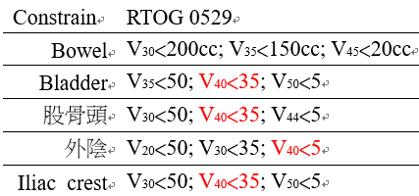
- 明確定義放射治療電腦計劃之評估方法及標準 | 50.4 / 54 Gy isodose surface encompass 100% GTV-T/N  50.4 / 54 Gy isodose surface encompass ≧ 97% CTV-T/N  50.4 / 54 Gy isodose surface encompass ≧ 95 % PTV-T/N  100% PTV-T receive ≧ 95% prescribed dose  No more than 20% of PTV-T/N receive ≧ 110% prescribed dose  No more than 1% of PTV-T/N receive ≦ 93% prescribed dose  No more than 1 c.c. outside PTV-T/N receive ≧ 110% prescibed dose  -----------------------  42/45 Gy isodose surface encompass 100 % CTV-pelvis  42/45 Gy isodose surface encompass ≧ 95 % PTV-pelvis  100% PTV-pelvis receive ≧ 95% prescribed dose  No more than 20% of PTV-pelvis receive ≧ 110% prescribed dose  No more than 1% of PTV-pelvis receive ≦ 93% prescribed dose  No more than 1 c.c. outside PTV-pelvis receive ≧ 110% prescibed dose
- 簡述放射治療可能引發之副作用 | Acute：skin reaction，leukopenia，thrombocytopenia，proctitis，diarrhea，cyctitis  Chromic：chronic diarrhea，rectal urgency，sterility，impotence，vaginal dryness，vaginal fibrosis/stenosis
- 於病人之CT定位圖中，分別畫出GTV及 CTV

